
Summer 2026
Spark

The quarterly magazine of the MG Car Club South East Centre

6

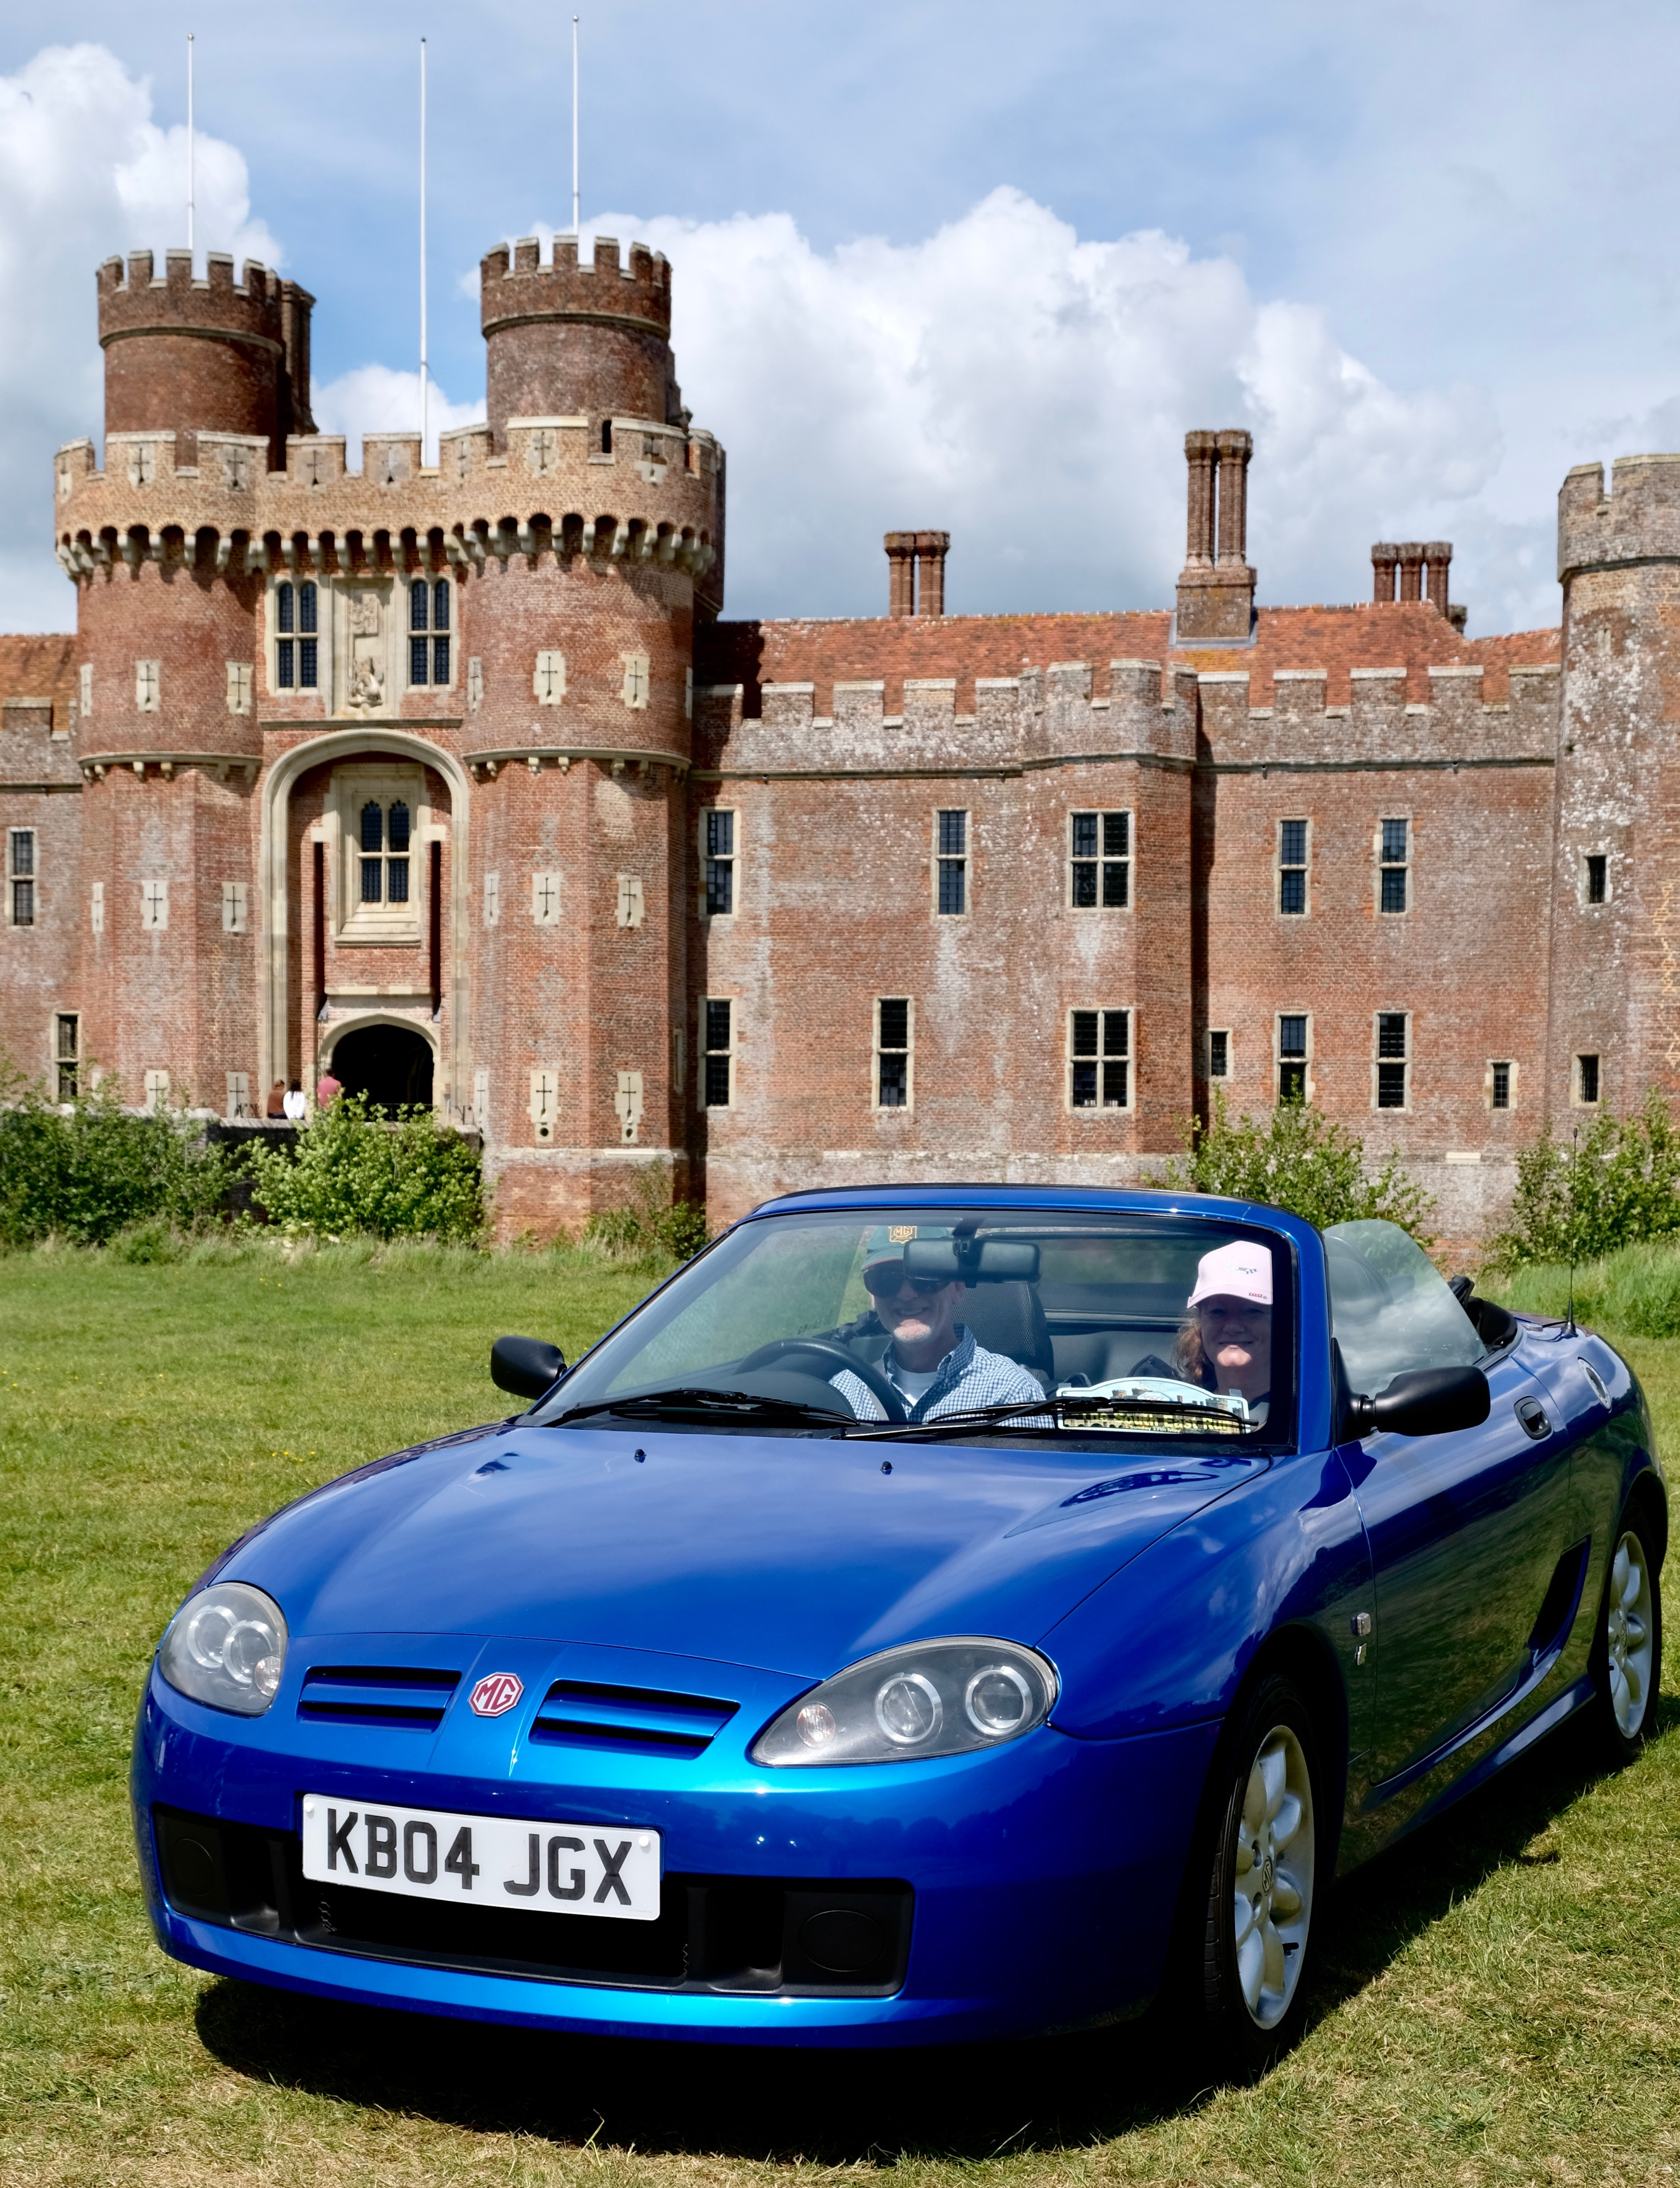

THIS ISSUE INCLUDES…
A Remarkable Lady | Easter Special | MGE – the Four Seat A
Blue Bird K3 sails again | Aviation Drive-it-Day | Best of British
South East Run | Alternative PoO | Filching AutoSOLO
Wilton Concours | Cars at the Castle | Mick Breare 1947-2026


Spark
Summer 2026
Spark Issue 6 Summer 2026
www.mgccse.co.uk

CONTENTS
2. The Editor / Contents
3. Chairman’s Chatter
4/ 6. A Remarkable Lady
7. Welcome to New Members
9. Spark Plug
10. Easter Special
11. K3 back on the water
13 / 14. Safe Landings on DiD Day
15/ 18. South East Run
19/ 20. MGE – Four Seater MGA
21. Best of British
22. Cars at the Castle
23. Alternative PoO 1 & 2
24. Filching AutoSOLO
25. Modern Gentlemen
26. Electric Spark
27. Wilton Concours
28/ 34. AROUND THE CENTRE
Sussex Wanderers | Pinner Natter North Downs | The Fairmile
North Surrey | MGF Register
Canterbury | Ashdown Adventurers
35. Obituary – Mick Breare
36/ 37. For Sale/ Wanted
38. Get in Touch
39. In the Heat this Summer
40. Retro Spark

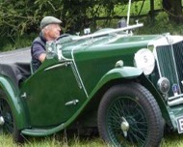
CONTRIBUTIONS
Do you have an article about your MG, or anything of interest, that you would like to share with the Centre? If so, then please get in touch with the editor and you could see it in the next edition.
Email spark@mgccse.co.uk
We welcome you to the Summer edition of your South East Centre magazine, Spark. It is full of interesting articles, competition results and many photos. Please circulate it to anyone with an interest in MGs as it highlights what our centre is all about.
This edition covers the second quarter of 2026 and includes contributions from the Natters, Wanderers and Members
If you or your fellow member are not receiving the quarterly SE newsletter via email it may be because your up-to-date email address is not held by the main administration at Abingdon or the South East Centre.
To update your details either go to the Members login area of MGCC web site, email mgcc@mgcc.co.uk or call 01235 555552.
This is your magazine so contributions to the Editor always welcome! Please get in touch as below.

THE EDITOR
Will Opie has been a member of the MGCC SE for over 50 years and has been playing with MGs all that time. He currently co-leads the North Downs Natter as well as being a member of the Centre committee and editor of Spark.
Cover Picture. Stephen Mitchell with his expert navigator wife Sharon arriving in their MG TF at the end of the SE run at Herstmonceux Castle
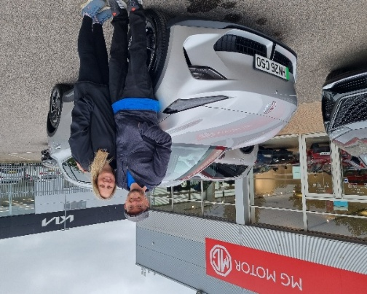
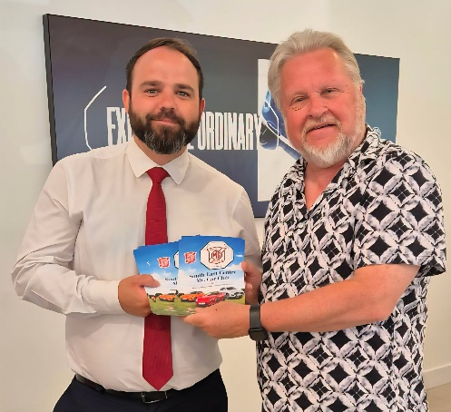
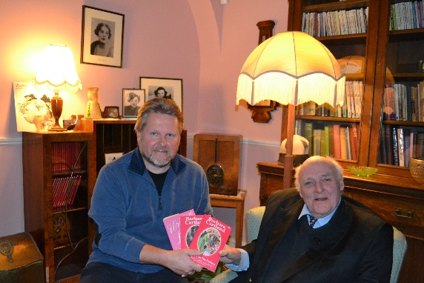
A new MG S5 joins the family – my daughter and her husband at Richmond MG
The MG bug has finally caught up with my eldest daughter. Despite being around MGs for most of her life she has never actually owned one but, with an extremely generous offer from MG Motor Richmond at Guildford, she took the plunge and entered the electric world as well as MG with a new MG S5. I wish her well and have sent her the link to join the club naturally. I am keeping my fingers crossed that it behaves well for her, but early signs are good.
My younger daughter has been without an MG for a while; she has previously owned an MG TF and her husband an MG ZR. Now, with a wide range and some great offers from the dealers I wonder if I can persuade her back to another MG?
Both of them actually had MGs as wedding cars – Number 1 was an MG SA and number 2 was my MGBGT LE. My brother-in-law is also an MG fan and currently has two on his fleet – a rare MG TF 85th Anniversary and a modern MG HS PHEV. He has owned a number of MGFs over the years and also an MGB roadster and Midget.
Does your MG love run in the family? Let us know by sending a piece to the editor.
Some may think that the MGF is a bit new for restoration but they would be wrong. We are seeing increasing numbers being restored or, as in the case of my own MGF, being “refreshed”. It has been away for a complete respray and a tidy up on some of the rust spots and lacquer peel that have appeared over the last 26 years. For a car with 137,000 miles on the clock the cost far outweighed its actual value but I guess that is not the point. Even with that mileage and two head gasket failures the engine still seems fine, a testament to the K-series. It gave me a scare last year when the alternator seized sending clouds of smoke out of the back but we overcame that one! It’s not just older cars that cause trouble and love and attention is needed whatever MG model you drive.
Speaking of older cars – my MGBGT LE behaved disgracefully at the Best of British event by popping a radiator sensor and depositing all its coolant over the Finishing Straight in clouds of steam and embarrassment. Thanks to the fellows who pushed it a few yards into position with the rest of our South East MGs. That did mean I was down to one MG for a few days waiting for the tiny part to arrive! Mind you, it was a baking hot day and there were lots of classics there and a great turnout form the MG Car Club - look out for the write up on page 21.
I was very sad to hear of the unexpected death of member, Mick Breare. I had only been chatting to him a few days beforehand at The Doghouse natter. There is an obituary on page 35.
Distributing the new MG Motor orientated leaflet at Richmond MG (see Page 25)
My byline photo in this edition shows me with Ian McCorquodale in the Barbara Carland Room at Brooklands. Ian, who sadly passed away in 2023, was the son of Barbara Cartland and was completely flummoxed as to why he had been asked to Brooklands to give a talk about his mother.
As he said, “she was a dreadful driver and usually ended up in a ditch”. She rarely drove, particularly in later years when she was chauffeured around in her white Rolls Royce.
If you have seen my talk on lady racing drivers “Fast Women, Fast Track” then you will have seen the reason he was there in the room named after his mother. The Ladies Society Race of 1931 was instigated by her to prove that “women could drive as well as men”. A group of her friends and acquaintances drove around the track in brand new MG C-Types (Cecil Kimber saw an opportunity to promote the new car). The wrong person “won” the one lap race, which was carried out when there was maintenance on the track, and they had to stage a new finish for the cameras. Princess Imertinksy was the new winner (as planned) and claimed that they had proved that “women could drive as well as men”. The race was a bit of a farce but there was no doubt that there were actually some great women drivers of the period on the Brooklands track at that time.
We look at one of those in this issue, Doreen Evans, who had a strong connection to MG, Brooklands and a garage on our patch at Wandsworth – see the next page.
Chairmans Chatter Tim Morris
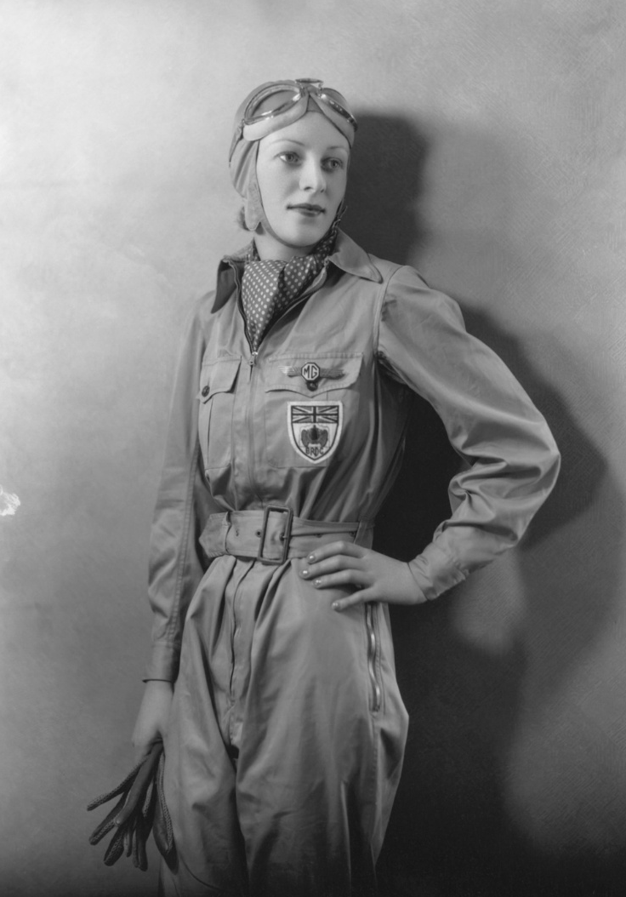
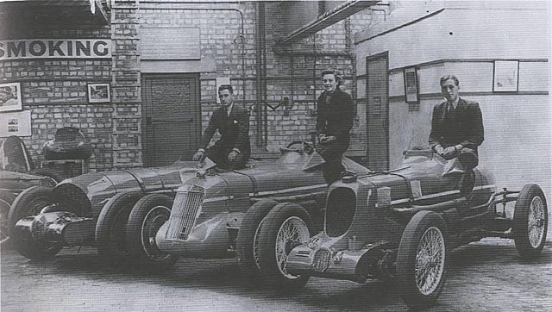
A rather glamorous photo of Doreen in her racing overalls.
(National Portrait Gallery Licenced)

Doreen with her brothers and their MGs at Bellevue Garage – she is sitting on the R Type. Source: M.G.Nuts.com
Doreen Barbara Mignonette Evans was not only a remarkable lady from a remarkable family but also comes under the auspices of the South East Centre with the family garage being based in Wandsworth.
Doreen was always destined for the track, her parents, Bertie Graham and Mignonette, were keen enthusiasts and took the young family to Brooklands as often as they could and the children were encouraged to drive as soon as possible. Her two brothers, Kenneth and Denis soon became successful racing drivers and she first took to the Brooklands track in 1933 at the tender age of seventeen. Her racing career, however, was short – lasting barely three years and she retired at the age of twenty when she married. Her impact and legacy, however, was long and we still remember her today.
The Evans brothers, being older, taught Doreen how to drive and she would compete with them as a passenger at Brooklands as a teenager. The brothers wanted to take racing more seriously and, knowing Hugh Hamilton at University Motors, were soon the owners of an MG Montlhery Midget.
Denis had begun the family Bellevue garage business in Wandsworth in 1931 with an emphasis on tuning fast cars – the ideal place to tune their own racing MGs particularly with an expert like “Wilkie” Wilkinson on hand to do the work. He soon gained the garage a reputation for fine race tuning and drivers, including bandleader Billy Cotton, would have their cars tuned at the Evans garage.

A Remarkable Lady

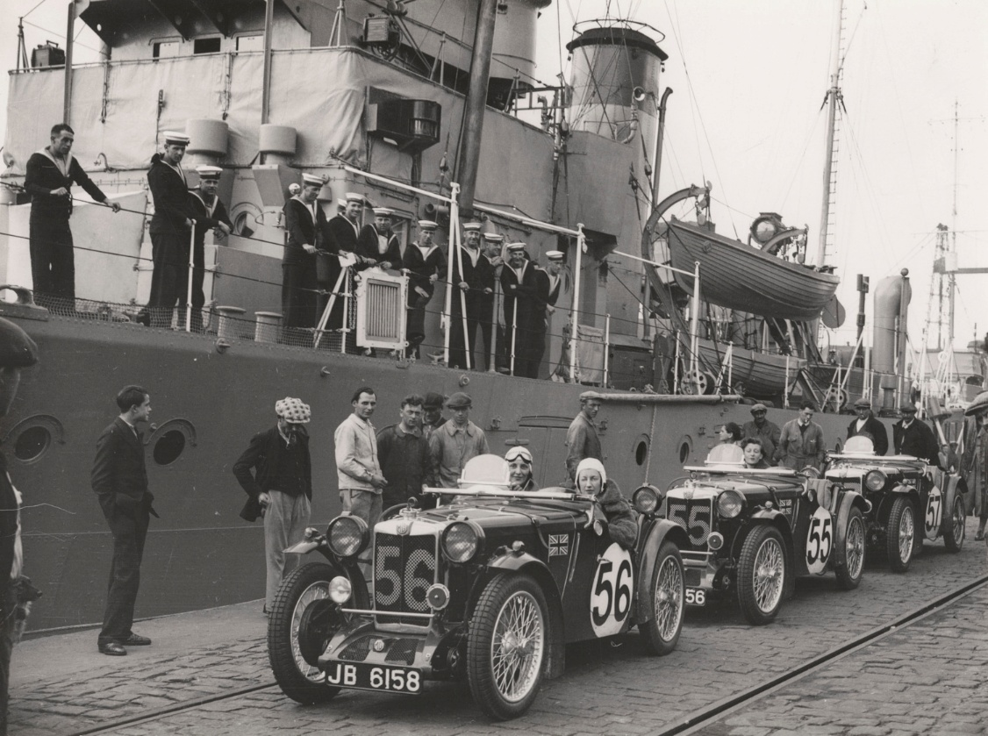
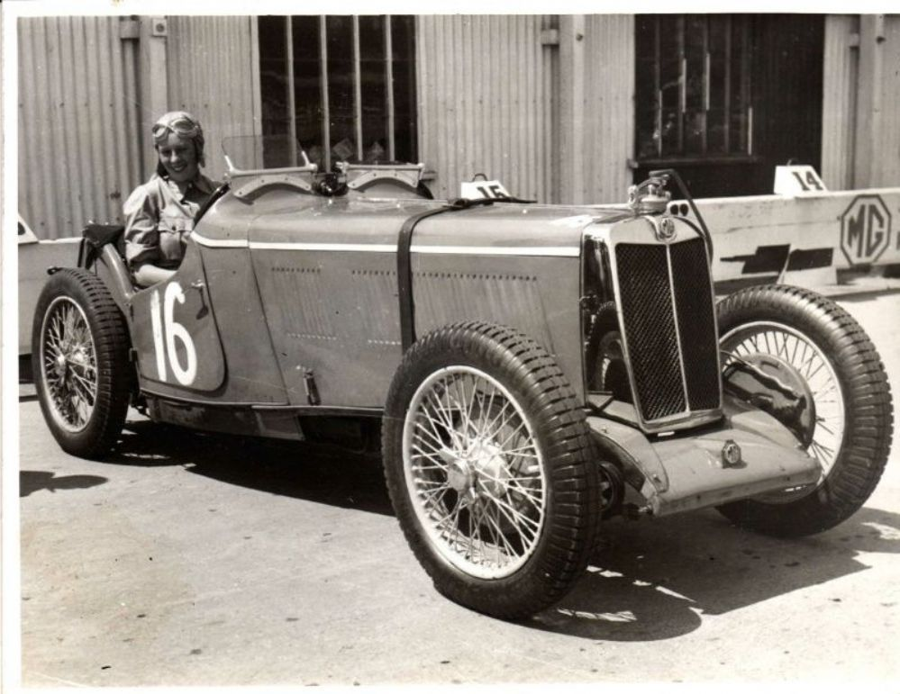
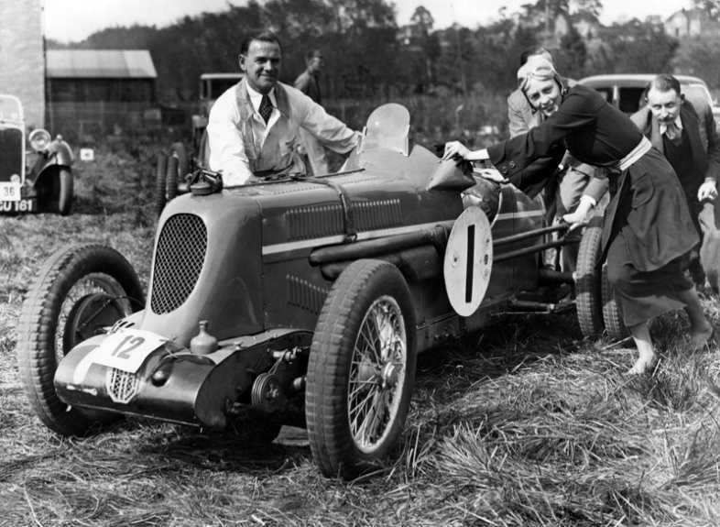
Being relatively close to Brooklands also helped the business. The Midget was the first of their racing MGs and as soon as Doreen gained a driving licence they all bought J2 MGs to compete as the Bellevue Team. They competed in hill climbs and trials around the UK as a team but Doreen wanted to try circuit racing so, her father bought her an MG Magna powered by the Wolseley Hornet 6-cylinder engine, naturally tuned by Wilkinson. The car and her driving ability soon attracted the attention of Cecil Kimber who then offered them support from MG itself. A good policy by Kimber as these cars were attracting a lot of attention from the public – so increasing sales of MGs!
In 1934 Doreen and her brothers ordered three of the new N-Type Magnettes in chassis form with race-prepared engines already fitted. They then installed their own lightweight body to the cars and raced as a team, often against the official MG team. Following her success as a privateer Doreen was asked to become one of the official MG works team drivers and in 1935 she gained MG much publicity as one of George Eystons “Dancing Daughters”. Named after a popular silent movie of the era, the six lady drivers took three MG PAs to Le Mans, they all finished together coming 24th, 25th and 26th and proved the reliability of these cars – great for more sales!
We hear today about a number of lady drivers in the 1930s but it was a concern that women were not capable of high speed racing. Doreen was one of many that proved them wrong. Writing in the Daily Sketch in March 1936 she made the point that “the thrill of racing is a tonic that more than compensates the nerves for any anxiety that may underlie ones conscious feelings”.

Doreen at the wheel of the MG L2 Source: M.G.Nuts.com
Doreen on the dockside in June 1935 with the “Dancing Daughters” on the way to France
(National Portrait Gallery Licenced)
Doreen pushing the Q-Type with “Wilkie” at a trial in Chalfont Heights
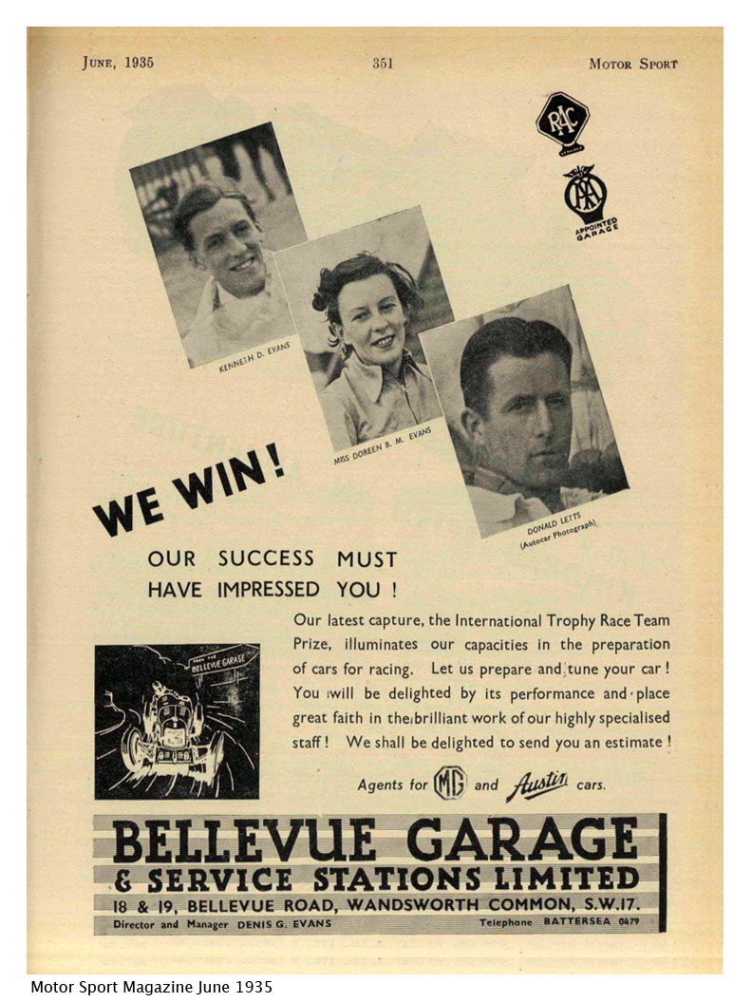
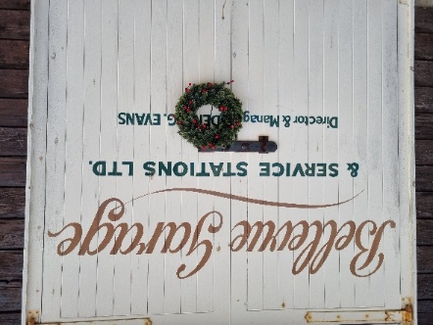
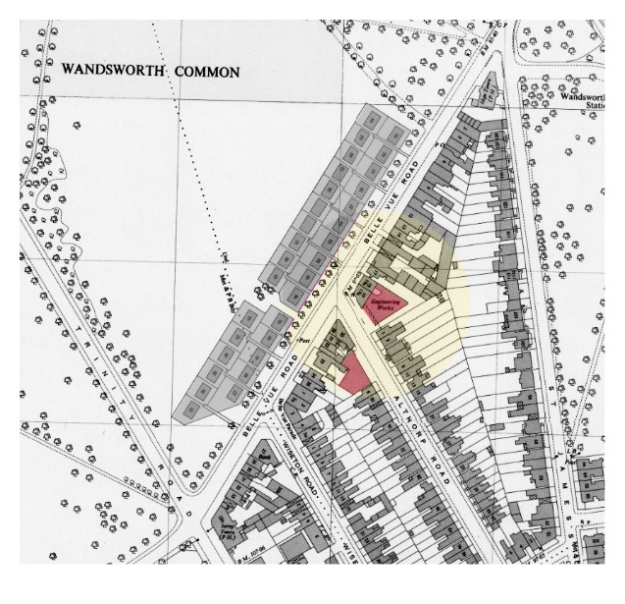
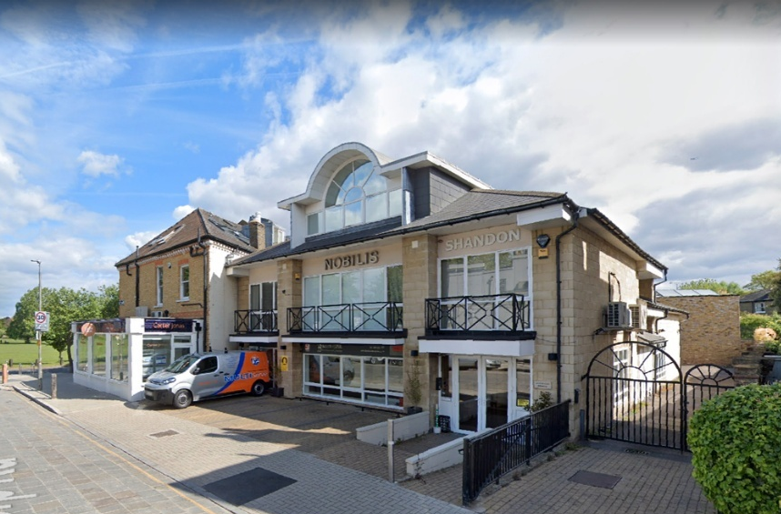
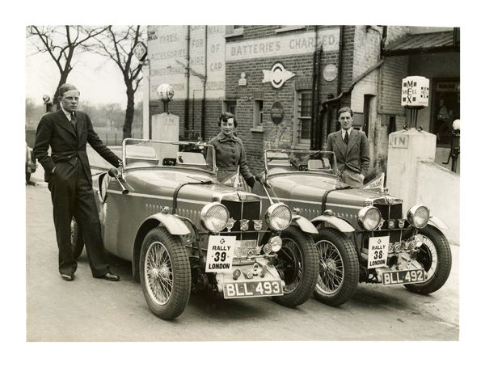
Doreen with her brothers outside Bellevue Garage
Source: hisotryofwansworthcommon.com
Bellevue Garage advert 1935 emphasised the Evans family
Recreated Garage Door at Brooklands Museum
The Evans cars were tuned to perfection and the driving was exemplary so they rarely had accidents or failed to finish. However, there was a near tragedy in the 1936 International Trophy race at Brooklands when Doreen narrowly escaped from her MG when it caught fire at high speed on the Railway Straight – unable to bail out without serious injury she managed to slow the burning car enough by the time she got to the Members Banking and Finishing Straight so she could jump clear – suffering only bruising and some burns to her legs – the MG though, was a write off smashing into the paddock safety barrier.
As well as being a team member with her brothers and MG she also competed solo with her Q Type Midget winning a Light Car Club relay at Brooklands and Le Mans in 1934. She won the Women’s Mountain handicap in Autumn 1934 at Brooklands in the car and had it rebodied as a slimline single seater in which she triumphed the following Spring reaching speeds of over 100mph.
She gave up her short career on the track in 1936 when she married a fellow driver Allan Phipps – she was to join him in a last race driving an Aston Martin but Alan crashed it on the first lap putting paid to her final race.
Phipps was the son of a Colorado Senator and came from a wealthy American family who later owned the Denver Broncos football team The couple moved to Denver, Colorado and they had three children but later divorced. She married again in the 1950s to George Boyer and lived on the YL Ranch in Wyoming which the Boyer family had run since
1905 (and still do). It was reportedly a tempestuous relationship but she lived the
rest of her life on the ranch
with a large number of cats
before passing away there
in 1982 at the age of 65.

Plan of Bellevue Garage in red on both sides of the road. The grey houses opposite are pre-fabs – now all gone.
Bellevue Grage site today Source:Google maps

The Centre is notified of all new members joining us who live in the South East area. We would like to welcome you to the club and hope that you enjoy your time with us and your MG. As you can see in this magazine the club is very active and there is plenty for you to do from pub meets to Autosolos – whatever you fancy. Check out our Facebook page and website for all the information about the club that you need.
So, welcome to you all.
Tim Morris, Chairman

Welcome to New Members


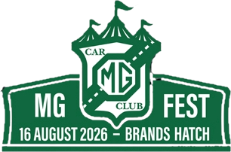
Spark Plug
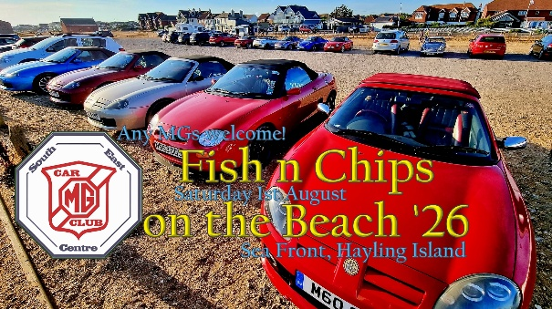
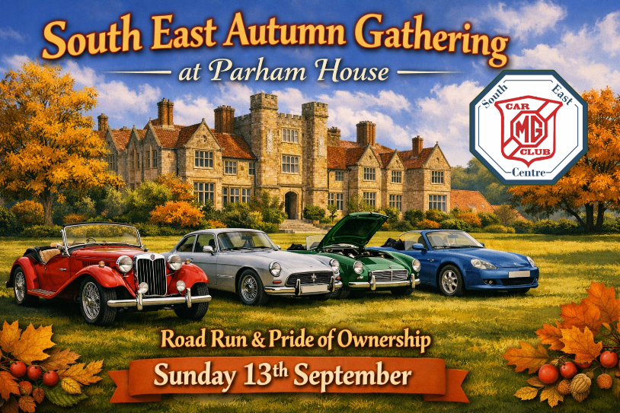
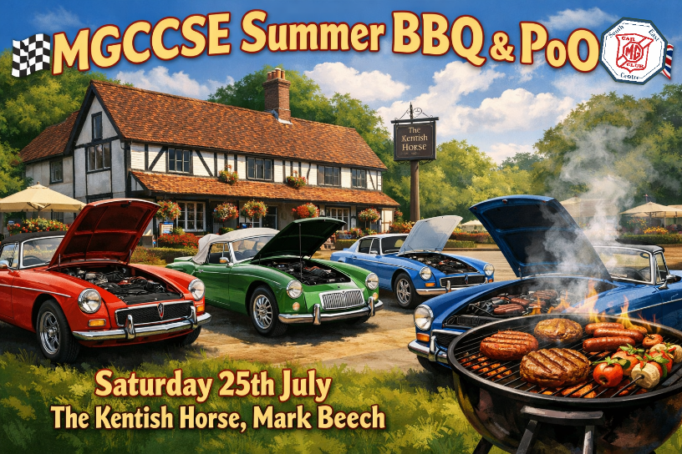
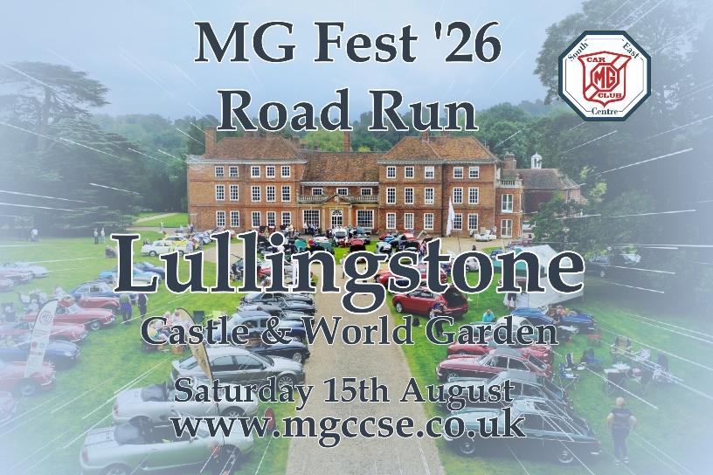
The big event coming up soon is MG Fest ’26 which is combined with our own Summer Event at Lullingstone the day before. The weekend of 15th/16th August is one not to be missed.
There has been much publicity about the weekend and I am sure most of you have tickets for one or both of the weekend events already … but if not they are still available.
There are more events however and we start with the final round of the Alternative PoO and MGCC Open Evening at the Fairmile in Cobham on Thursday 9th July. If you have not been to a club event before then this is an ideal starter – usually around 40-50 MGs on the lawns in front of the pub on a nice Summer’s evening with a chance to meet some of the committee and Natter leaders as well as fellow enthusiasts.
The Bromley Pageant of Motoring is on the 19th July and you may be able to get a last minute place on that.
The Summer BBQ (Style) and PoO is back at the Kentish Horse in Mark Beech on Saturday 25th July. A pleasant lunchtime gathering in the heart of the Kent countryside with a Pride of Ownership thrown in.
We’ll be back at Brooklands on the 26th July for our last show of the year there – the Classic Car Show and Jumble.
We’ll end July on the 30th with an evening Autotest at Capel.
August begins with Fish n Chips on the Beach at Hayling Island on Saturday 1st and, of course, the BIG weekend is on 15th/16th.
We had to postpone the Fawley Hill Run to 6th September due to mechanical failure at Fawley. There might be some new places for that one if you are quick.
We’ll be heading to Parham House in Sussex for our early Autumn Gathering which will include a run into the event and Pride of Ownership. That takes place on Sunday 13th September.
That will be followed by our second Naviscat of the year on the Surrey/Sussex borders on the 20th September.

Details of all our club events can be found on our website at
www.mgccse.co.uk


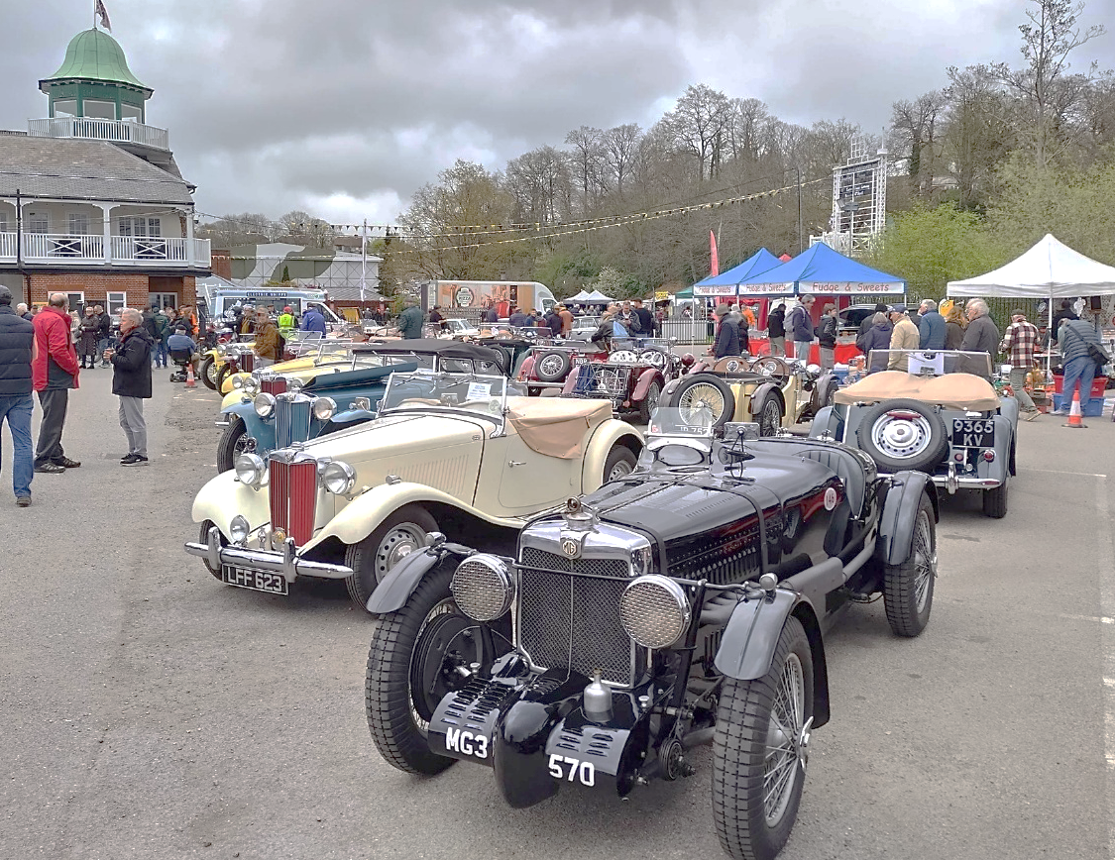
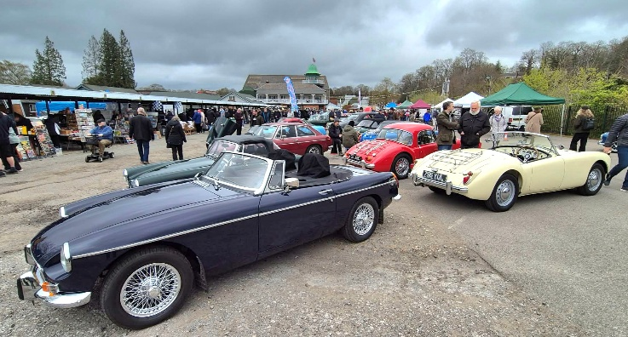
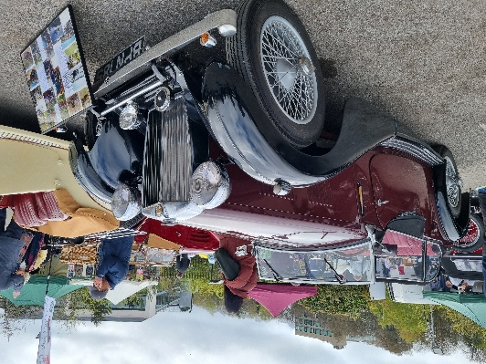
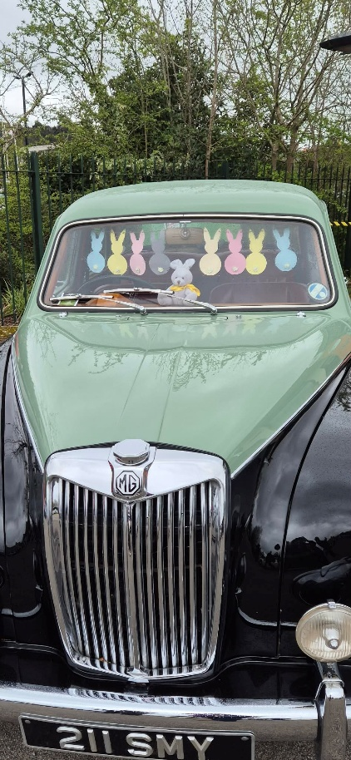
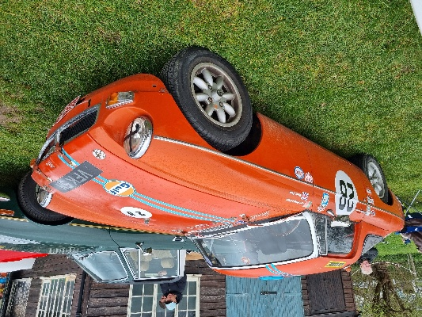
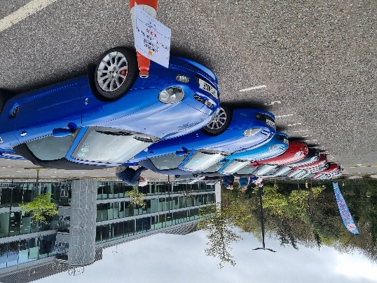
The Brooklands Easter Gathering is a relatively recent event which derived from a cancellation of the New Year’s Day event due to bad weather a couple of years ago. With the improved weather at Easter it was always going to be a popular meeting – particularly as many cars that had been SORN over winter have now been released into the wild again. So, this year it was similar to the NYD meet with over 5000 people and 1000 cars attending throughout the day. The MG Car Club expanded its presence as well - the T-Type and MGF Register are staunch supporters of Brooklands events but this time the local Fairmile Natter also took a space. This meant they took up the slack in the Campbell car park when Brooklands realised that MGFs are predominantly younger than 30 years old – so they were back in the Heights again – along with the Aston Martins Ferraris, McLarens, Alfa Romeos, Morgans etc – so not too bad company! In all the MG Car Club fielded around 50 cars throughout the three groups and there were plenty more MGs around the site as well.
Far left: Heidi Clark’s MGB Sebring special
Left: The Fairmile Natter looking down the Campbell Car Park.
Above: This Magnette entered into the Easter Spirit
Far left: The MGFs were out in The Heights
Left: Nice MG VA with the T-Types
No-one was going to turn away this very special MG K3 from the T-Type’s stand!
Click the link below to view a video of the Easter Gathering
EASTER GATHERING
Easter Special Tim Morris
K3 back on the Water Tim Morris
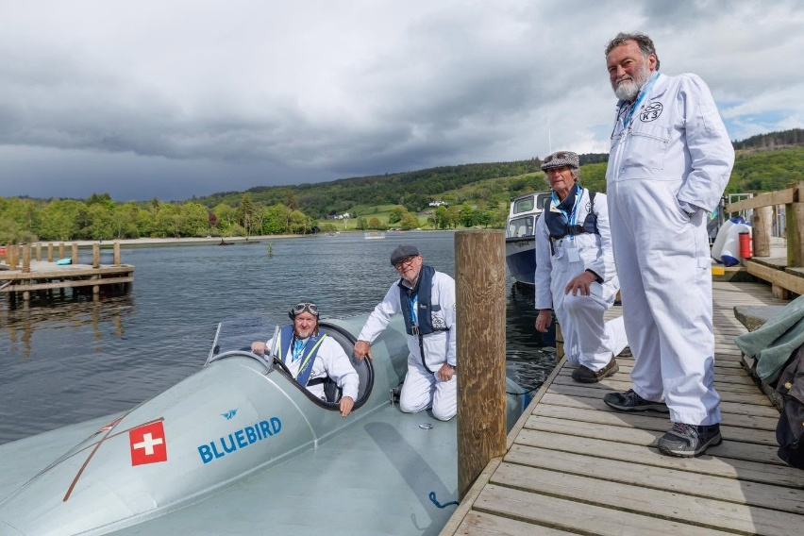
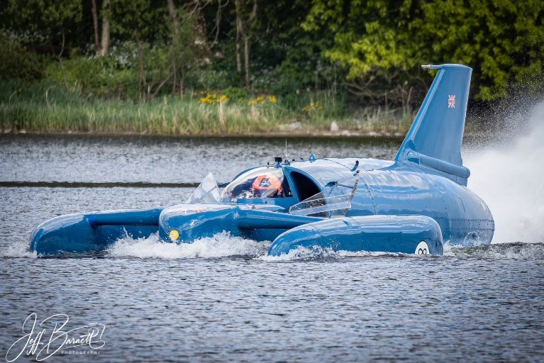
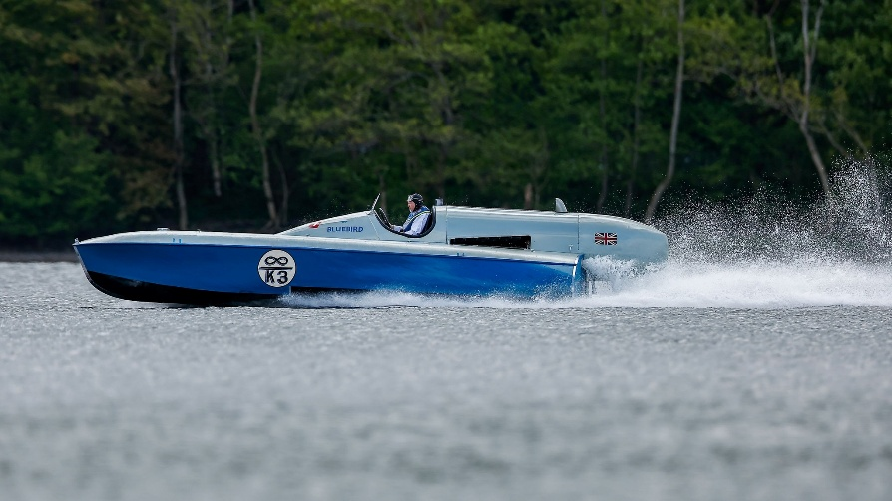
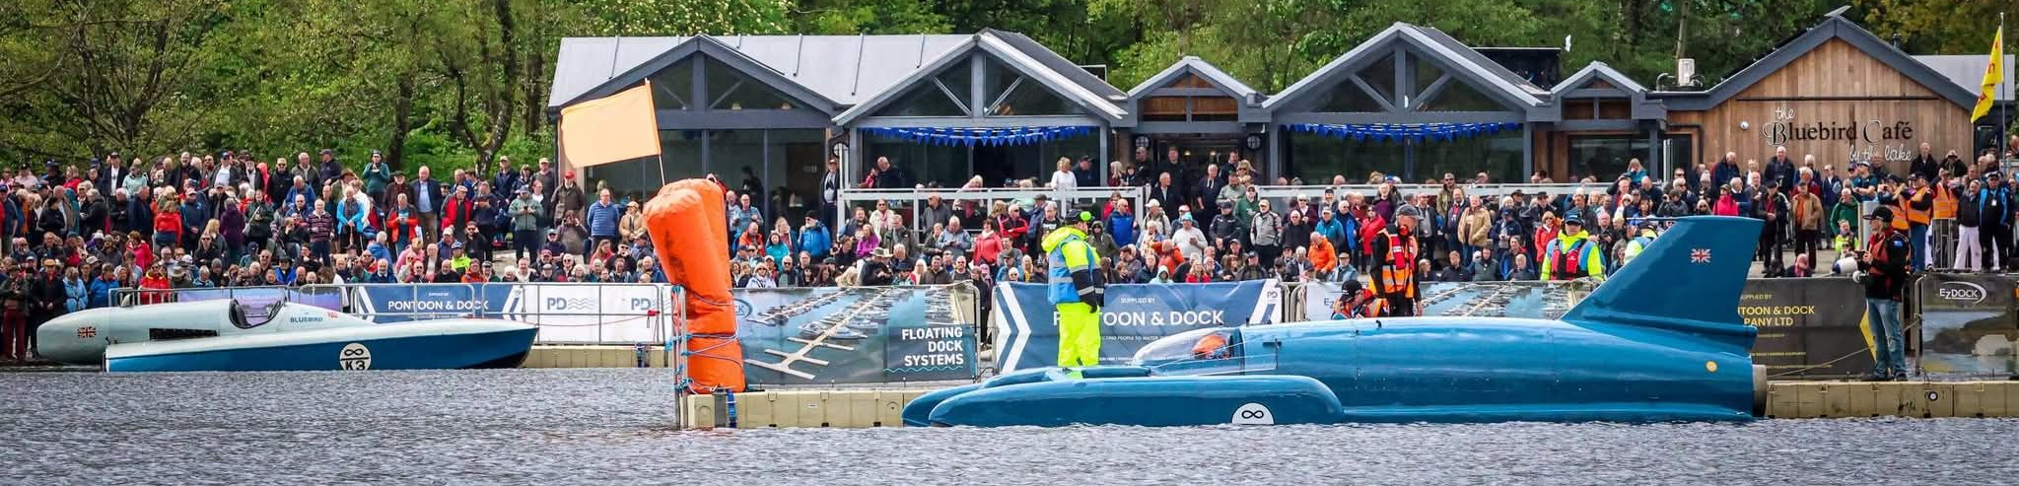
Above: K3 with Karl at the wheel out on Lake Coniston – source unknown
Below: Karl Foulke- Halbard at the wheel of K3 with team members Roy Bills, Patrick Newman & Andy Taylor - Pic Neil Draper (Filching Manor)
Those that have visited Filching Manor on one of the MGCCSE annual Autotests will know that something very special lies within one of the old chicken sheds – Sir Malcolm Campbell’s Blue Bird K3. Most will have marvelled at the three-times World Water Speed record boat but, perhaps, not the most auspicious of locations!
However, the return of another Campbell boat, Donald Campbell’s K7, to the Ruskin Museum in Coniston and the installation of a jet engine gave a unique opportunity for Karl Foulkes Halbard to get K3 out of the shed and onto the water, albeit several hundred miles away from Sussex.
In the hands of Sir Malcolm Campbell K3 broke three speed records – the first on September 1st 1937 at 126.32mph breaking a five year record held by Gar Woods. The next day he broke it again at 129.5mph – both records were on Lake Maggiore in Switzerland. That was tantalisingly close to the 130mph barrier and it would be another year before Sir Malcolm exceeded that on August 17th 1938 back in Switzerland but a different lake – Lake Hallwyl and a speed of 130.91mph.
The original boat was powered by a single engine that had come from Campbell’s last land speed record car – a Rolls Royce R Type V12. The boat is a single-point hydroplane and could not be converted to a three-point so Si Malcolm and his team designed a new boat – K4. That boat pushed the record up to 141.74mph in 1939 on Lake Coniston. Although converted to a jet engine post-war no more records were broken with this boat which was subsequently scrapped.
K3 was sold and later found its way to be an exhibit at Thorpe Park – you may remember it’s early motto “Thorpe park – a Trip Through History”, it was a very different to today’s thrill ride extravaganza. Karl’s father, Paul, rescued it from there and began a lengthy restoration. Following his death Karl reactivated the project fitting a Rolls Royce Meteor engine and that was finally celebrated in fitting form for a week in May on Lake Coniston – but not quite at 130mph.
Two Campbell boats on the water at Lake Coniston on May 14th – Malcolm Campbell’s K3 and Donald Campbell’s K7 - source unknwon
K7’s mighty jet engine fires up on the water – Ruskin Museum Jeff Barnett


Safe Landings for Drive-it-Day Tim Morris

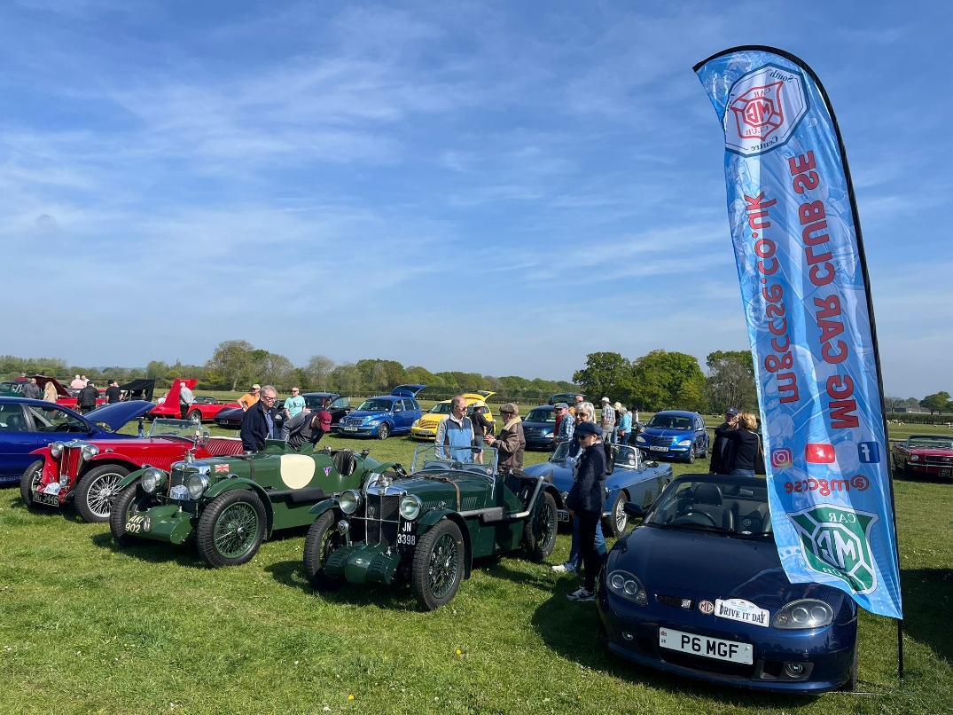
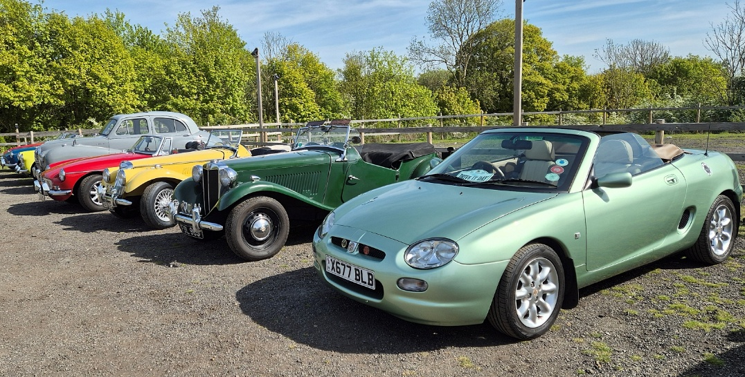
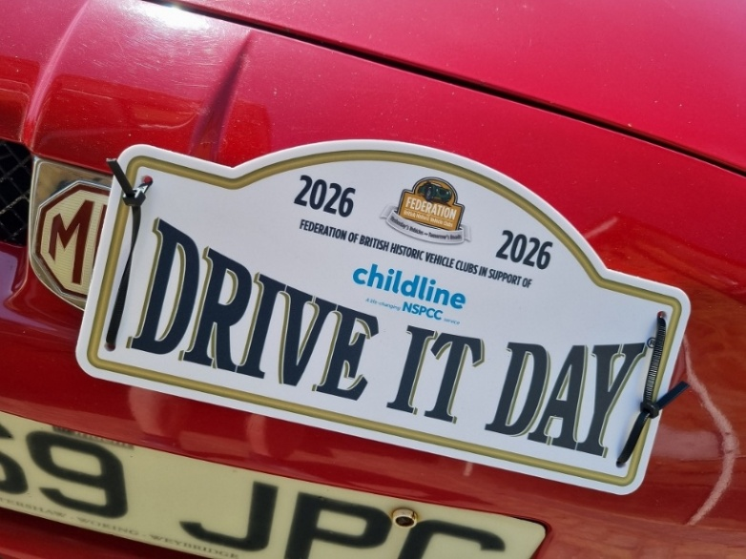
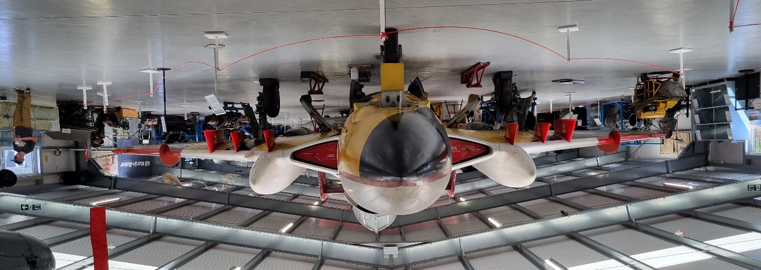
Inside the new hangar at the Gatwick Aviation Museum
MGs gathering at Bocketts Farm
MGs on the edge of the Headcorn runway
This year our Drive-it-Day events took on an aviation related theme. The first event joined a classic car meet at Headcorn Aerodrome where the South East group mingled with dozens of other classics on the edge of the runway. The flag flew giving Ron’s TF a good dusting as the bottom poles seemed to be missing!
The Lashenden Air Warfare Museum was also open with its collection of WW2 aircraft parts largely recovered from surrounding Kent fields.
Further west the Centre’s road run began at Bocketts Farm, Leatherhead – a popular start venue for classic car events Signing on in the Old Barn Tea Rooms and a cup of coffee later the entrants donned their flying jackets and set forth. The suggested Google route took us along some nice country lanes over the North Downs, including some great hollow lanes with their steep tree-rooted sides.
AVIATION DOUBLE-HEADER
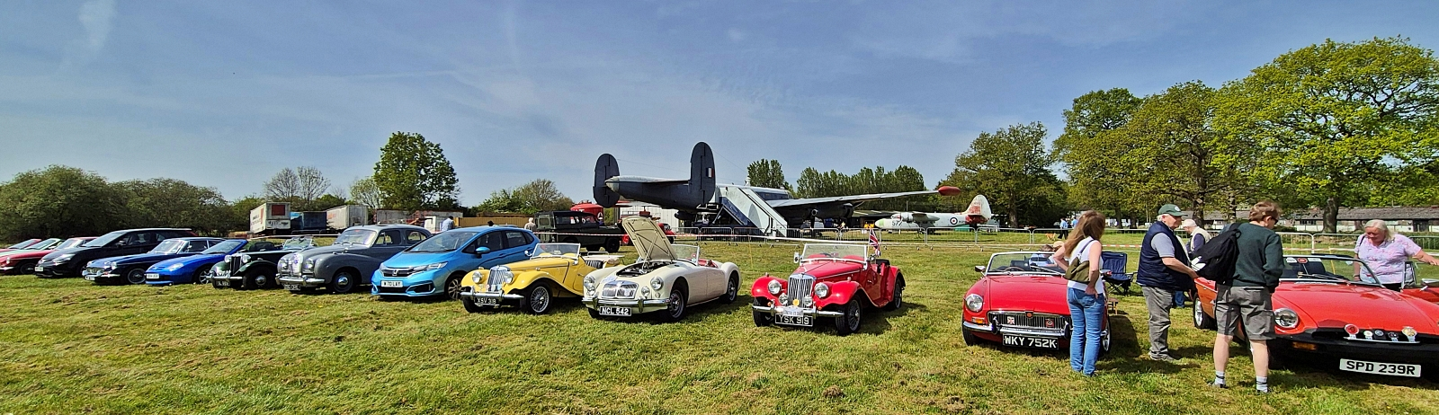
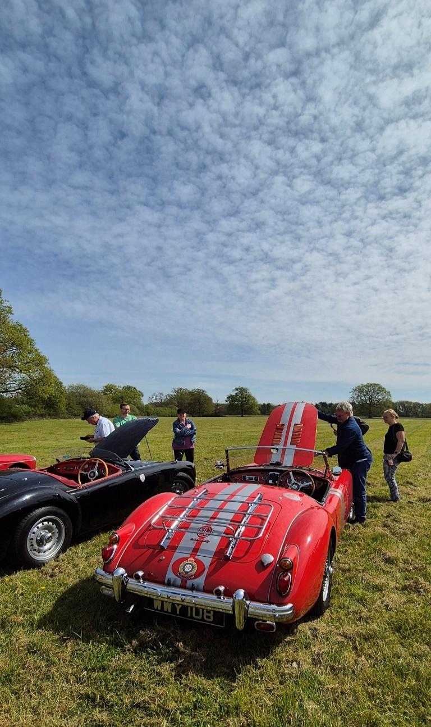

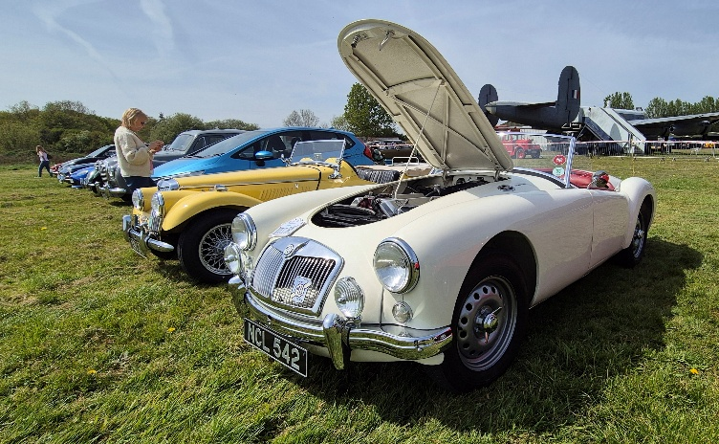
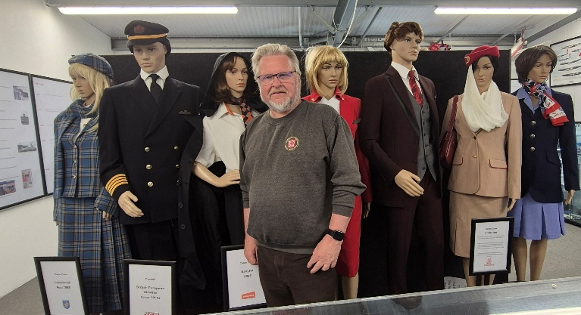
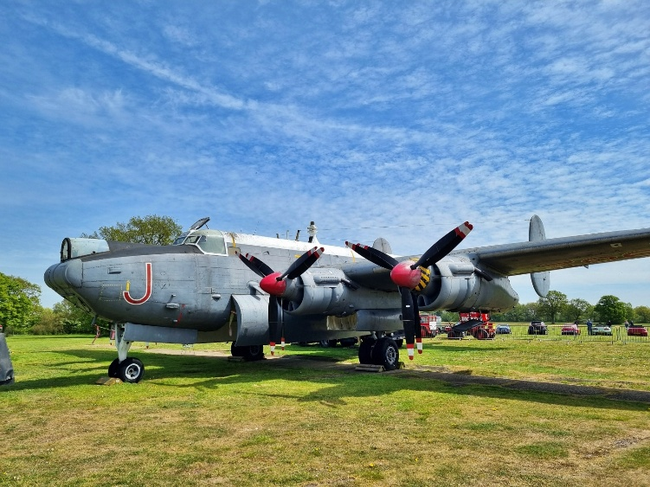
Turning towards Gatwick Airport from Charlwood village the entrance to the museum is immediately on the left. The large field at the back of the museum provides a buffer before you end up on the edge of the Gatwick runway itself, with its constant stream of big and small jets queuing to take off.
The Museum itself was founded in 1987 by local businessman Peter Vallence with an aim of providing some local aviation history and education for local students. Sadly, he passed away in 2013 and the Museum is now run by a charitable Trust set up by Peter.
In 2016 a large new hangar and visitor centre was opened which houses most of the Museum’s collection of aircraft including an English Electric Lightning, Hawker Siddeley Harrier, Gloster Meteor and a de Haviland Sea Vixen. The larger aircraft remain outside including an Avro Shackleton and Blackburn Buccaneer.
The MGs lined up immediately behind the Shackleton facing the Gatwick runway. Many on arrival took to their chairs for a picnic lunch whilst others headed for the Museum itself to have a look around the exhibits and also learn about the history of Gatwick Airport itself.
Whilst the west and middle of our patch were flying high the far east took a more nautical theme with a run of MGs from Canterbury past the “Cinque Ports” along the Kent coast.
Click the picture for a video of the Gatwick Drive it Day Run.
The chairman tried to recruit some new members – they weren’t very receptive though.
The RAF Shackleton was too big to go in the hangar
Lined up just behind the Shackleton
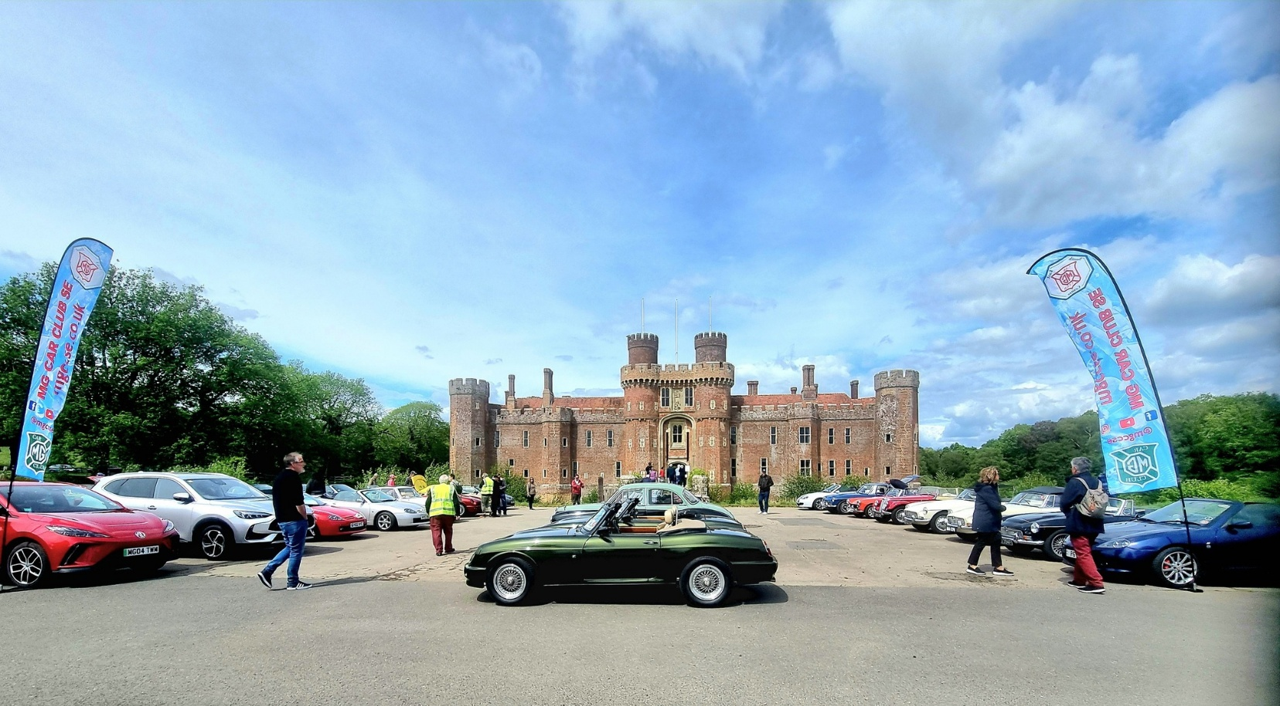
South East Run Finally Reaches Herstmonceux

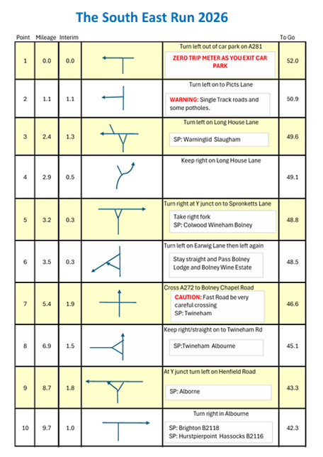
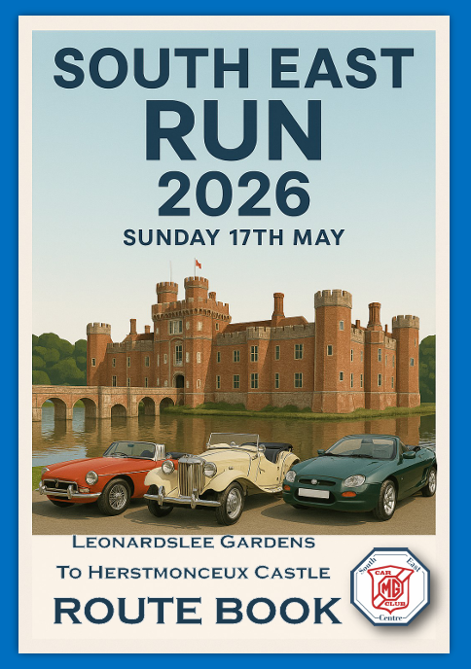
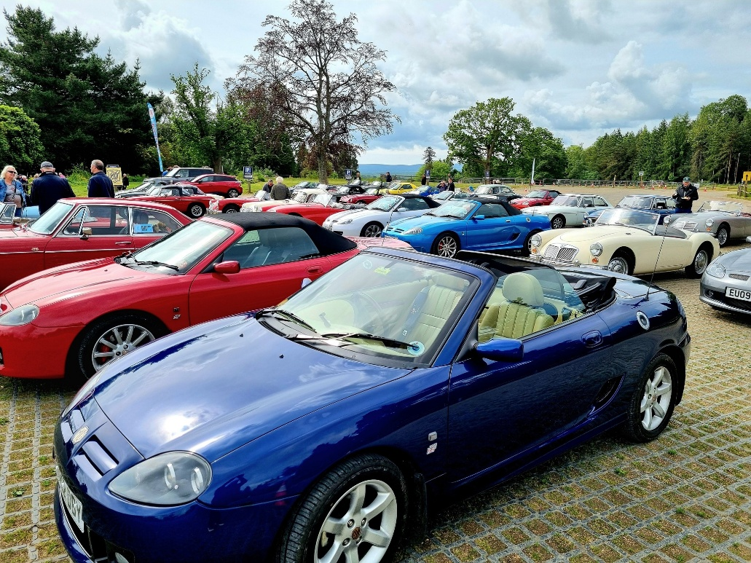
MGs parked up at Leonardslee waiting for the statt
The weather forecast leading up to the South East Run was looking particularly dire. Dark clouds and rain – both of which failed to materialise and morphed into clear skies and sunshine. Just right for a top down run in the Sussex countryside.
Leonardslee Gardens have been a destination point for the Centre in the past and are particularly spectacular with Rhododendron blooms at this time of year. However, this was our start point so there was little opportunity to actually enjoy the gardens themselves. Perhaps this will be a destination for a future South East run?
The route book for every entrant
MG parking right in front of the Castle
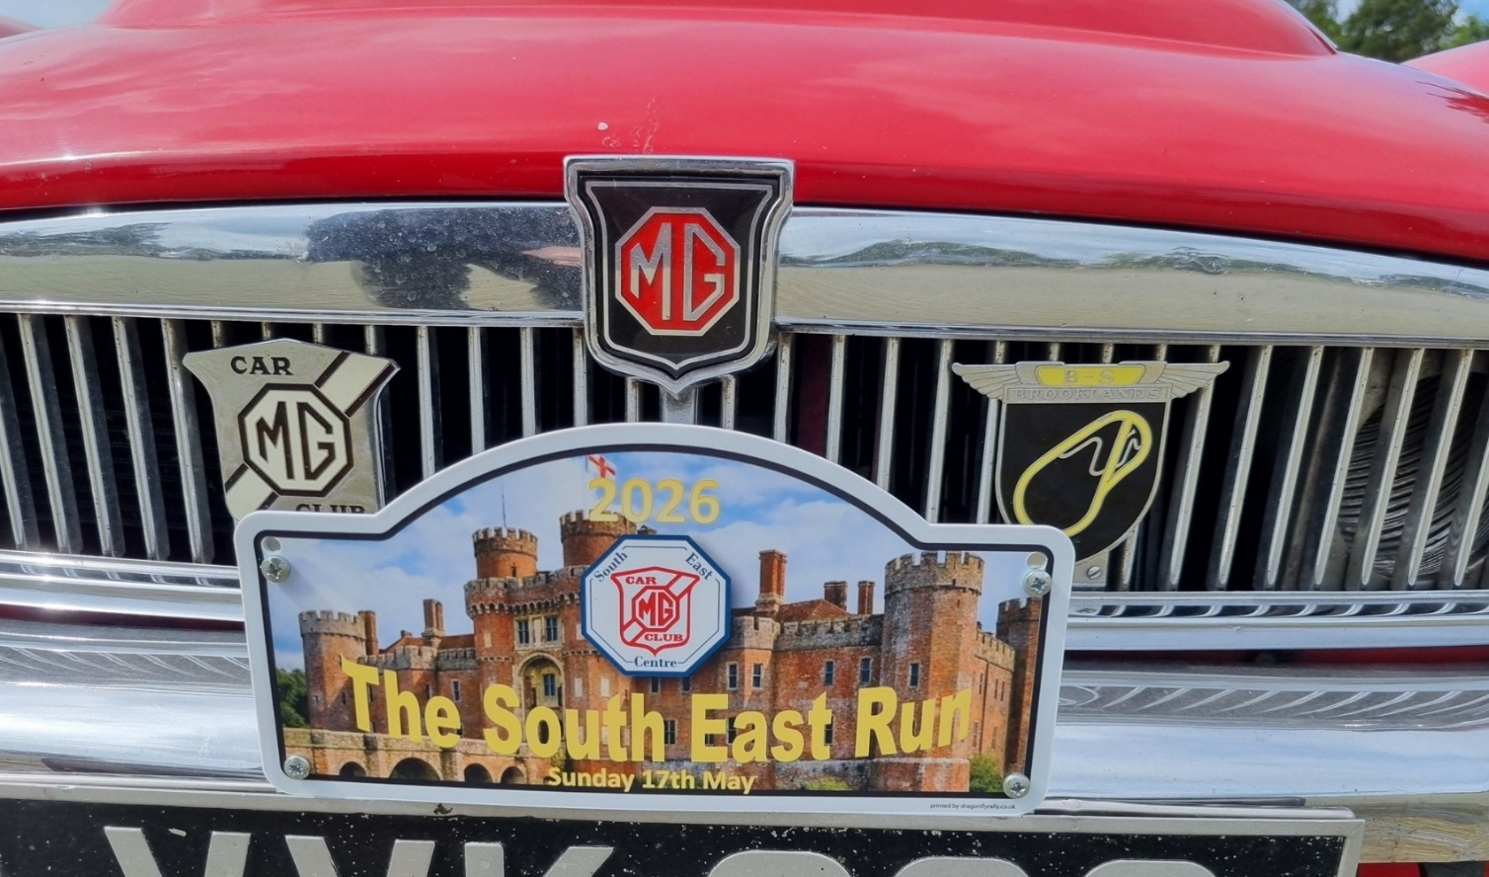

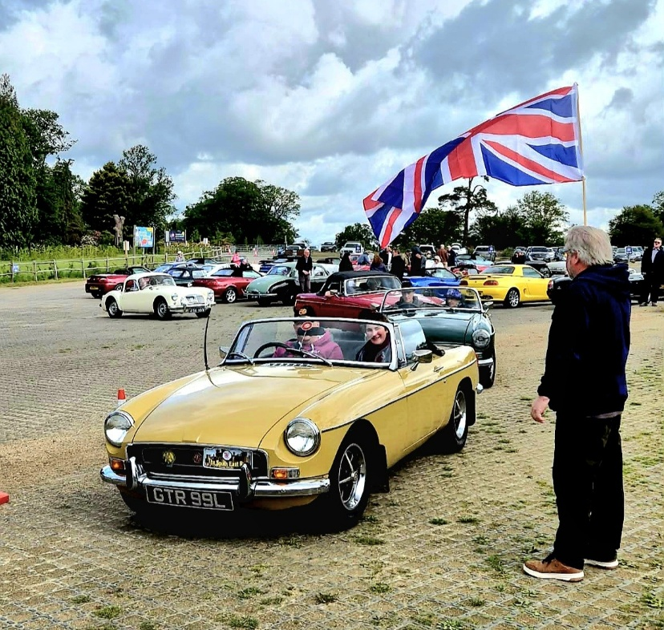
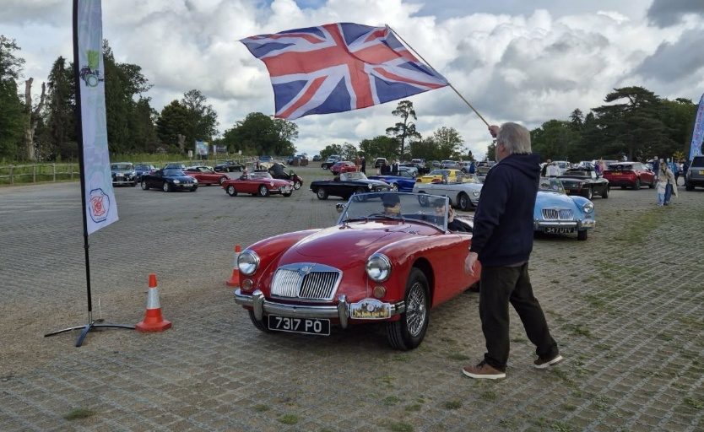
The South East run rally plate
Leonardslee Gardens were created in 1801 by the Beauclerk family and an Italianate house built in the 19th century. The current house was constructed in 1852 by William Hubbard who sold it to his son-in-law Sir Edward Loder. It was Loder who added many of the garden features around the ponds built to power the Gosden Furnace further down the valley. He also introduced animals including kangaroos, wallabies, gazelles and beavers. In 2010 the gardens were sold and closed but re-opened in 2017 when it was sold on again to the Benguela Collection and a 10 year restoration and improvement plan put in place.
However, we were here for bacon butties and a cup of coffee before the Chairman, Tim, unfurled the big Union flag and began to wave the MGs off on their journey to Herstmonceux Castle.
The route was devised by Philip Roussell-Smith and Austin Banner who strove to include varying road types in the plan. That began with a series of narrow single track roads just a mile from the start – ensuring that everyone was thrown in at the deep end. Further along you encountered quaint Sussex villages, speed bumps and even short stretches of dual carriageway.
The final section took the MGs alongside the walls of Pevensey Castle, the oldest building along the 52 mile route. First constructed in AD292 the Castle was the largest of the Roman Saxon Shore Fortresses and the 500 metre long outer wall still remains almost to its full height. It was here in 1066 that William the Conqueror landed and built another fortress inside its walls.
Chairman flags away cars from Leonardslee

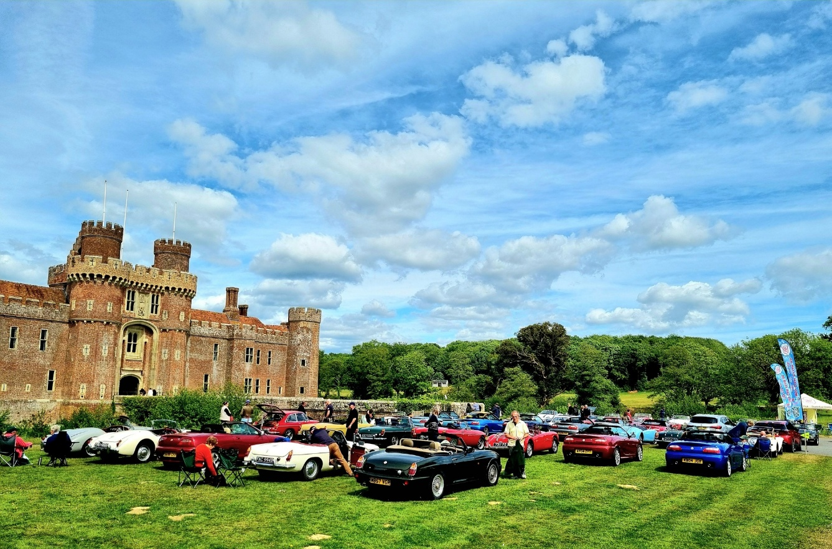

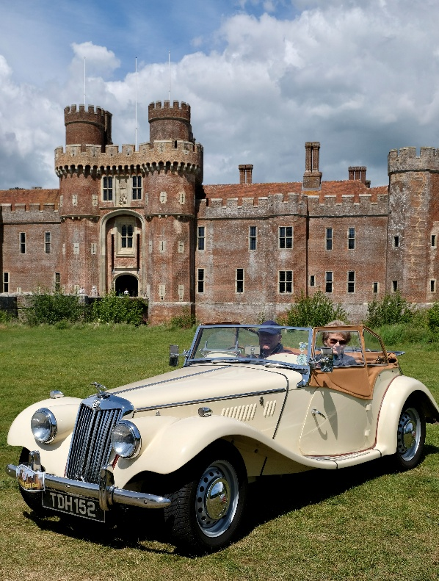
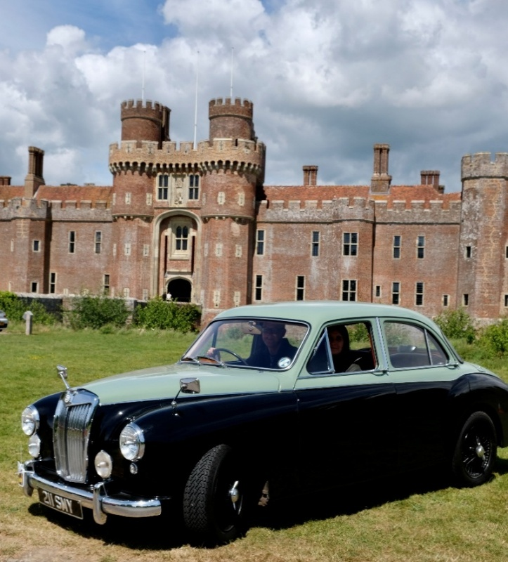
The drive from Pevensey to Herstmonceux Castle used to be under water and ships could sail almost to the door of the castle in the 15th century, today you drive a winding road across the water plain and along a long driveway until you reach the castle as its sits, majestically, with the remains of a moat on two sides. The castle is much older than it looks as it is constructed of red bricks but was actually built in 1441. Brick building was introduced by the Romans but later discarded by the English and this is one of the earliest examples still left standing in the UK. It has had a chequered past being owned by the Fiennes (Dacre) family, one of whom was executed for murder leading to the castle being seized by Henry VIII. It was later returned until the 15th Baron Dacre squandered it away through reckless gambling. It was dismantled in the 18th century into a romantic ruin with no accommodation but was rebuilt in the early part of the 20th century by Colonel Lowther into the castle we pretty much see today.
MGs on the grass in front of the Castle
Click above to view a video of the South East run
Ian & Hilary McCullough’s MG TF
Matthew Pannett’s MG Magnette
The castle was occupied by the Royal Observatory from 1957 and new observatory buildings constructed on the driveway to the castle. They remained until 1988 but the observatory buildings are still there and are now occupied by the Observatory Science Centre. The Castle was acquired by a benefactor and donated to the Queens University of Kingston, Ontario and today it is a UK offshoot of that educational establishment. Much of the interior buildings are now used for accommodation and classrooms for the students. It has recently undergone some vital renovation work when students were not allowed to occupy it and has only recently re-opened under a new name of Bader College, after its founder. That was the reason we couldn’t visit last year but that was more than compensated for by the welcome we received and prime parking position for our MGs.
Once at the castle guided tours were available which allowed us to see behind the castle walls and tour the main rooms, much of which had an education facility flavour with chairs and desks but it was a fascinating insight into the Castle’s history and the juxtaposition of the modern facilities nearly 700 years later.
As a bonus to the run itself, Will Opie, photographed every car arriving with the Castle in the background. Digital copies are available from Will if you email him your registration number – spark@mgccse.co.uk
There are more photos on our website at – www.mgccse.co.uk
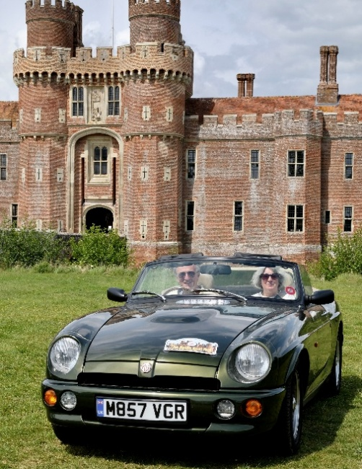
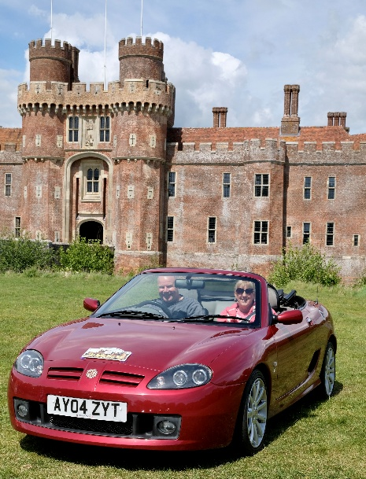
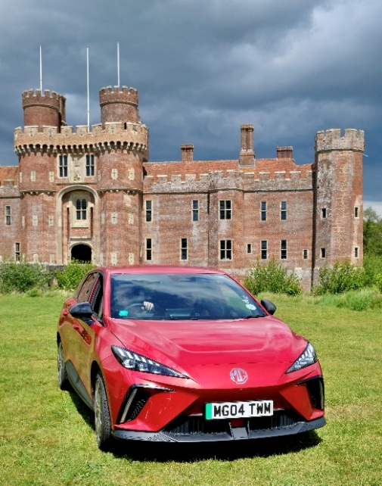
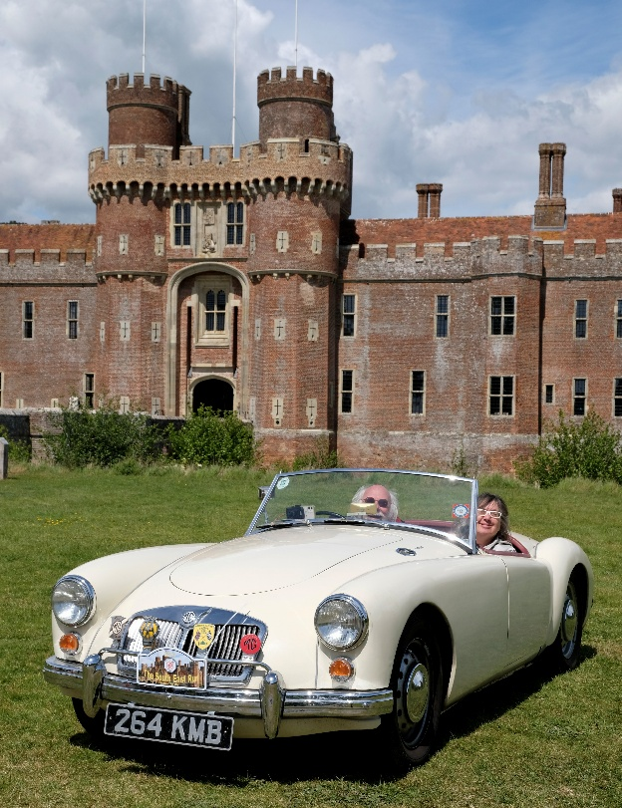
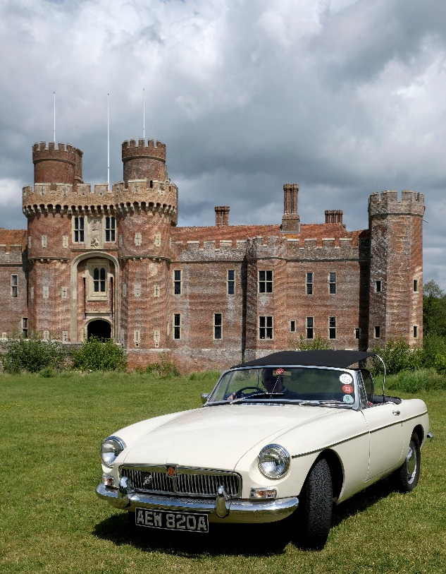
Neil & Claire Woolhouse in their MG TF
Paul & Leah Lefevre in their MGA
Gary Randall’s early MGB
Allan & Helen Jenkins in their MG RV8
Tim & Liz Morris in their MG4
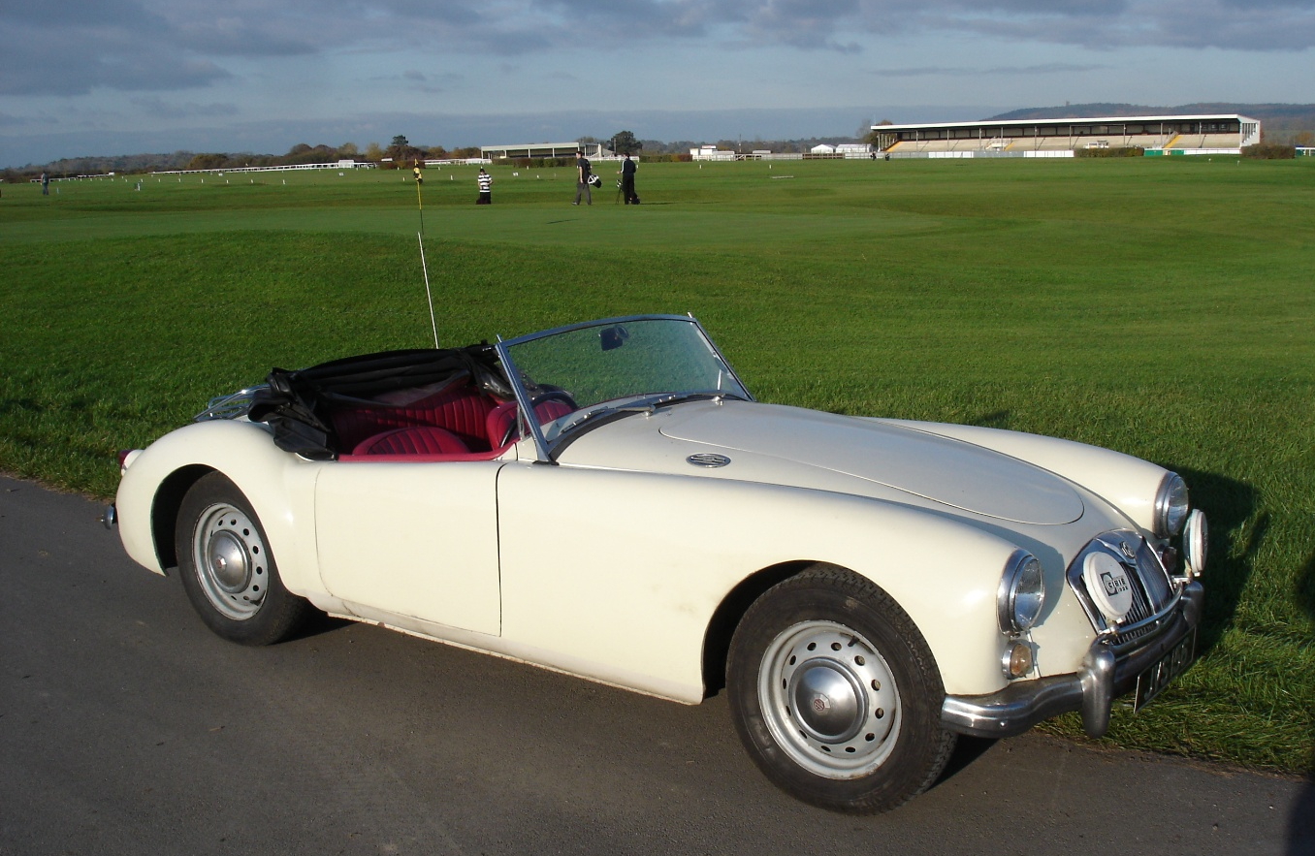
MGE – the Four Seater A Tim Morris/ Richard Harvey
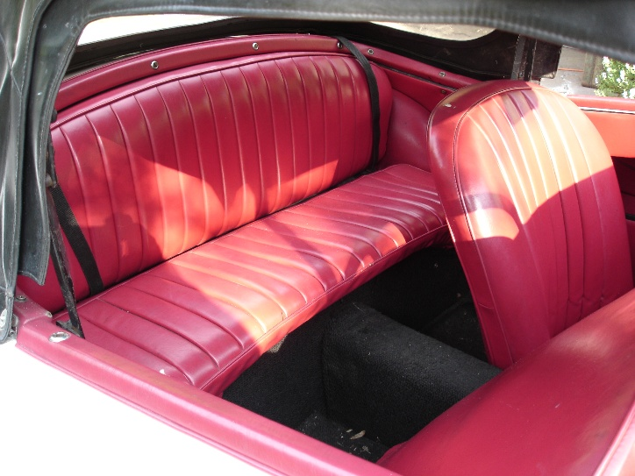
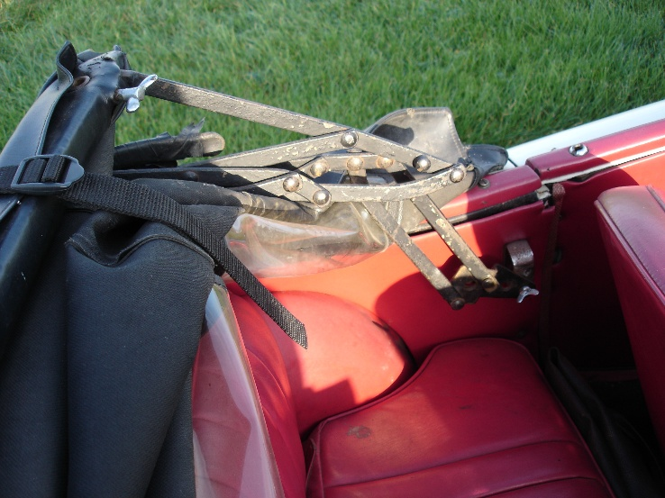
We all know about MG A, B, C and F but what happened to D and E?
Both suffixes have been used – the MGD was seen in a drawing for a proposed MGB replacement in the 1960s and the MGE could be said to be on the MG EXE prototype now in the British Motor Museum. But before that there was another MGE – a four-seat variant on the MGA.
There was an early idea to create a four-seat version of the MGA and both were being considered at pre-production. The Two-seat finally went into production however, but the four-seat idea was still there. In 1954 John Thornley believed that there would be a demand for such a car in the US where no European manufacturers were offering four-seat sports cars under £1000. He wrote to the BMC board stating “In our view DO1062 (the MGA project name) lends itself to redesign as a 4-seat car with either a folding head or rag top. The chassis frame has been designed so as to facilitate elongation amidships and all wings, the trunk unit and the scuttle could be used as they stand”.
Modelling for the four-seater had been carried out by the time of the two-seater’s release in 1955. A prototype named EX189 was created but the record sheets show it as an MGE. Why an “E” – well, Interestingly the Twin Cam was mooted to be an MGB, a larger sports coupe the MGC and a smaller “buzz box” the MGD – hence the MGE for the four-seater. No drawings exist but it was believed to have had a smaller fuel tank to allow more room for the seats.
It is believed that four or five prototypes were built and the car seen here is thought to be one of those.

Thanks to Richard Harvey for the story and photos, Peter Knowland, and John Price Williams who mentions the car in his book “The MGA”.
The hood mechanism is a little intrusive for anyone in the back but allows the hood to fold behind the rear seat
The seats have been re-upholstered at some point – front seat tips to allow rear access
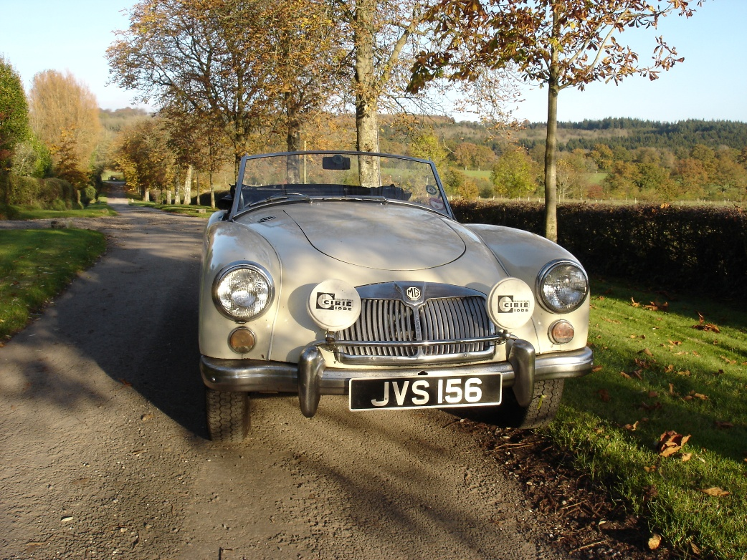
Richard Harvey found this car in Singapore in 1979 and records show it as an MGA1500 built for export with no deviation from the standard other than an adjustable steering column and rear axle ratio of 4.55:1.
The rear scuttle has been extended backwards to allow for the rear seat and brackets made to hold the hood and extend it when folded down. The spare wheel in the boot has been moved nine inches to the back and there is a locking boot lid with the fuel filler inside the boot. The rear bumper is two pieces, possibly to hold a rear wheel on the outside.
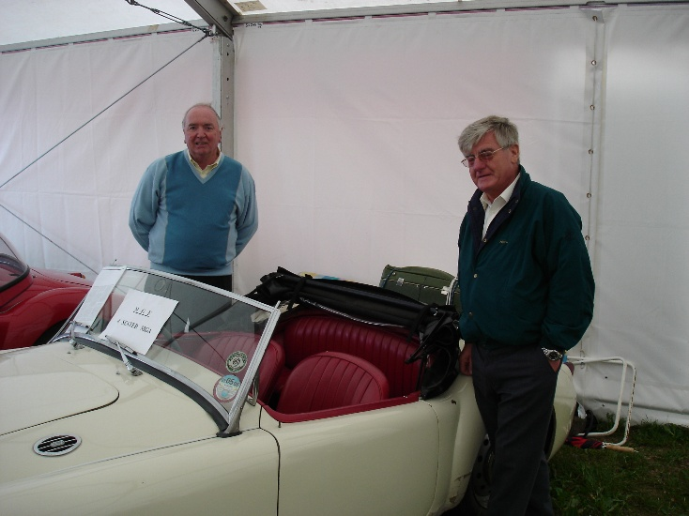
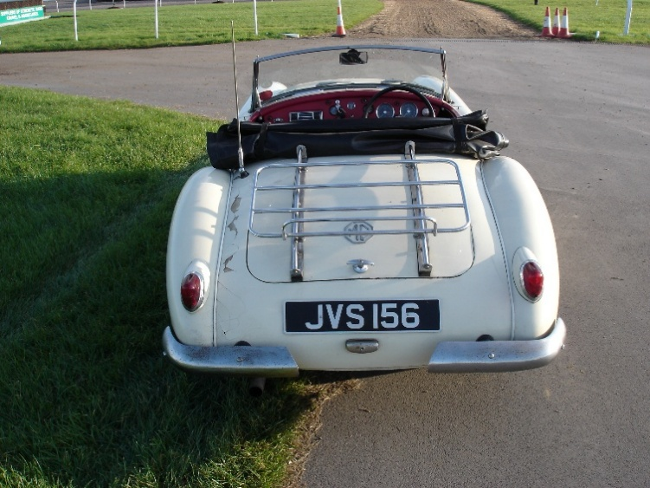
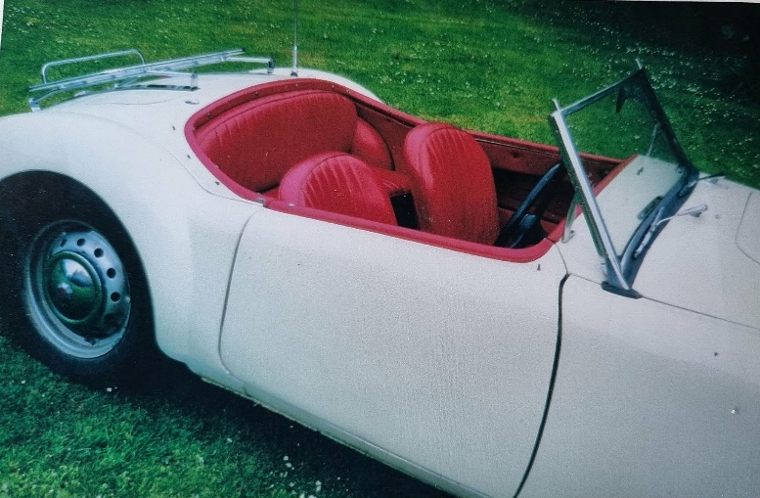
The MGE at Silverstone for the MGA 50th anniversary with two of the original mechanics in the competition department – Tommy Eales and Dudley Pike
Two part rear bumper – possibly to accommodate an outside mounted spare wheel?
Richard appealed for information about the car in Safety Fast and Enjoying MG in 1996 and an apprentice from Henley’s dealership, Peter Knowland, came forward to say that he had seen several of these four-seaters in the Abingdon factory on a site visit in 1956.
There was a possibility that this car was a later coach-built modification however several pointers indicate it is factory original – there is no petrol filler neck hole for one and MGA experts have examined it and concluded that it was factory built.
When imported to the UK the MGE was given a registration of FPR224V, a little incongruous since the car was of 1956 vintage. After years of frustrating communication with DVLA it was issued an “undetermined” Scottish number plate of JVS156.
At Silverstone Richard met a man from Germany who also owned a four-seater… but he broke it up for spares as he did not think it was authentic! Having seen this car he instantly regretted that decision.

The MGE with hood removed
Best of British Tim Morris
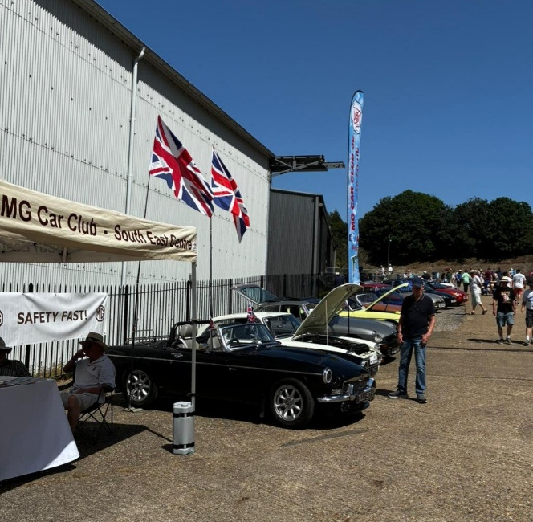
The T Type Register began the MGCC line-up
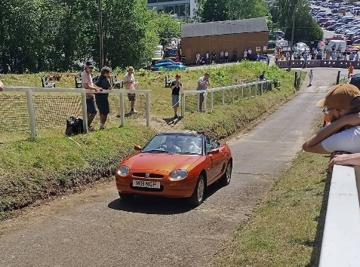
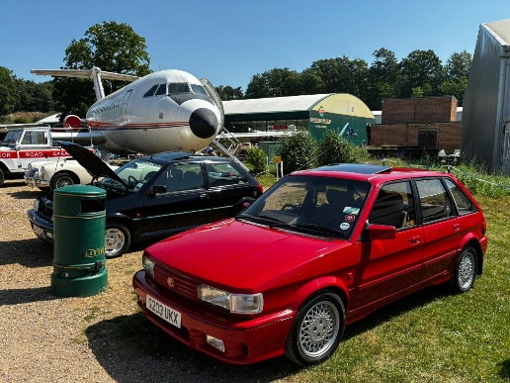
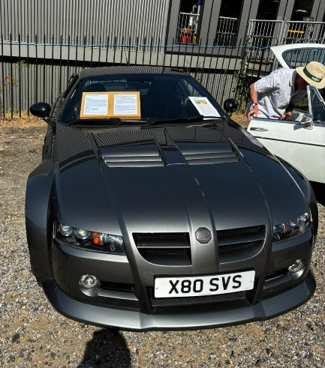

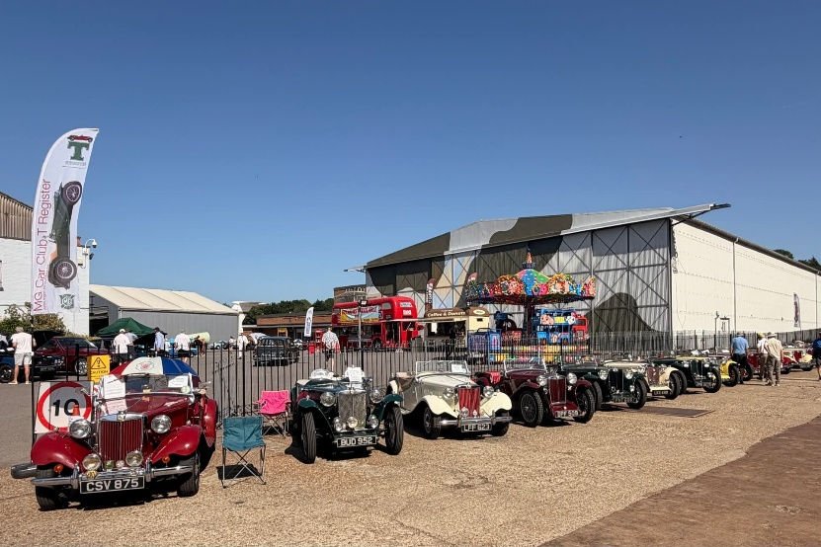
Click above to view the Best of British Videos
MGF tackles the Test Hill
One of the two red MG Maestros – not with the club!
This rare MG SV-S had a very appropriate number plate.
The Gazebo provided welcome shade as the MGs disappeared into the distance
The show took place on the hottest day of the year and the hottest May day since 1944 – only surpassed by the following day! Brooklands Best of British always attracts a fantastic array of British Classics and this year was no exception. The MG Car Club pulled off its best attendance so far with cars stretching the whole way along the Finishing Straight headed up by the T Type Register and then more general MGs from the Centre running all the way to the Banking.
Despite some construction troubles early on the Centre team managed to get the Gazebo up and it really was needed as we sat under it for most of the day. Many members came to say hello and the Chairman found time in the heat to make a video of our attendance with BrooklandsMuseum.tv. You can see those videos on our YouTube channel by pressing the YT symbol here.
The heat was not kind to the MGs and we heard reports of breakdowns on the way home and the Chairman’s own fan temperature sender on his MGBGT popped out of the radiator leading to a spectacular steam driven arrival as the contents of the cooling system evacuated over the engine!
Elsewhere there was plenty to see including two red MGF Maestros and a red MG Montego – is it only red ones that survived? Of course, there were lots of other makes and a gaggle of C5s from C5 Alive drew attention as did Paddington Bear who didn’t venture outside due to the heat but received visitors in the Vickers Suite. You would think a bear from deepest Peru would be used to the heat, wouldn’t you?

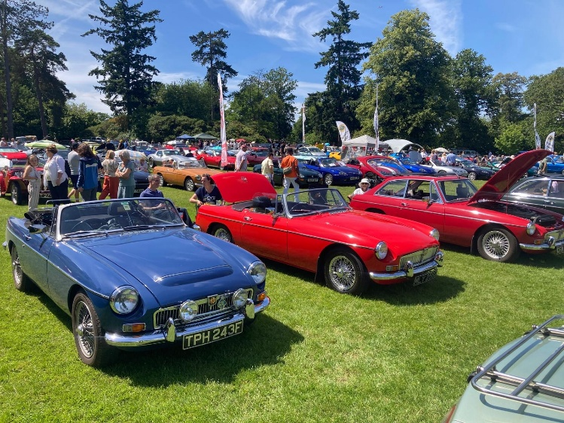
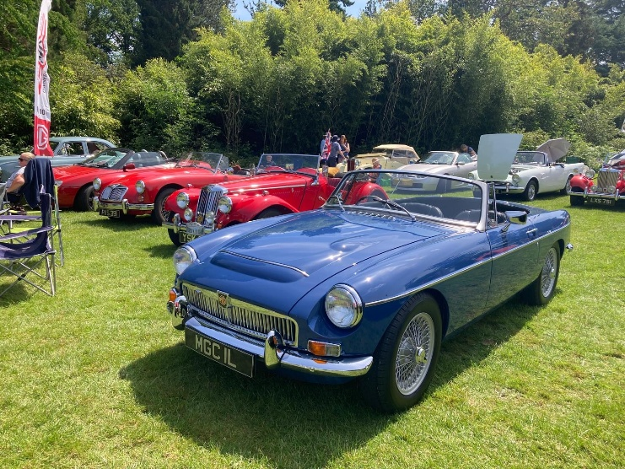
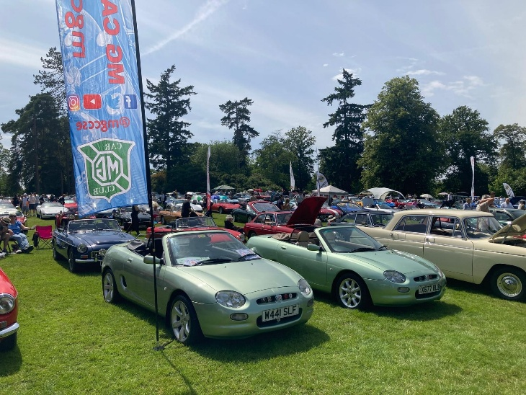
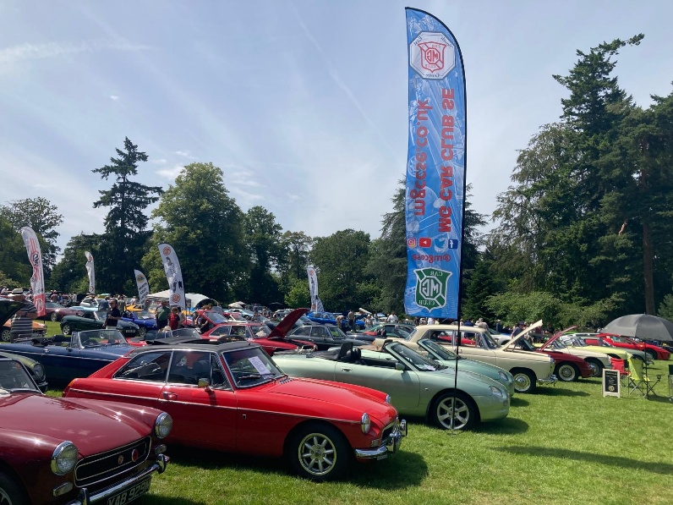
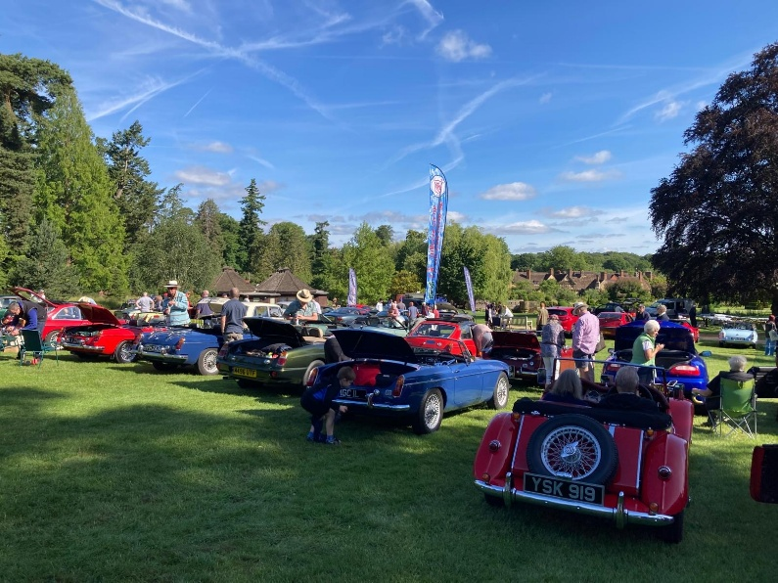
This was the 4th time attending this event at Hever Castle and what a success it was!
Over 450 cars on the hill looking down to the castle. 32 of those cars were MGs joining the SE centre display.
It was a perfect day with the wonderful gardens and a chance to visit the castle as well as meeting many owners and other clubs on display.
Cars at the Castle Andrew Mitchell
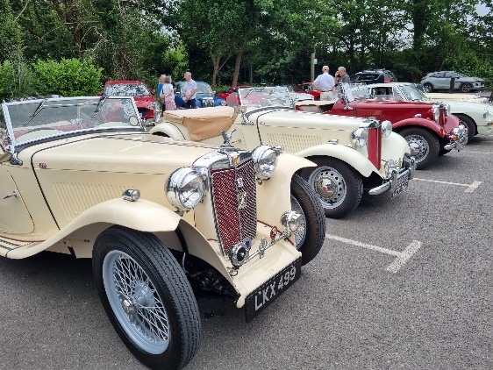
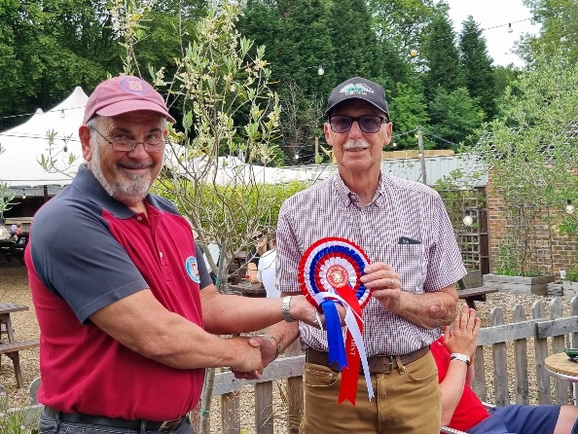
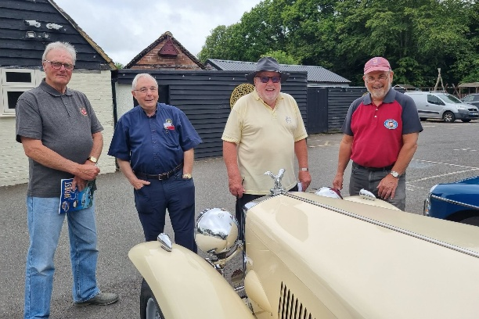
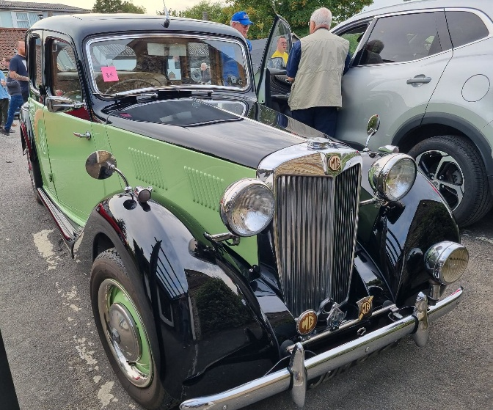
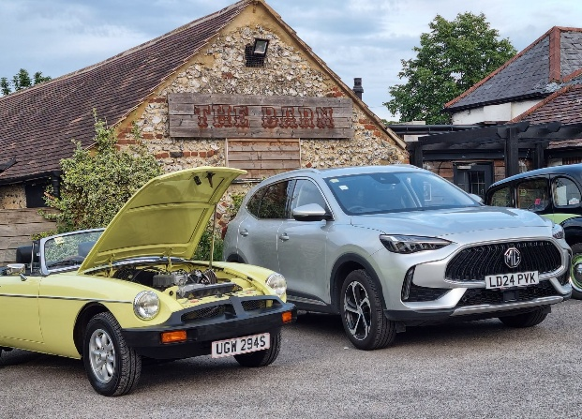
John Morgan hands David Lepper his rather large Car of the Show rosette
Daid Lepper’s TC was Car of the Show at The Surrey Oaks
Modern MG and rubber bumper B at The Doghouse
Mick Breare’s delightful YB Car of the Show at The Doghouse
Judging was a very relaxed affair
Moving on to Round two, just a few days later, at The Surrey Oaks in Newdigate we were blessed with even more pleasant weather. That allowed the entrants to enjoy a cool drink and lunch outside on the terrace at the pub.
There were a similar amount of entries to this round as The Doghouse which was good as this is usually the lesser attended of all the rounds.
The warm weather made for a very relaxing lunchtime’s judging and some had to be reminded to actually vote rather than enjoy the pub’s ambience.
The Car of the Show this time was won by David Lepper in his MG TC. Most Used was Vic Young in his MGCGT, Best All-Rounder was Philip Roussel-Smith in his MGB Roadster and Best Restored was Karl Foot in his MG RV8
The overall winner after two rounds is Roger Gasson and dog with his MG Magnette closely pursued by Dan Adams in his MGC Roadster.
Will that all change after Round 3 at The Fairmile? This is usually a very well attended event as it is combined with a club “Open Evening” and there is plenty of space on the Fairmile lawns – that means lots of bonus points!
The Alternative Pride of Ownership is an established regular trio of events in our annual calendar. This year the three rounds are at The Doghouse, Walton on the Hill, The Surrey Oaks, Newdigate and the final round will be at The Fairmile in Cobham on Thursday 9th July.
The first round at the Doghouse took place in the car park rather than the filed at the back of the pub as a confusion of messaging meant the owner had gone on holiday and not left the keys! However, there was enough room and it was a pleasant evening sitting outside the pub and wandering around the MGs. A larger number than usual entered the Best Restored Class including Mick Breare’s rather wonderful MG YB. Mick won the Car of the Show but it turned out to be bittersweet as he sadly passed away just a week later – see obituary on page 35.
Dave Naylor with his L2 Magna picked up another prize to add to his bulging trophy cabinet as the Most Used, Dan Adams’ MGC roadster was Best Restored and Steve Fletcher’s MGCGT was Best All-Rounder.
Alternative PoO 1 & 2 Tim Morris
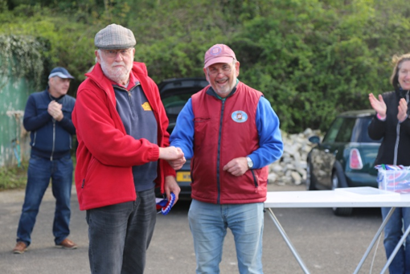
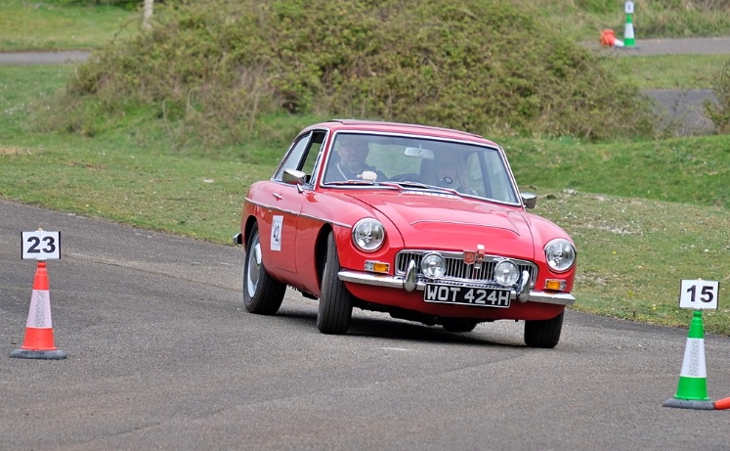
“it was quite windy and we struggled at times with keeping cones in the right position”
Our main competitive event since the last edition of Spark has been the Filching Manor AutoSOLO in April. We were fortunate to have a dry day, but it was quite windy and we struggled at times with keeping cones in the right position, timing beam cameras and even one of the control marquees being blow over.
We had an excellent entry of 46 cars including 17 MG drivers. This included one family of three, Father and two sons, using an MGA Coupe. There were also some MGCC members having their first attempt at AutoSOLOs Including Jason Caile in his MGCGT (pictured), Robyn Smith MGB and Laurie Kendall MGA Coupe.
The Filching Manor site is relatively difficult to run an event on because of fairly small paddock and car holding areas and often time in the past has been lost changing over competitor car groups. We tried a new arrangement this year by running only two test routes and this helped reduce competitor changeover.
Fastest MGCC entrant was Martin Neal in his Austin Healey sprite, closely followed by David Smith in his MGB. Photo is of Martin Neal receiving his rosette.

Jason Caille in his MGCGT on track at Filching

Martin Neal was the fastest MGCC entrant in his Sprite.
The SE Centre is again running the BBQ (Style) Lunch and Pride of Ownership at The Kentish Horse Pub at Mark Beech, just south of Edenbridge on Saturday 25th July. It’s a great social occasion and includes participant judged Pride of Ownership in the pub grounds.
Sadly, the Evening Autotest in June had to be cancelled due to the low availability of MGCC entrants, but the planned event on 30th July will be run as we have reasonable number of MG drivers. Anyone is welcome, the test routes will be kept relatively simple and mainly forward only. The location is Aldhurst farm, Temple Ln, Capel, Dorking RH5 5HJ and the evening starts at 6.30pm with scrutineering. The driving tests run from 7.00 to 9.00pm before we retire to the adjacent Dorking Brewery Taproom for the results.
MGFest 2026 at Brands Hatch is on the 16th August. In addition to the race program, the SE Centre will be running the California Cup Autotest on behalf of the MGCC. The previous day, the SE Centre will be running their Summer Gathering at Lullingstone Castle including a Road Run through scenic Kent from Brands Hatch as well as a Pride of Ownership Competition.
Please contact John Morgan on 07802 770025 or email competitions@mgccse.co.uk .

Competitions – Filching Autosolo John Morgan
Modern Gentleman Tim Morris
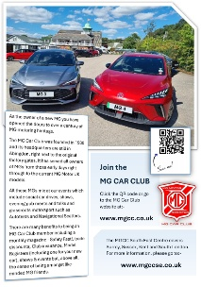

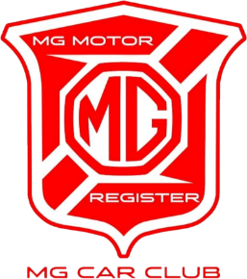

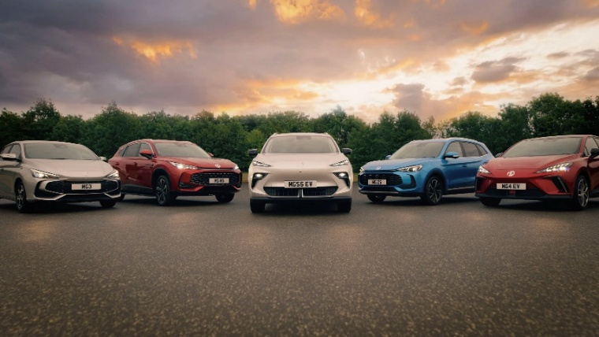
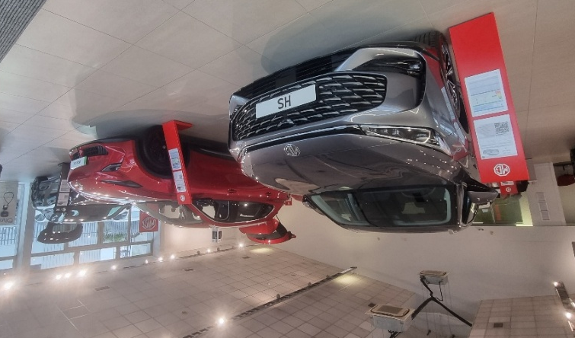
We briefly mentioned the new MG engineering Centre in Frankfurt in the last issue of Spark. We now hear that SAIC are to build a manufacturing facility in Spain. The choice was between Spain and Hungary but either would bring MG Motor into mainland Europe and the EU. That will bring jobs to the region and also means less tariffs of course as they will no longer being importing into Europe. The new plant will be based in Galicia and will bring 2000 jobs to the region and an investment of 200 million Euros. It is due to open in 2028 and will produce around 120,000 vehicles a year and will be perfectly placed to help achieve the EU 2035 zero emissions ambition.
Generally, MG are doing well with UK sales and now reach 4.3% of the UK market. That may not sound much until you consider that the top brand, Volkswagen, is on 7.3%. This puts MG in the top dozen or so manufacturers selling vehicles in the UK and the top Chinese manufacturer, outselling BYD, although it is a close-run thing. Sales in the UK have reached record-breaking figures with just under 50,000 cars sold this year so far – 91% of those have been electrified in some way. There has been a 74% increase in sales of pure electric vehicles making MG one of the leading manufacturers in electric vehicles.
MG have announced a new European subsidiary - MG Motor Switzerland. This will mean the country moves from being importer led to its own directly managed operating structure, much like MG Motor UK. This further reflects the parent company’s long-term commitment to the European market.
MG have now sold over one million cars in Europe since the launch of the MG6 and have over 1,300 outlets in 34 markets. That number is growing rapidly with more and more modern MGs seen on our roads.
The MG Car Club recognises these new MG owners and have formed a Register to cater for any new MGs coming along – the MG Motor Register. As a new Register it does need support and currently only has four committee members so, if you are a modern MG member, why not think about volunteering?
We have designed a new leaflet to go into our local MG Motor dealerships in the South East to encourage new owners to join the club – see right and Tim handing them out at Richmond MG Guildford in his column.
100,000,000 and 1
In a ceremony at MG’s London HQ head of UK and Europe Wiliam Wang handed over the keys to the 100,000,001st owner of an SAIC vehicle. Natalie Nobes was the buyer of an MGG4 Urban personally handed over by Mr Wang. Natalie’s grandfather was an MGB owner and she would sit in it as a child wondering what it would be like to own an MG – now she has her own electric MG!

Natalia Nobes receives the keys of her MG4 Urban from William Wang
The MG Motor Register caters for all modern MG models from the MG6 onwards.
If you have not registered your modern MG against your Membership number then you can do so on the MG Car Club website. This helps the club identify you and also how many modern MGs are with the club – at present there are over 200 registered... but we think there are more!
Some of the current MG range of electric, hybrid and petrol models – MG3, MG HS, MG S5, MG ZS, MG4. You can add MG4 Urban, MGS6, IM5, IM6 and Cyberster to that list.
Richmond MG showroom in Guildford
Electric Spark Tim Morris


The MG4 Urban has only been on sale in the UK for a few months but the version sold in China has been on sale since last year and is already getting a 2026MY update.
It has added two new colours from the paler end of the palette. Exterior at the front resembles the original Urban with extended headlights and a black two part lower bumper with blue driver assist light. It features new 17” wheels and a subtle rear spoiler.
The interior features two new colourways – Yacht blue and Midnight Purple complemented by coloured ambient music-sync lighting. Front 8-point massage seats have been added along with a 4-point passenger leg rest. A new Horizon Robotics Intelligent driving system has been added along with natural voice controls for things such as the entertainment, sunroof and ventilation.
New parking features have also been added including automatic front-entry parking, DIY parking mode, parking speed adjustment, dead-end road parking, low-speed parking spot detection, and smartphone-vehicle parking visualisation.
The power train features a 120kw motor and choice of 42.8kwh or 53.9kwh batteries. The new solidcore battery will also be an option.
The new MG4 Urban update was debuted at the 2026 Beijing Autoshow. Will this version come to the UK and Europe? Well, it does seem to be a more premium version than the Urban on offer in the UK – which is essentially a budget model. However, China does not sell “our” original MG4 which has just been facelifted in our home market – to them the Urban is the only MG4.
MG07
The updated Urban debuted at the Beijing Motor Show alongside the MG 4X and a new car - MG 07.
This will be a new flagship coupe and offered in EV and PHEV formats. As well as being a good looking car the MG 07 will feature a new link up with Autonomous Driving company – Momenta. The 07 will feature that company’s Momenta R7 and XHEARTX7 chip to improve navigation and parking space to parking space technology. It possesses physical scene understanding and predictive reasoning similar to an experienced driver – identifying cause-and-effect relationships, proactively performing defensive manoeuvres, and pre-emptively avoiding potential risks. This greatly enhances both the safety and practicality of intelligent driving. As usual there is confusion over the name and it is not to be mistaken for the current MG7 which has been available in petrol form in some markets for a while – that zero is important!



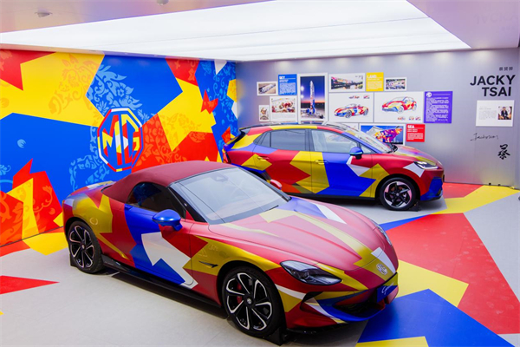
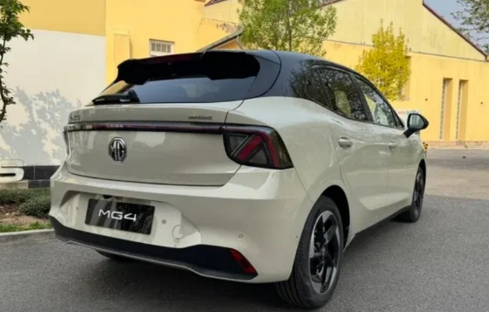
The upmarket MG07 has been revealed in China
Above and left: the MG4 Urban 2026 facelift model available only in China … at the moment.
MG Motor teamed up with pop artist Jacky Tsai and the Luxun Academy of Fine Arts to create these eye-popping variations for the Cyberster and Urban at the Beijing Show.
Wilton Concours Jon Glover

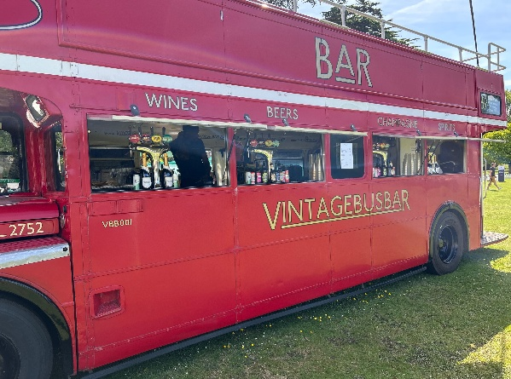
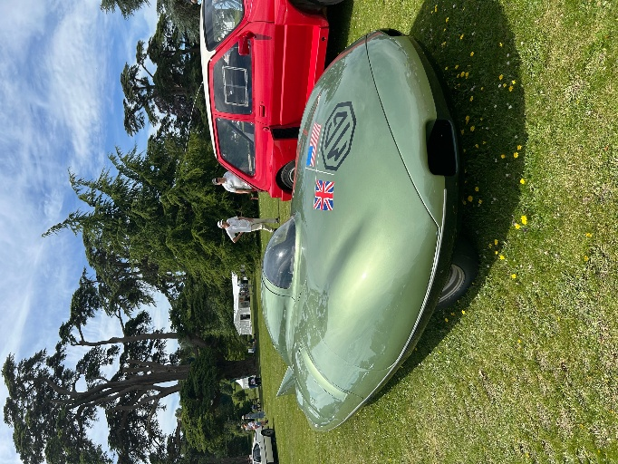
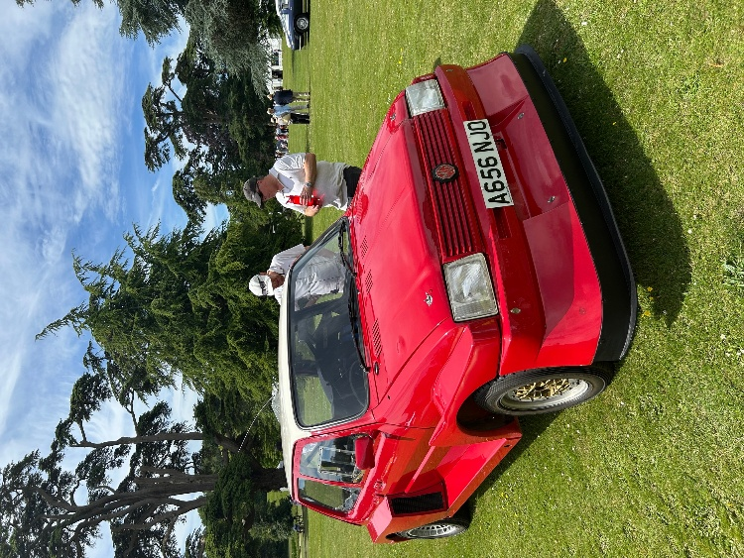
Geoff Radford’s stunning Tigress on display, a frequently seen car in the centre.
Jon Glover was an invited competitor in his MGCGT at the Concours. He sent us these photos, great to see two SE centre cars in the Concours!

Concours Des Legendes - an exclusive 3 day event at Wilton House near Salisbury.
A new event with two SE centre cars on display.
Wilton House made a great back drop to this new event

The all-Important Vintage Bus Bar
The British Motor Museum brought along the record breaking EX181 MG speed car.

This original MG 6R4 prototype was also from the Museum.

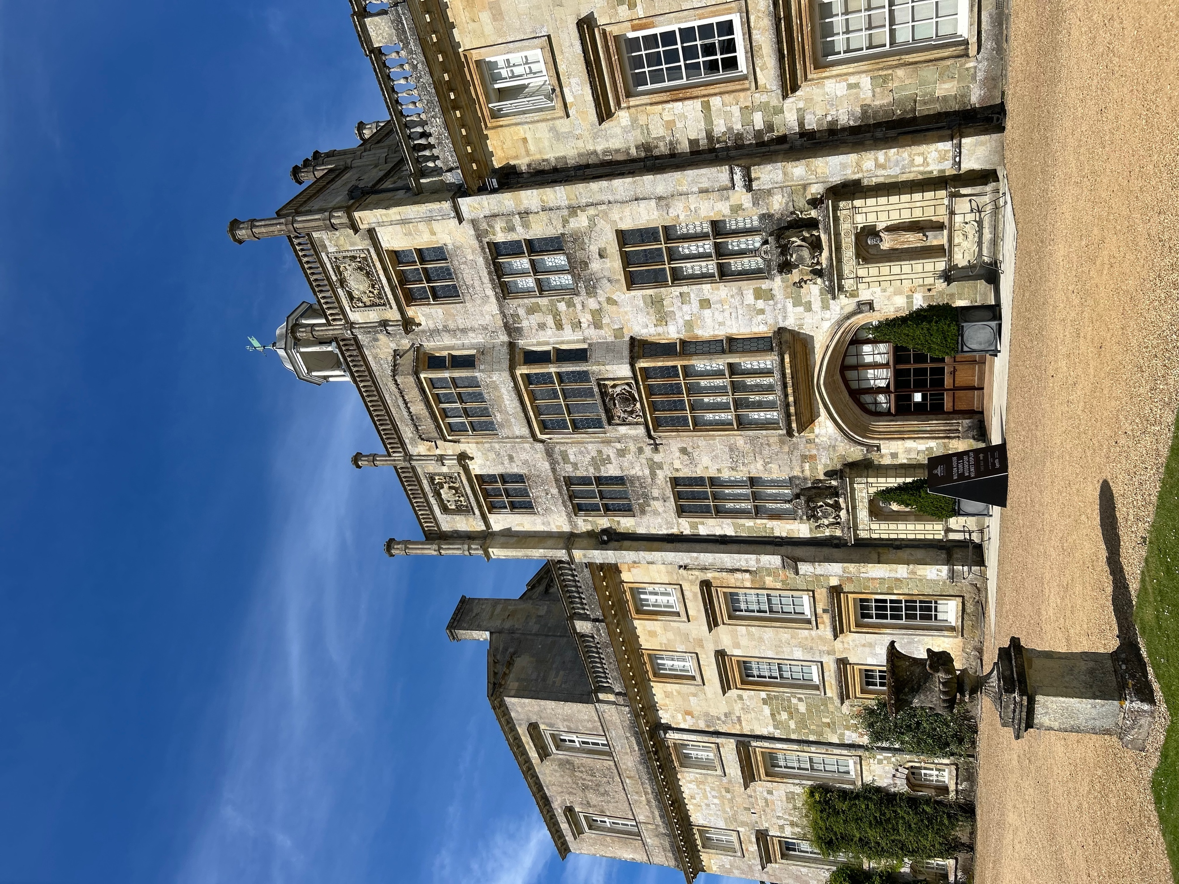
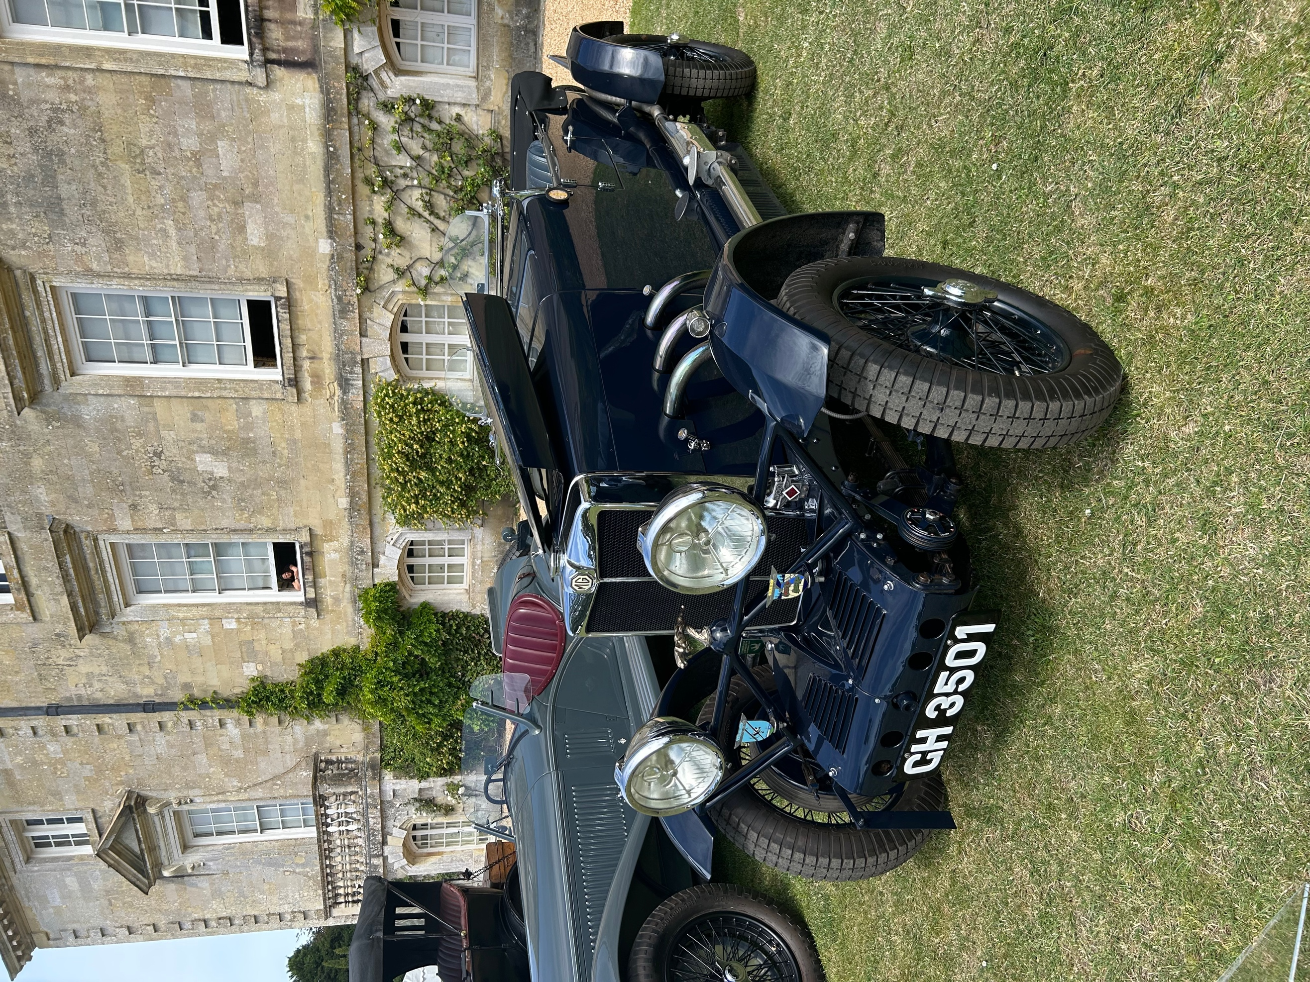
Jon’s MGCGT on Display
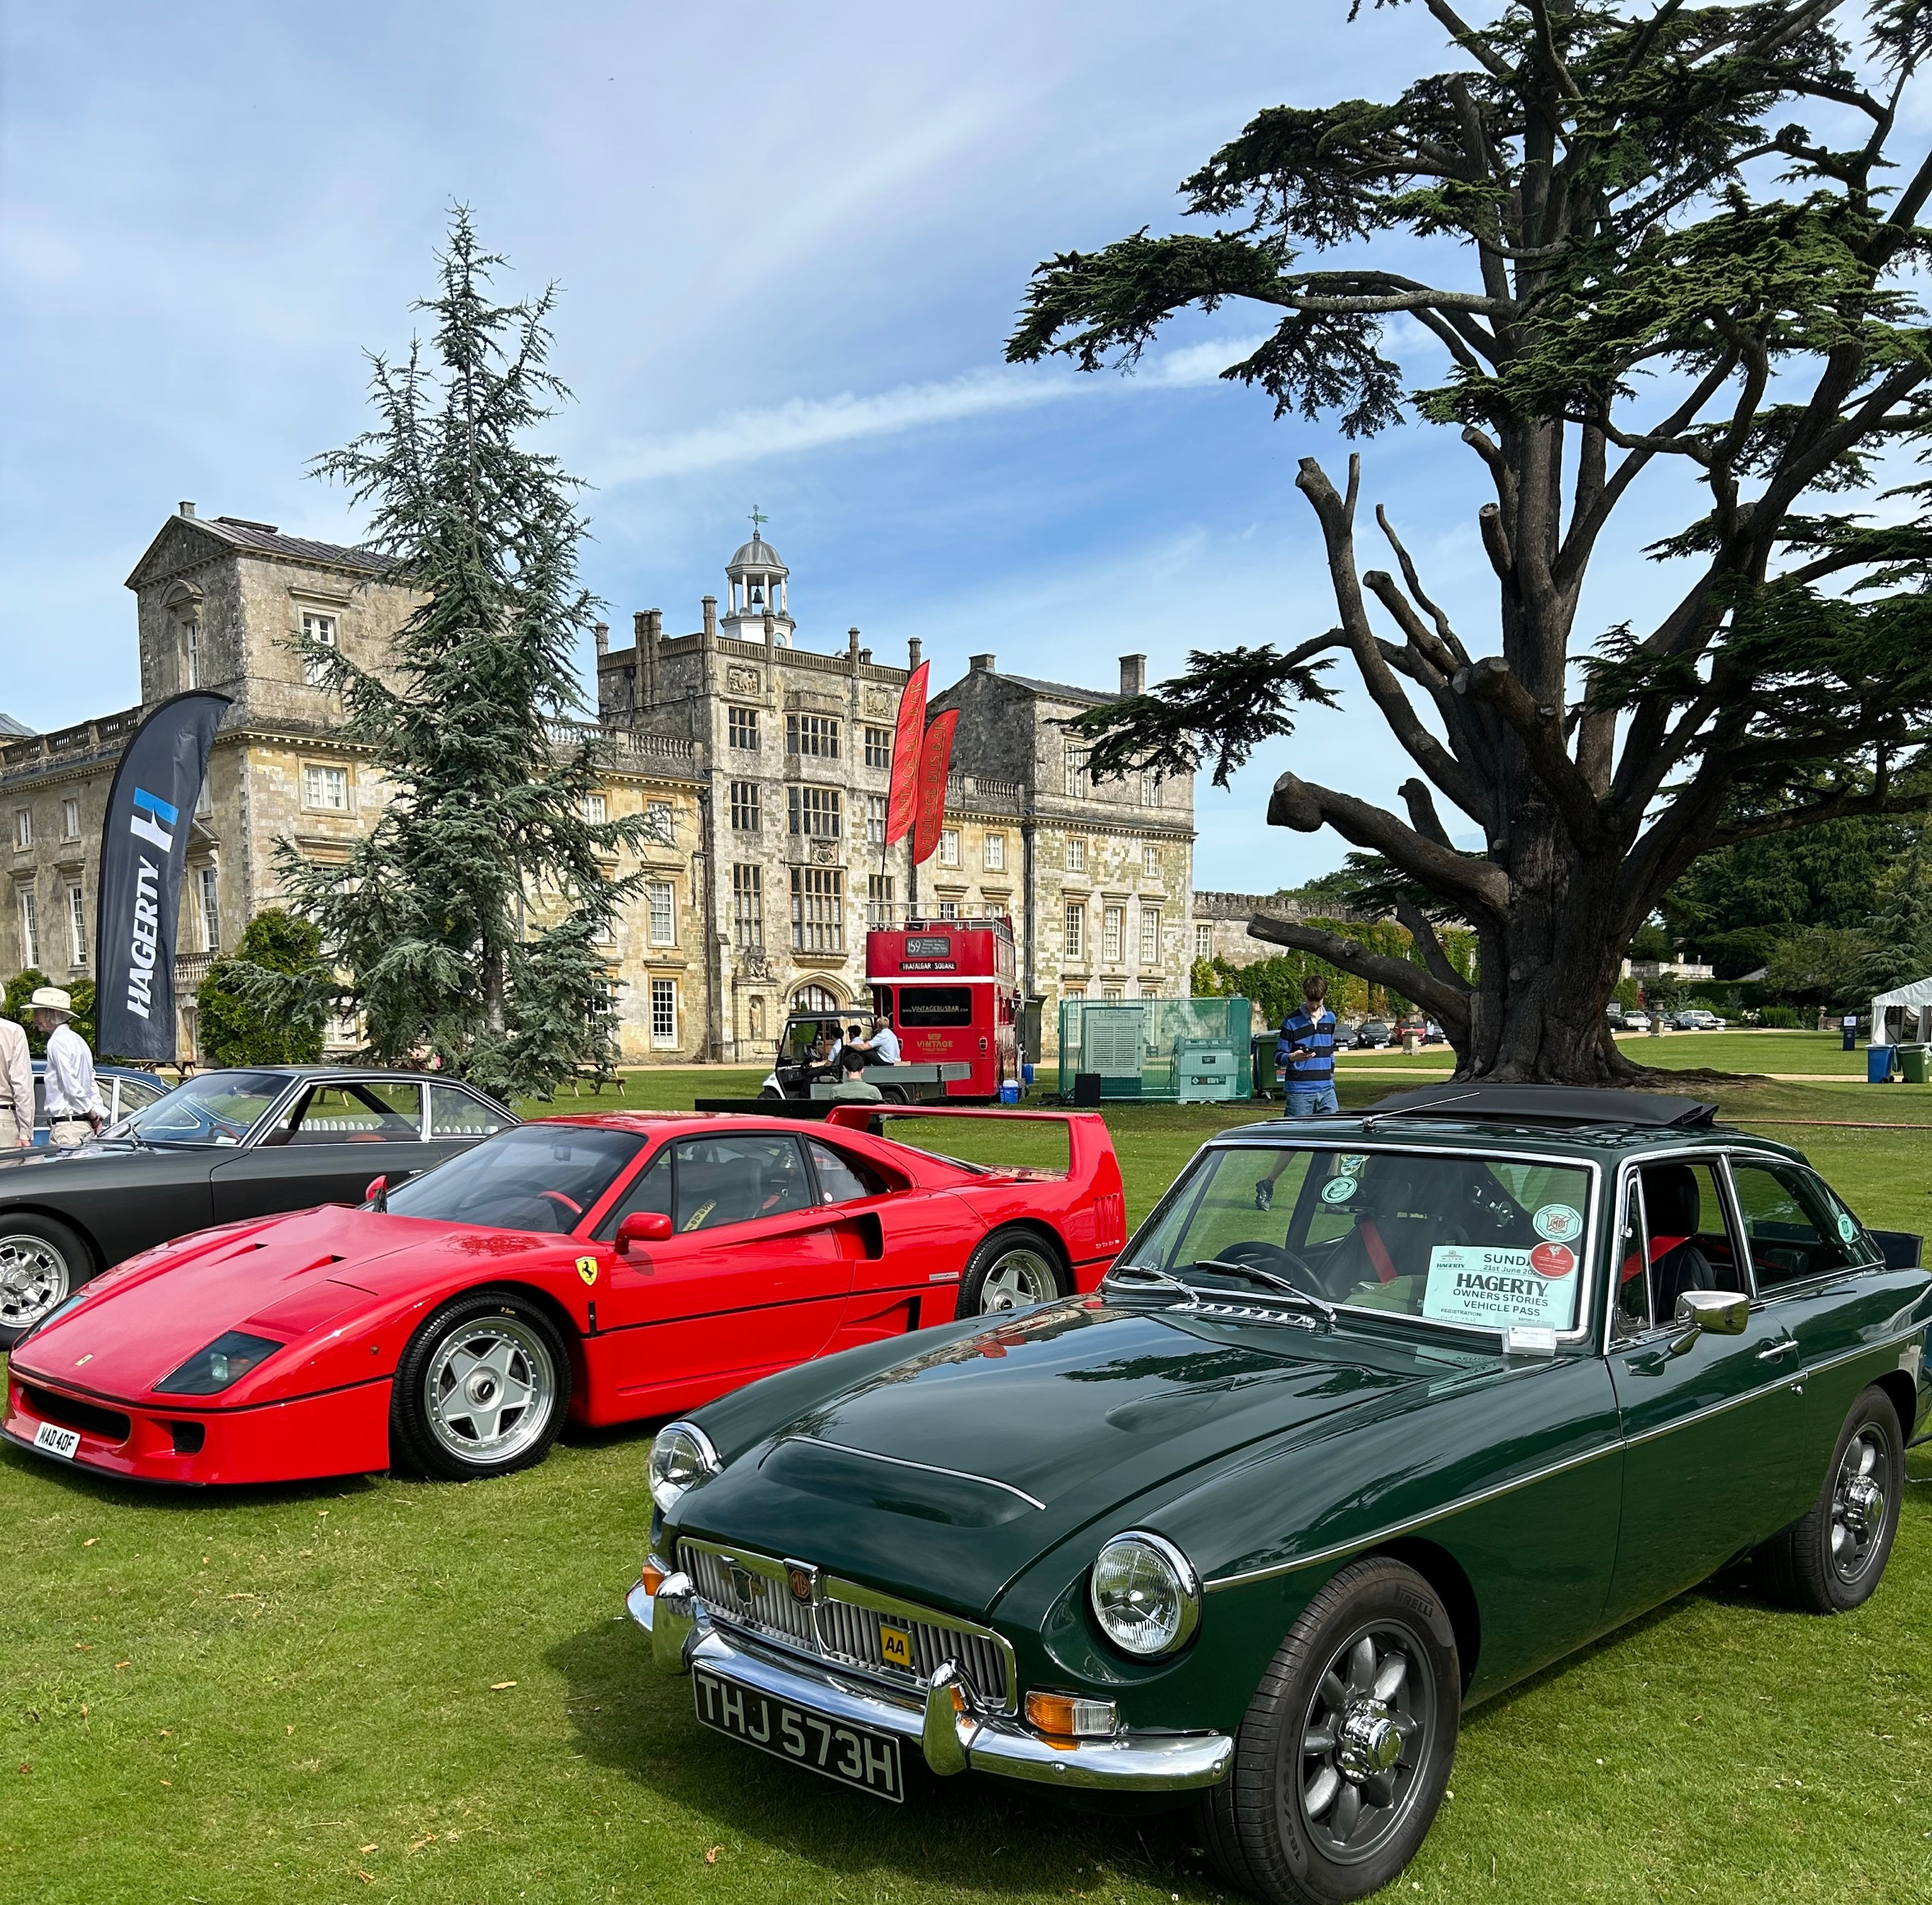
AROUND THE CENTRE

A good turnout at our mid-summer evening gathering!
With vineyards and wine tasting outings, our natter is looking forward to following regular natter attendees Tim and Clare Luffingham’s adventures on the Africa Rally in their Toyota! The money raised is for E3 charity (a Christian charity bringing hope and enabling sustainable development in South African communities stricken by poverty and HIV).
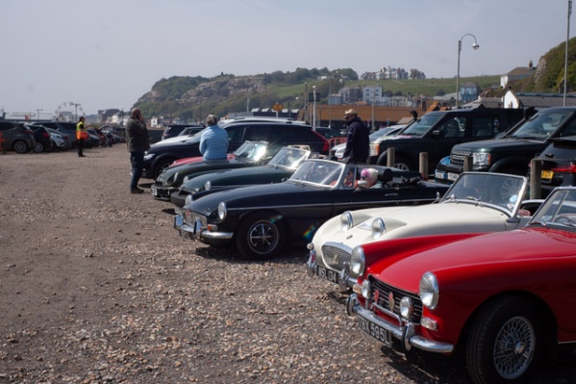
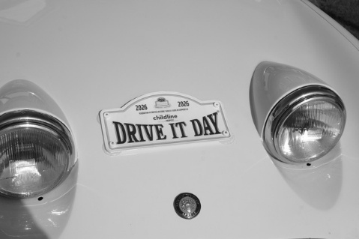
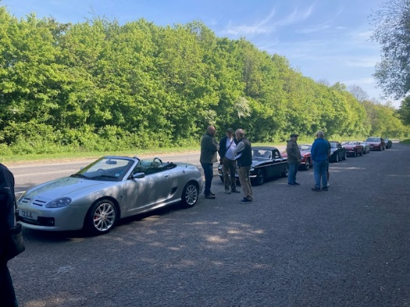
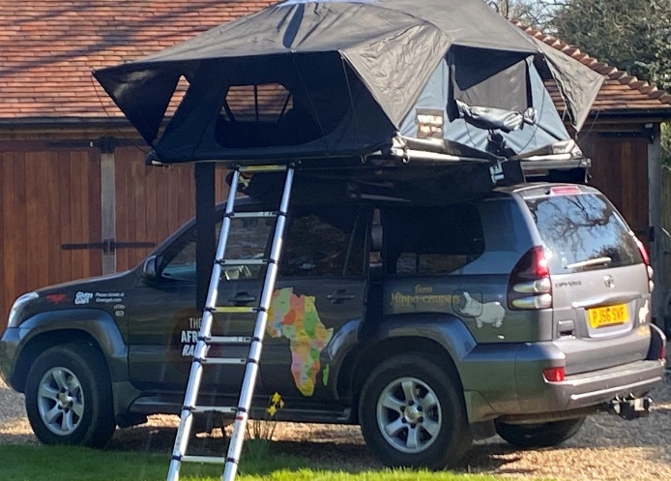
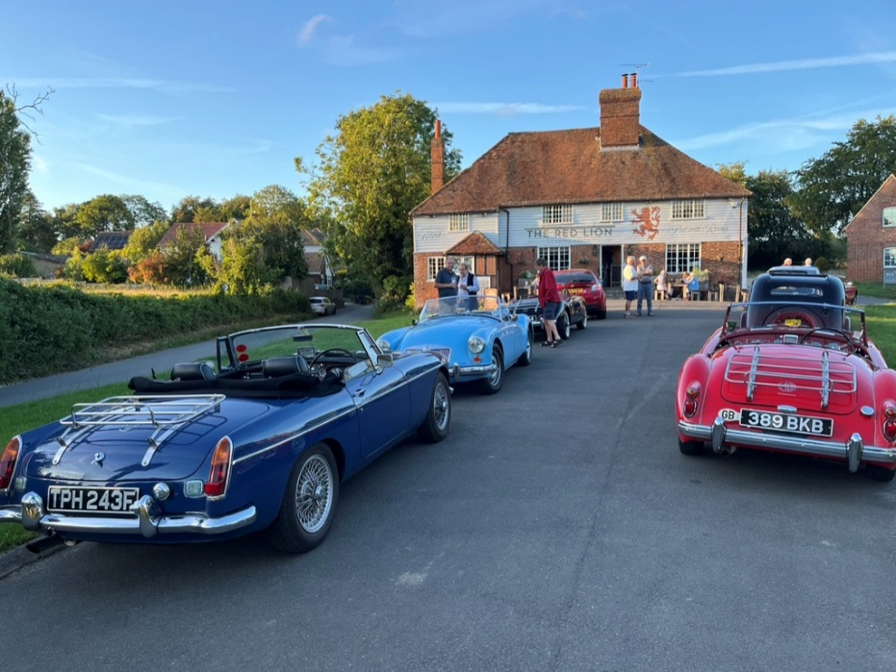
CANTERBURY NATTER
John Clark

Good gathering at our June natter The Africa rally Toyota with new roof tent!
NORTH DOWNS NATTER
Will Opie & Ray Ruffels
Thanks to John and David Brenchley for the photos
The Drive it Day on April 26th was well attended by some 10 cars, and we also welcomed David and Helen from a local Natter in their lovely Froggy. New member Dean and his wife Chantal graced us with their RV8 that at least had a different exhaust sound! Mick took the lead and after a loo stop at the Tenterden Railway we made good progress to Hastings, and even all arrived somehow!
Coffees and munchies were sought out before we set of again. An impromptu stop in a local pub car park managed to split up a previous well managed convoy into a convoy of chaos!!!
Chaos descended again in Folkestone where JC went the wrong way then found himself on his tod driving towards Sandwich on the correct route, and others did their own thing and ignored the route notes!.....and others peeled off home as arranged….HOWEVER…We all ended up in Sandwich for a well-earned beer.

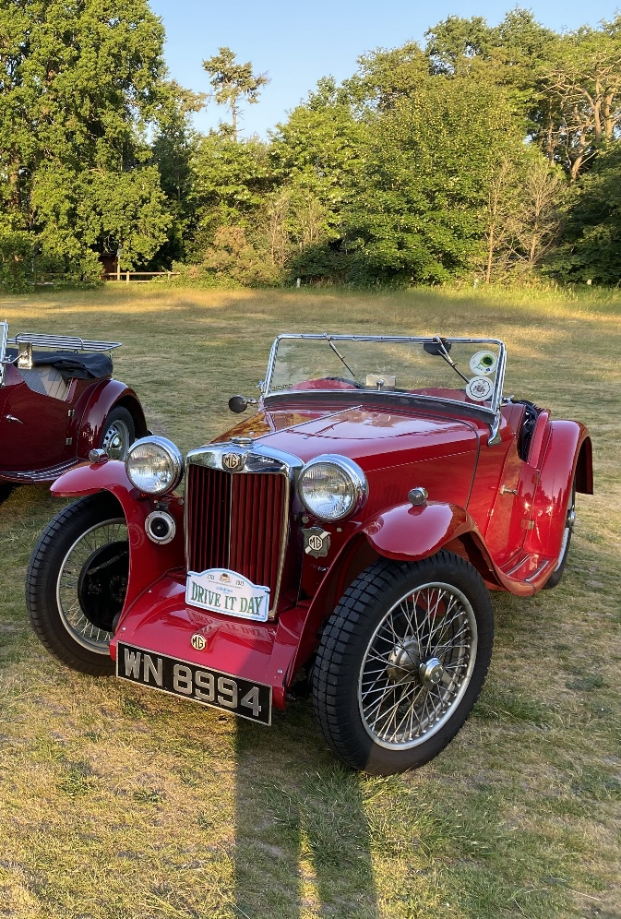
FAIRMILE NATTER
Ian Ailes & Jon Glover

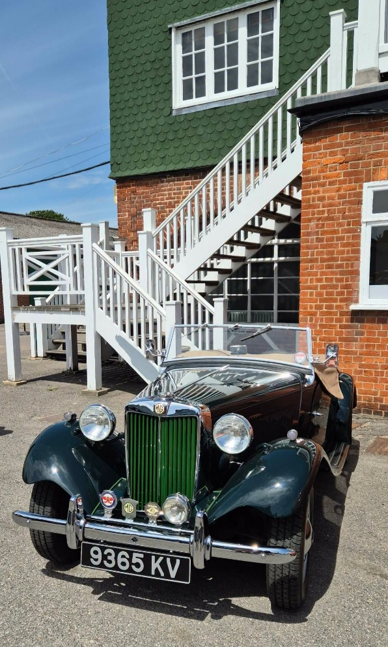
Ian Ailes TD suitably placed for getting up to the Members’ Bar
Above and Right nice supercharged TC.
The PB today is owned by Roger Marlow, he was surprised to hear from a previous owner from the 60s on the phone!
Several Fairmilers attended Brooklands Relived on Sunday 14th June to celebrate the opening of the track in 1907. Pre-1960 cars were allowed access to the Museum. Whilst three of us were admiring a PA Airline Coupe a man asked us if we could help him trace his MG PB which he had owned and rebuilt in the 1960s. He had some paperwork from the MMM Register but had not found the car. In passing, he mentioned the name of the current owner – Roger Marlow.
I nearly fell over because Roger was a Fairmiler before he moved to Chester a couple of years ago. “Ruby” was the oldest car to attend the Fairmile regularly. I still had his number on my mobile, so I called Roger – he was gardening! Imagine his surprise when I told him that I had found a former owner of his car from 1966! I just handed the phone over and let them get acquainted! Ironically, a few years ago Roger reunited a lady with her TF who had bought it new in 1955.
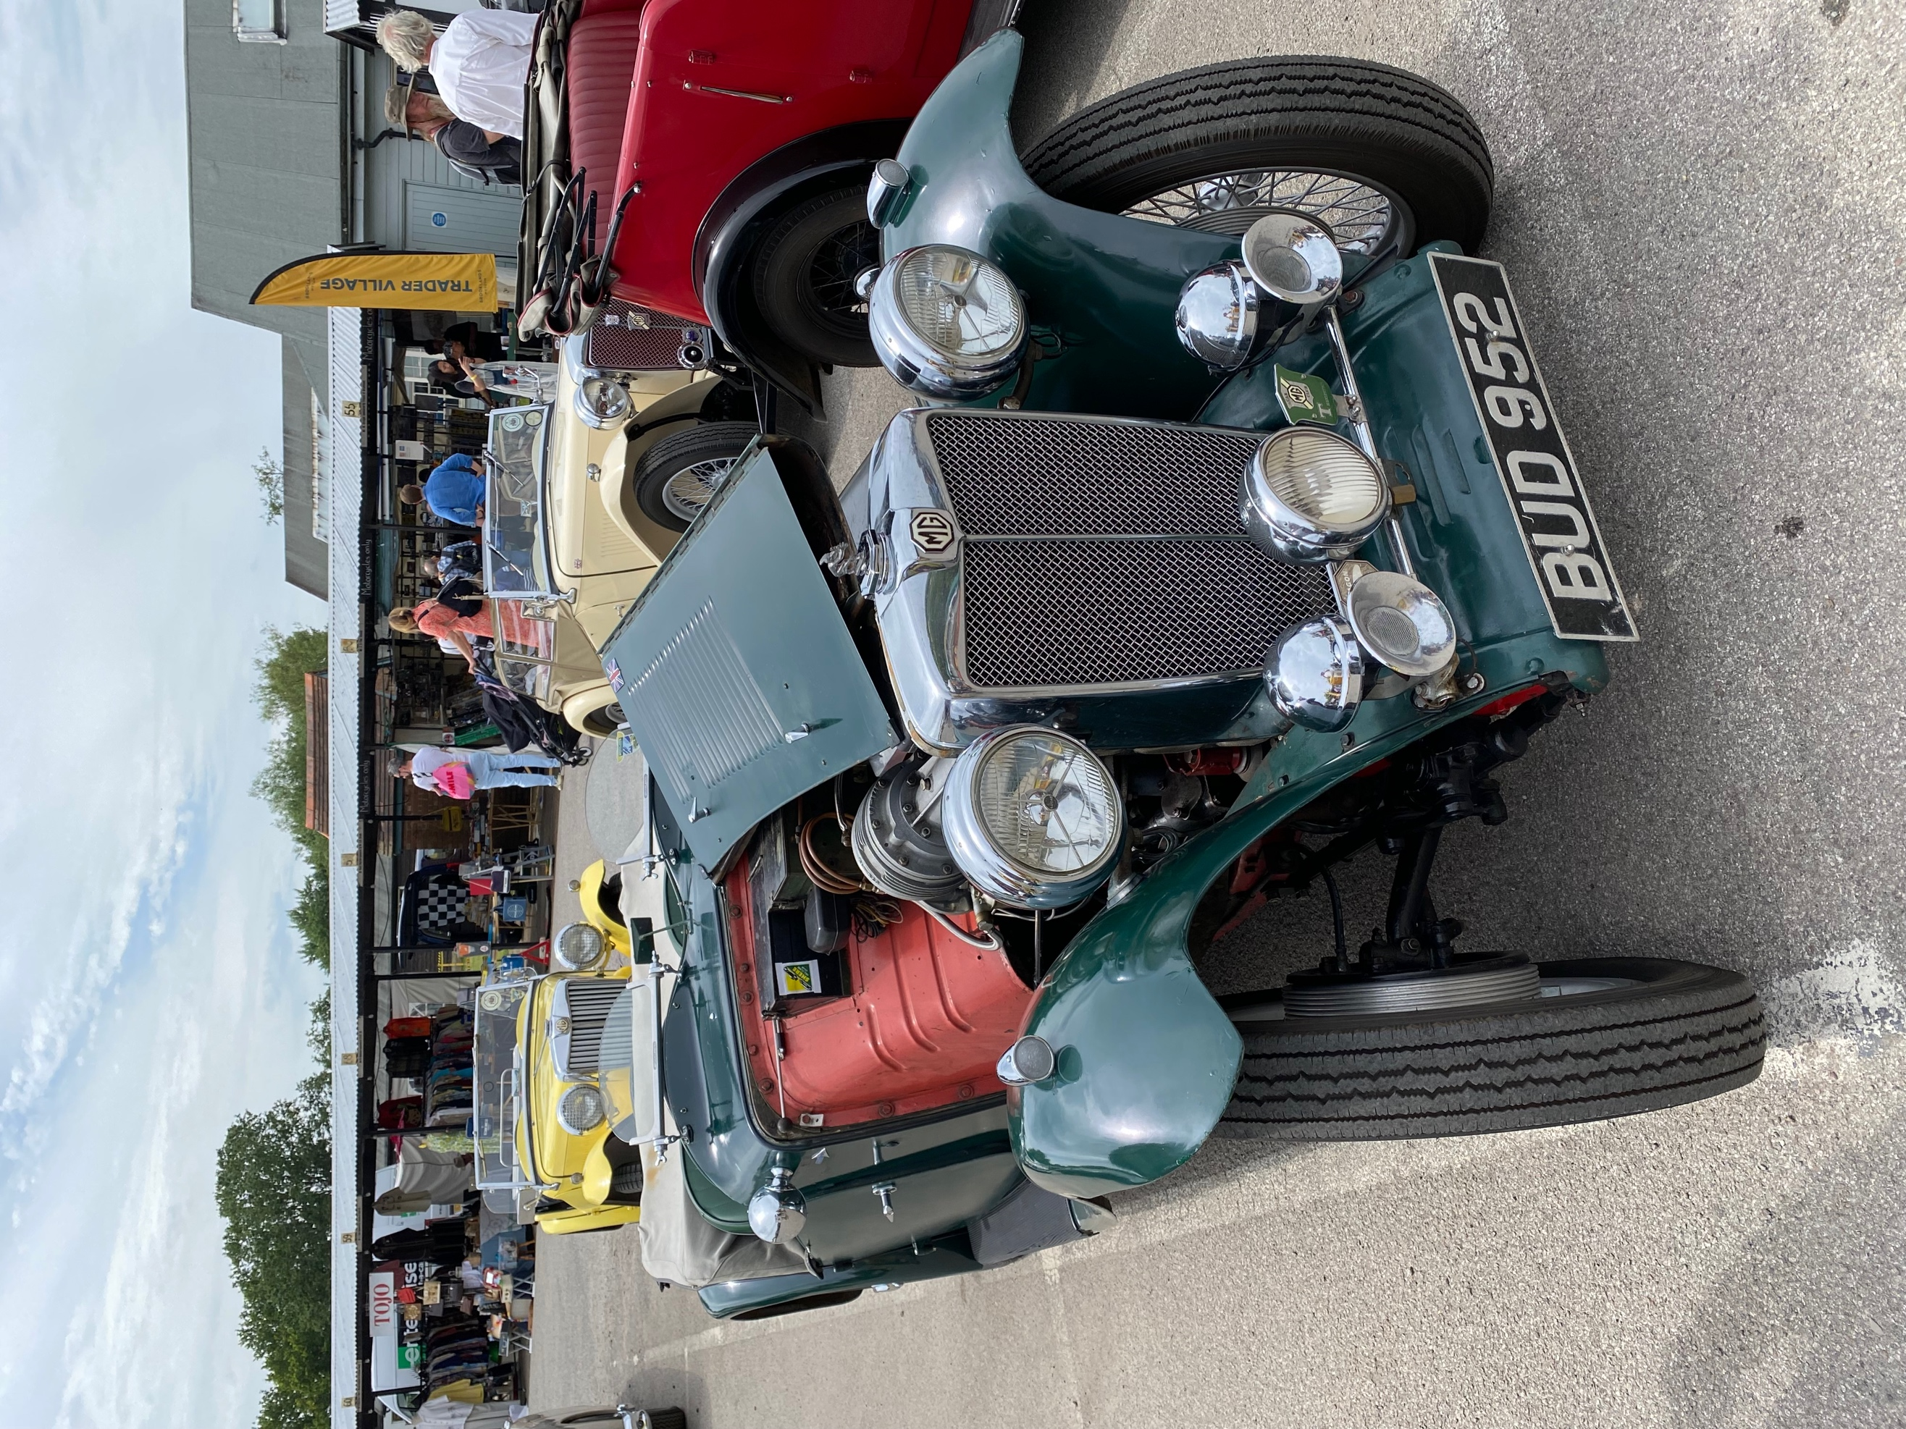
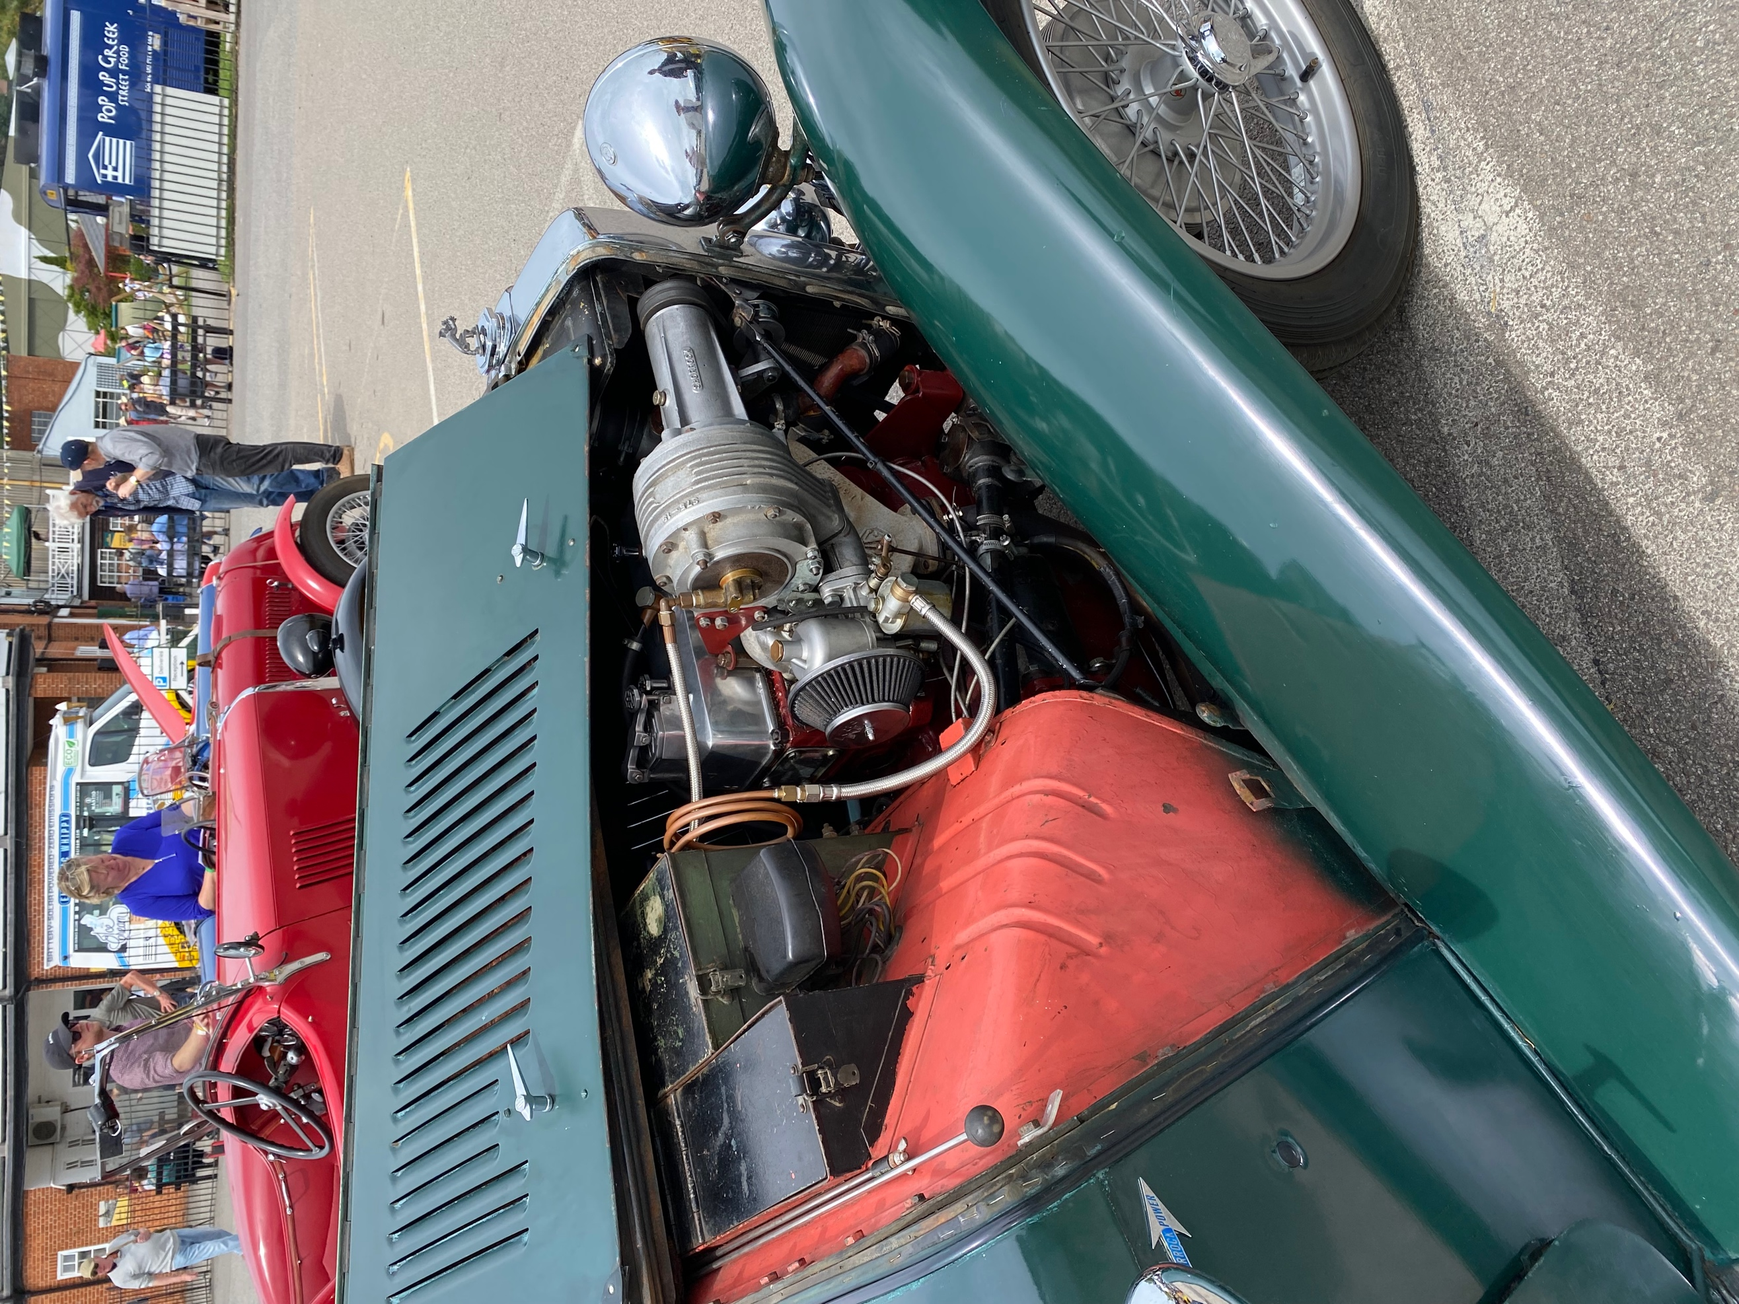
SE MGF REGISTER
Tim Morris
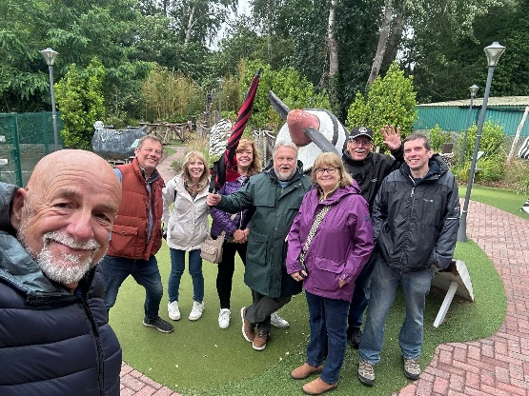
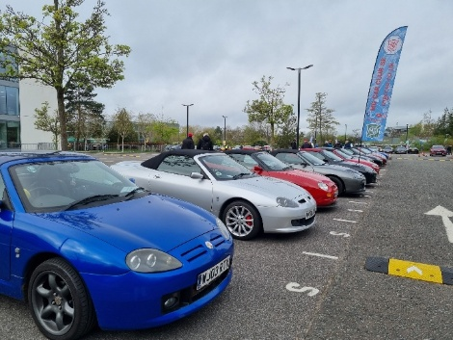
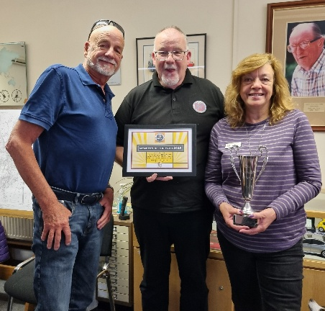
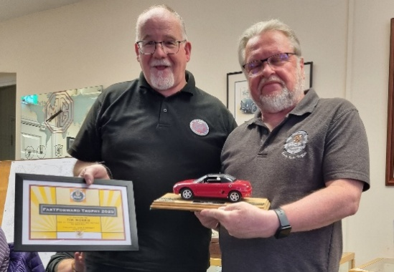
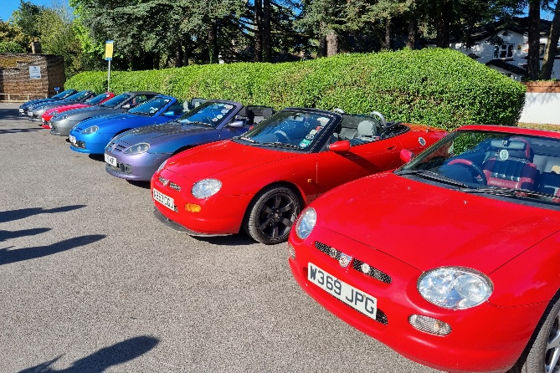
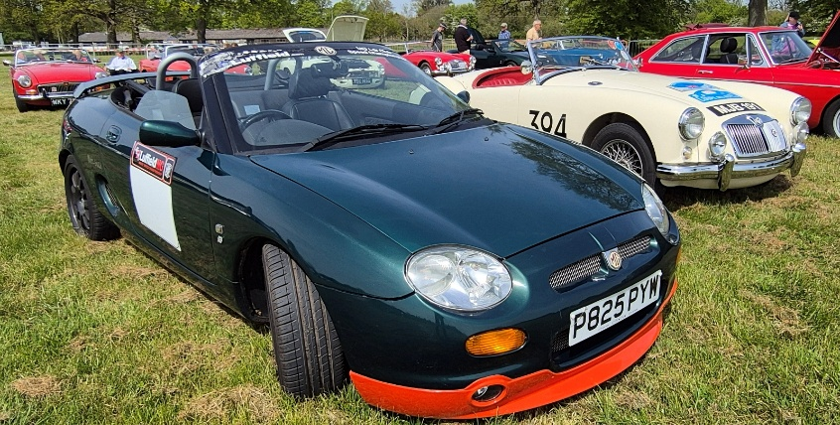
Above: Marc Hanson’s Sprint MGF at Gatwick

Left: MGFs at the Bells of Ouzeley Breakfast Meet
The golfers celebrate getting to the end of the Safari
It was good to see Marc Hanson’s Sprint MGF back in action when Annie and Alice drove it to the Centre’s Drive it Day meet at the Gatwick Aviation Museum. This early MGF has not been used much in recent years but Marc gave it a good clean up and it started on the button looking good next to his MGA.
A few MGFs joined in the run from Bocketts Farm but holidays and other commitments got in the way of a large turnout of F/TFs.
Before that some went to the MGF register AGM at Kimber House where some also received Register Awards. Alan & Jo Bradley won the “Members of the Year” Trophy and Tim Morris was the recipient of the last ever FasTForward Trophy. That magazine came to a close at the end of 2025 after 20 years of production , all with Tim at the helm.
To mark the occasion Tim gave his own MGF a bit of a refresh paint and body wise after 26 years of being in his care on the road! It is now looking splendid.
The last of the MG breakfast meets took place in April at the Bells of Ouzeley in Old Windsor – it was a nice morning and a good turn out of topless Fs (but not so many non Fs) – thanks to Gerry and the Pinner natter for organising.
We also had a good turnout of MGF/TFs at the Brooklands Easter Gathering with some 21 cars in our line up. We were outside the main show in the “moderns” section once again having being usurped by the Fairmile Natter!
Some of us were back at Brooklands for the Best of British with the Centre and we’ll be back again on 26th July for the Classic Car Show.
We held our annual mini golf challenge in June and this year we returned to Safari Golf at Hersham which, surprisingly, is still there despite being threatened with a 400 house redevelopment! With Gerry and Jack absent we were able to congratulate a new championship winner in the form of…… Paul Bridgman (albeit staving off the rain showers)
Well done and we will see where we end up next year. We’ll be at MGFest and the Day Before in August of course so keep an eye out for us.
MGF & TFs at the Brooklands Easter Gathering
Alan & Jo Bradley receive the Members of the Year Trophy at the MGF Register AGM
Tim receives the final FasTForward Trophy from MGF Register Chairman, Ian Wright
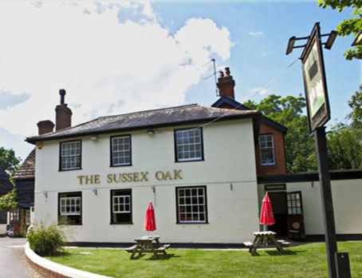
SUSSEX WANDERERS
Andrew Ratcliffe / Ursula Griffiths

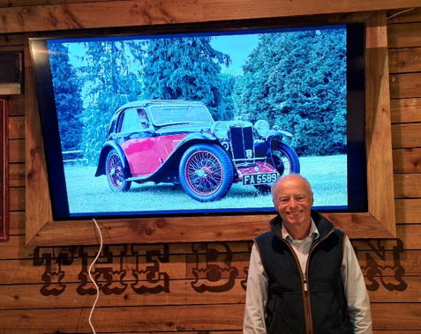
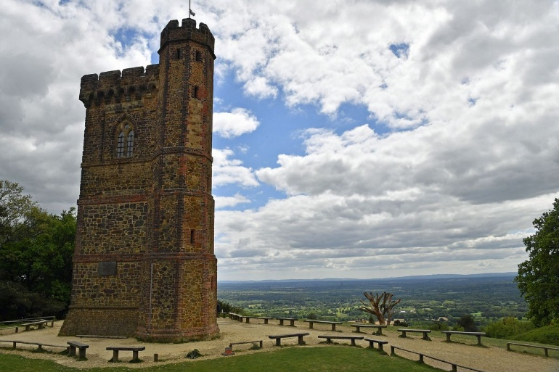
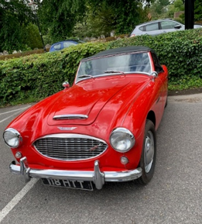
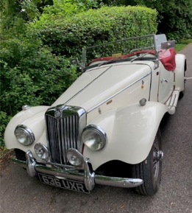
Spark editor Will Opie in the Doghouse with his P Type Airline Coupe on screen at the April talk.
Our May talk by Martin Atkins who is CEO of the Green Lizard Technologies on the topic of ‘Sustainable and Synthetic Fuels’ had to be deferred to the November meeting.
This was replaced by another film evening.
We had an excellent illustrated talk at our April Meeting by Will Opie on the subject of ‘MMM Cars and in particular, his restoration of a P Type Airline Coupe’. The subject had been requested by a couple of the regular Natter supporters and Will gave an excellent and enlightening talk providing a clear understanding of the MMM cars special features.
His own Airline Coupe restoration has been recognized as one of the most original and is used by members worldwide as a point of reference for other restorations.

NORTH SURREY NATTER
John Morgan & Austin Banner
The Suggested Route actually included a ‘foray into Surrey’! It included visiting the area around Leith Hill, the highest point in Surrey.

The Team at The Sussex Oak laid on 41 lunches, and it was clean plates all round after everyone enjoyed their delicious meal. There was plenty of opportunity to meet up for a chat, and there was a lively ‘buzz’ of conversation.

We meet on the second Wednesday of each month and in August we have a summer BBQ at The White Horse in Maplehurst which is always well attended.

Sussex Wanderers had another successful meet in June when the day started with coffee, biscuits and chat in the pub. There was some viewing of cars in the car park, with quite a few MGs in evidence, and a couple of other marques, like the red Healey
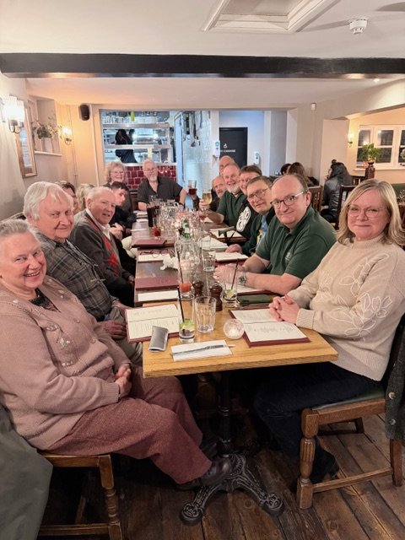
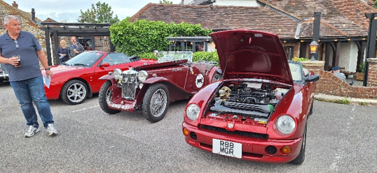
As noted previously the Pinner Natter has been growing in membership and as a result our meeting nights have had to be changed from a Tuesday night to a Monday night when the pub is a little quieter. We have experimented and we now currently meet on the second Monday of the month.
The first big event of 2026 was the Natter’s post-Christmas Dinner at the beginning of February at which 24 members and guests attended but the alcohol imbibing was somewhat limited as many of us were up early next morning for a trip to the season opener at Stoneleigh. Around 8 members had the energy to travel there! It was another good event and, in my opinion, much busier than last year and annoyingly there were plenty of items to spend money on!
The next weekend saw our first Breakfast Run of the year to the Bells of Ouzeley in Old Windsor where along with members of the South East Centre MGF Register we had 24 sitting down. Although the weather wasn’t too good and the Thames was near to bursting its banks we were able to spend a couple of hours in the warm talking about almost everything but MGs! This was followed by another successful Breakfast Run at the beginning of March when the weather brought out more classics and allowed a good walk down the Thames towpath as the water level was back to normal.
The Post-Christmas Dinner at The Case is Altered
PINNER NATTER
Gerry Edwards
The forthcoming July meeting will be a social Boule game in the pub garden on Monday 20th July.
The Natter MG display at the Walton-on-the-Hill Pageant on May 16th was a little limited this year with just five cars as several Natter supporters were not available this year.
The natter lunch/run/visit on 11th June, to the Vintage Bentley Specialists in Liss was excellent (apart from all the services roadworks that have descended in the area causing traffic mayhem) They undertake complete restoration of 1930 and earlier Bentley cars and amongst others they were restoring the 1923 and 1925 Le Mans cars. The showroom reception area was like walking into a 1920s car dealer! There will be a longer report in the next issue of Spark.
Contact John or Austin for more information
The June meeting hosted the first round of the SE Centre Alternative Pride of Ownership. Fortunately, it was a pleasant dry evening and 18 cars took part. Mick Breare’s MGYB was voted Car of Show.

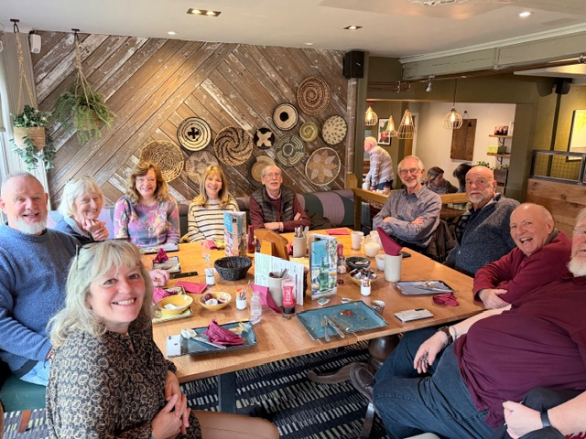
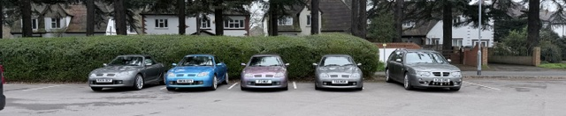
One of several Breakfast Meets this year at the Bells of Ouzeley in Old Windsor
More recent MGs gathered at the Bells of Ouzeley
There was a good attendance from the Natter at the Easter Gathering at Brooklands and 7 members took their cars – several of us met up on the way home for a beer or two which finished a good day off rather nicely.

Breakfast Runs have continued monthly except for May when various Bank Holidays got in the way. Perhaps our best Breakfast Run took place on the 14th June when a good number of members took the opportunity to eat breakfast outside and then have a cruise on the Thames afterwards! This will be repeated!

Summer Natter evenings are good as this always gives us the opportunity to show off our cars in the pub’s car park and in both May and June we had a large turnout of members – indeed at our June Natter we filled the pub up very quickly! It is good to note that there is an increasing Natter membership and so that we can continue to grow which have changed our meeting nights from the first Tuesday in the month to the second Monday in the month.

With the late Spring and early Summer period there have been a good number of events to attend at weekends. As most, if not all, South East Centre events are well away from the Pinner area members generally attend events arranged by Abingdon Works Centre and its Natters and just recently many members attended the Spring Chicken Run and Chesham Natter’s Pride of Ownership. In May members turned out in force for the big Watford Classic Car Show and just last weekend a good number of members attended the Iver Heath Classic Car Show on a scorching day and where a busload of Chelsea Pensioners arrived to judge the best car in the show! At the beginning of July 9 Pinner members have booked into the Chorleywood Classic Car show and this will be a good event as it includes supercars as well! Pinner Natter is delighted to have all of these events within just a few miles of the Queen’s Head in Pinner which is our Natter home. On top of this a local pub has started a monthly Saturday morning classic car meeting and a local garden centre has started a bi monthly classic car meeting. Both of these locations have attracted a good range of cars and most importantly a fair number of them have been entered by young people and this has to be a good thing.

And finally, to welcome in early Summer a good number of us are attending the Goodwood Festival of Speed which is almost on top of us!

Pinner Natter always welcomes visitors so if any reader of Spark is in our area please come and join us – you will receive a very warm welcome. Last month we had two visitors and it seems they would now like to join us!

The Pinner Natter wishes everyone a very enjoyable Summer!

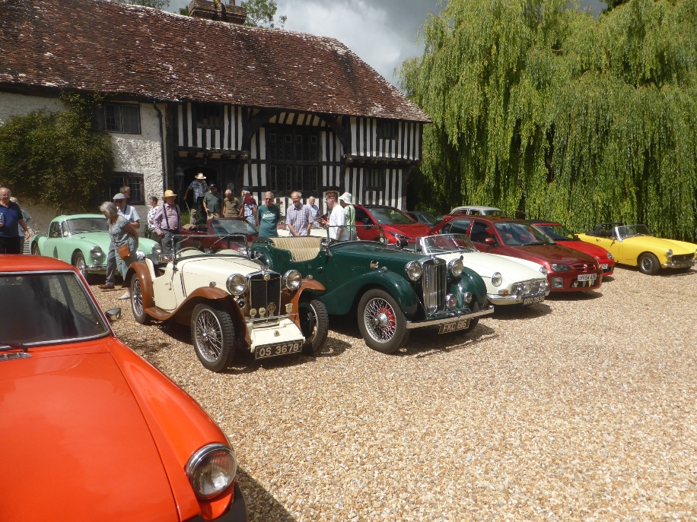
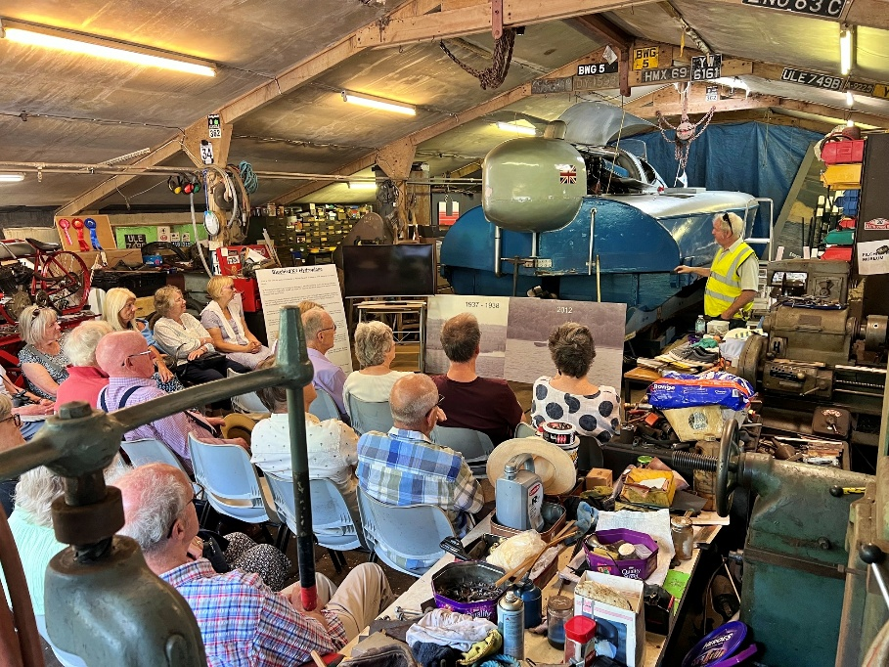
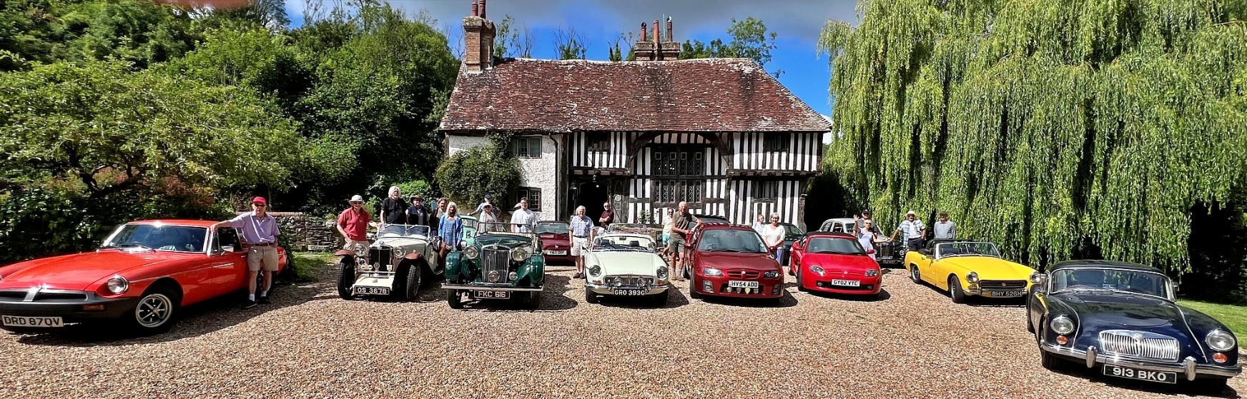
ASHDOWN ADVENTURERS & ASH NATTER
David Oakenfold with Ian Russell

Filching Manor will be familiar to members of the South East Centre as the location of the annual Filching AutoSOLO. The Centre will be back there again next Spring so do keep an eye out for that. However, the club has not visited Filching for the house and museum itself for several years now.
Members from the Ashdown Adventures and the Ash Natter combined to rectify that at the beginning of July.
Filching has a good collection of vehicles and motoring memorabilia, mainly contained in former chicken sheds at the rear of the manor house.
The collection was largely assembled by Karl Foulke-Halbard’s father, Paul, and includes a sizeable collection of Campbell family items as well.
The main feature of this collection is Malcolm Campbell’s Blue Bird K3 Water Speed record boat so recently seen firing up on Lake Coniston. (You will have read about that earlier in Spark).
Another sizeable item in the collection is Gina Campbell’s Agfa power boat but it was, inevitably, K3 that drew the attention.
After it’s outing to the Lake District K3 is now back in its workshop and the group were given a fascinating presentation on the boat, it’s history, restoration and the latest adventures in the north.
It was a good day out and great to get two groups together, as the pictures show, with the cars parked in front of the manor house.
Nice mix of both Natter’s MGs in front of the Manor House
Inside the K3 workshop for a talk on the boat
Gathered outside the front door of the house
Obituary – Mick Breare 1947-2026
It was only in May that Mick Breare and Jo Birkbeck organised the Y Type Register’s Spring run which was based at the Wroxton Country House Hotel near Banbury. Mick organised a fun quiz for them on one of the nights and that is typical of the man he was, always willing to help out.
We last saw Mick just a couple of weeks ago at the first of our Alternative PoO nights at the Doghouse in Walton on the Hill. An occasion where he was proudly showing off his newly restored MG YB and was over the moon at winning the Car of the Show award.
Mick has owned several classics over the year including a Mercedes 280SE, two MGBs, a red 1968 MGCGT and a rare 1963 DKW1000S Deluxe. The latter of which was the subject of a talk he gave to the North Surrey Natter.
He was an accomplished engineer and over the last ten years had enjoyed getting back to MG life particularly with the YB and attending monthly natters at the Doghouse and also with Epsom MGOC. He had enjoyed attending and organising MG events for the club and he and Jo were busy getting lost in France with some of our South East members on the EEOTY recently.
Latterly he and Jo had joined the Y Type Register committee. The Register paid tribute to him by postponing their AGM which was due to take place next weekend (4th July 2026).
Mick had won several awards with the South East Centre including the Social Championship for best attendance at Centre shows and events last year as well as PoO awards for his MGCGT. I am sure that his YB would continue to win awards this year as it was such a fine restoration. He was also given a special award in 2021 for his help with the distribution of the Centre newsletter. In the 1990s Mick and Ros would attend local natters at the Coulsdon Manor Hotel and was a regular entrant in the Alternative PoO. In 2000 and 2001 Mick was also a member of the South East Centre committee when Doug Bush was the chairman.
Mick was born in Lewisham in 1947 and has always been a South London boy finally living in Chaldon. He joined the Metropolitan Police and on retirement stayed on as a civilian with the Police. He was also working as a consultant for an Investigations company in Tunbridge Wells. When not investigating or with the car clubs Mick liked nothing more than a spot of gardening, taking part in his local pub quiz, eating out or just enjoying a pint down his local pub.
Mick’s wife Rosalind passed away in 2021, they were married for 50 years, and he had recently found new happiness with fellow Y Type owner Jo Birkbeck. Our condolences go to her and to Mick’s family.

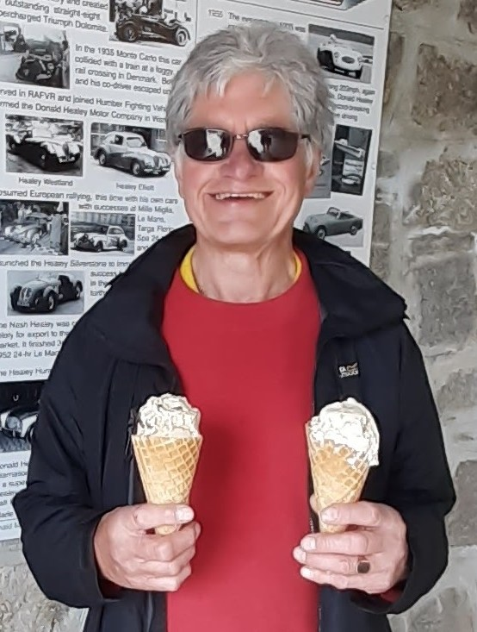

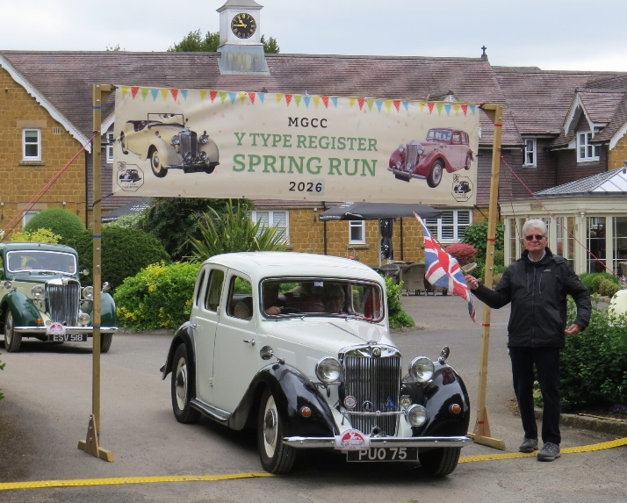
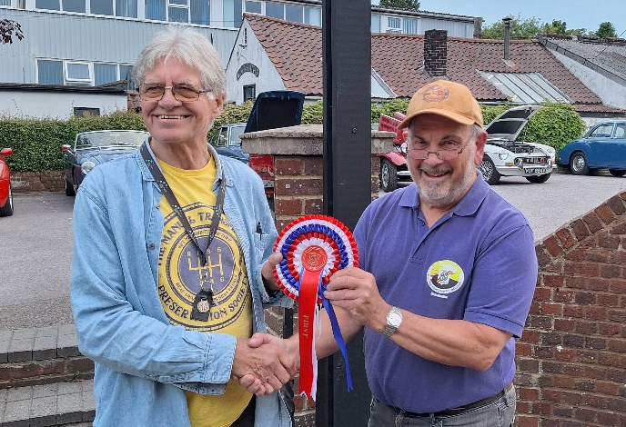
Mick waving cars away at the Y Type Register Spring Run
(Y Type Register)
Mick received the car of the show award at the Alternative PoO in June
Mick never did things by half – including ice creams (Y Type Register)
For Sale and Wanted

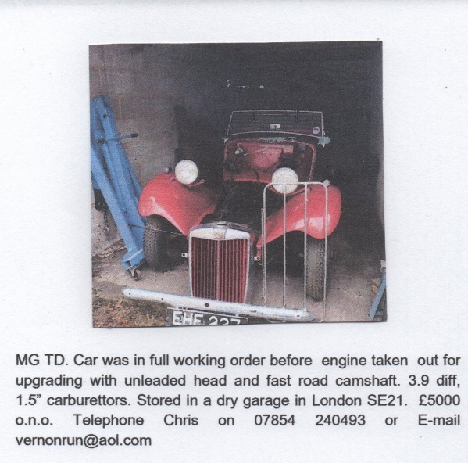
Y-type MG, 1947 in two tone green
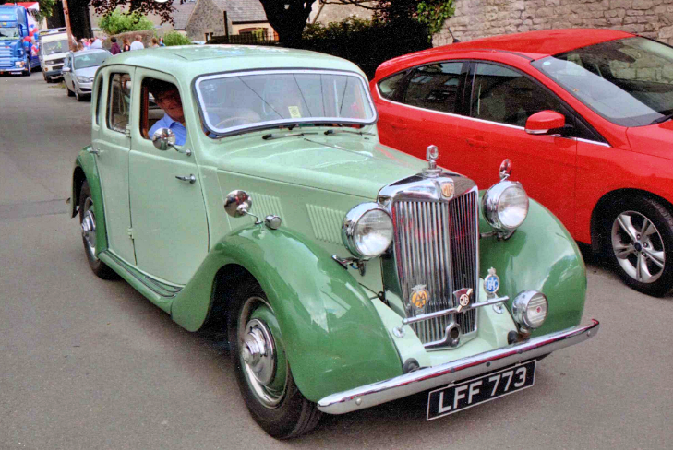
In A1 condition bodily and mechanically. Body refurbished 2013. Engine overhaul by George Edney 2019. Dry stored in controlled environment. Used for trips abroad, as well as Y-type meetings. £9,000 ono. E-mail for more details and restoration photos, jbghorgan@gmail.com or billjantaylor9@gmail.com

TD Almost complete for sale- see below

Offers invited – for you to inspect at and collect from –
THE VILLAGE GARAGE , East Grinstead .’
RH19 2HG,
Where the items are securely stored .
01342318080- ask for Adam
Or email – enquiries@the village-garage.com
OPEN TO REASONABLE OFFERS .

MGC Parts for Sale

MGCC MEMBER has a large quantity of C and B spares for sale – surplus to requirements after C GT rebuild .
Many new and boxed .
Many original used but serviceable .
Too numerous to mention but include-
Fibre Glass Sebring valances front and rear.
Original C steering wheel – leather intact.
Chrome rocker cover.
Chrome sill covers – Chrome C door treads.
Passenger side quarter light .
Useable drop glass and rear GT glass- including tail gate .
Unused red seat belt kit.
New Headlights Various .
Original Sunroof wind deflectors .
Boxed C flywheel .

Engine side water jacket plate £12
Lucas windtone horn £10
Altette horn (working) £20
12volt coils (checked OK) £18 each
Bonnet hinge rear support bracket £5
Gearbox support bracket £12
Engine fan belt pulley £15
Wheel hub covers 3N0. £8
A steering column support plate £4
4.00 x !9 Dunlop tyre 5mm tread £18
4.50x 19 Dunlop tyre (4mm tread) and wheel £25
4.75/5.00 x 17 tyre (5mm tread) on centre spoked wheel £25
4.00x 19 Firestone tyre (6mm tread) £18

Contact Philip Bayne-Powell on 01483 811428 or e-mail 1942mgman@gmail.com

TD / Y Type Parts for Sale

Y-type Distributor DKYH4 type DA36 anticlockwise £20
TD bulkhead support brackets black powder coated £15
TD/TF/Y steering rack gaiters new £15 pair
TD used rear springs £18 pair
TD brake and clutch pedal on shaft £15
TD starter motor £20
TD anti roll bar rubbers £12
TD front hub spacers £5
Y-type exhaust manifold £20
Y-type inlet manifold £15
Y-type air cleaner manifold £15
Y-type accelerator pedal £8
Pair 7” stoneguards £15
For Sale and Wanted
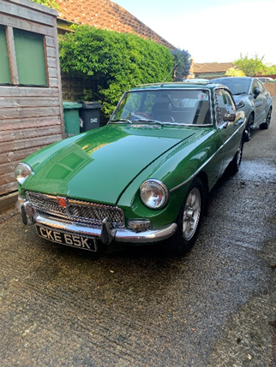
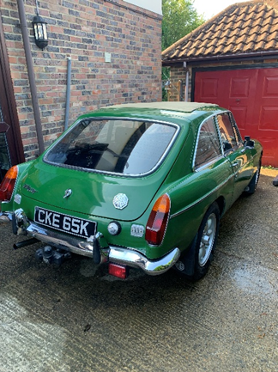
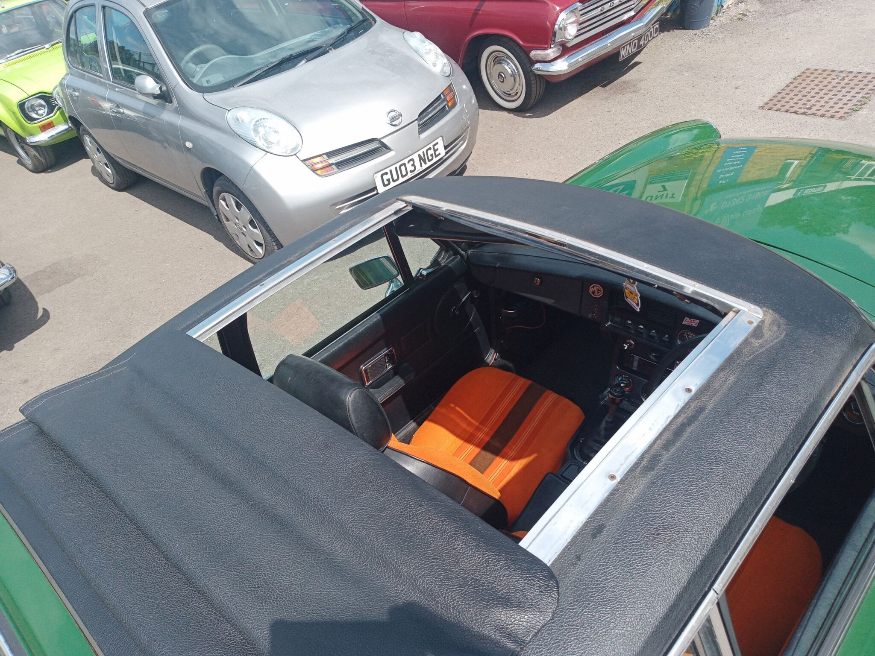
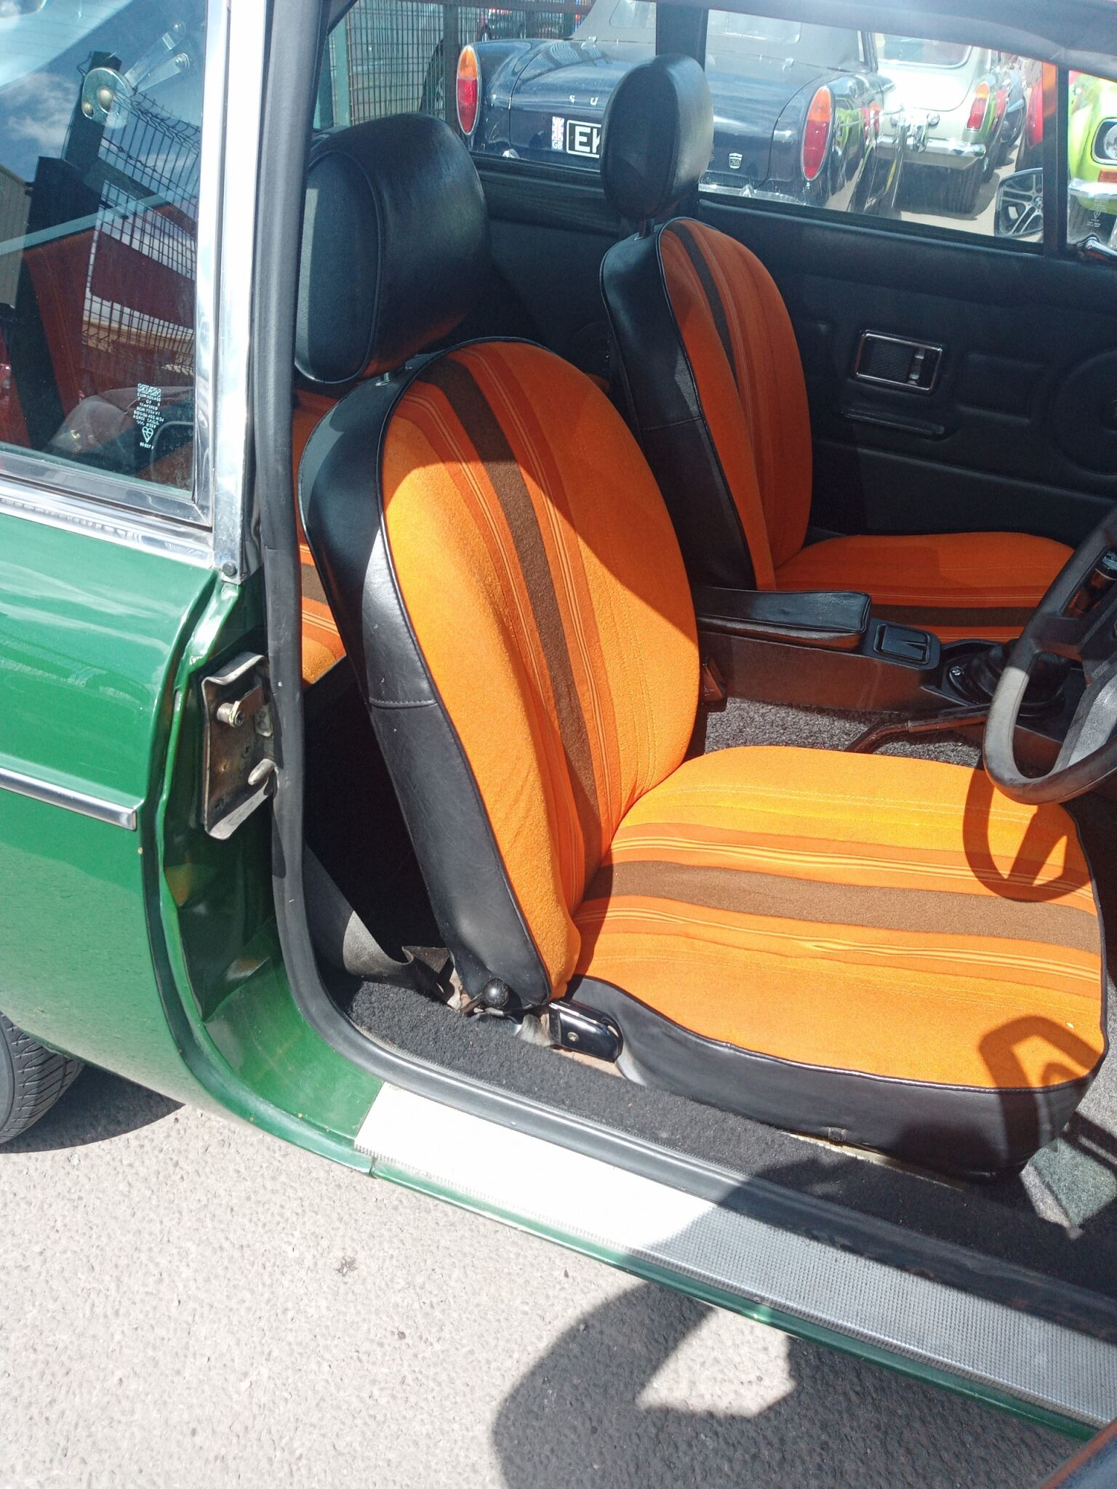
For Sale £4000 1978 MGBGT full service new front callipers
Excellent condition. Contact Village Garage East Grinstead.
Contact Adam 01342318080 email enquiries @thevillage-garage.com
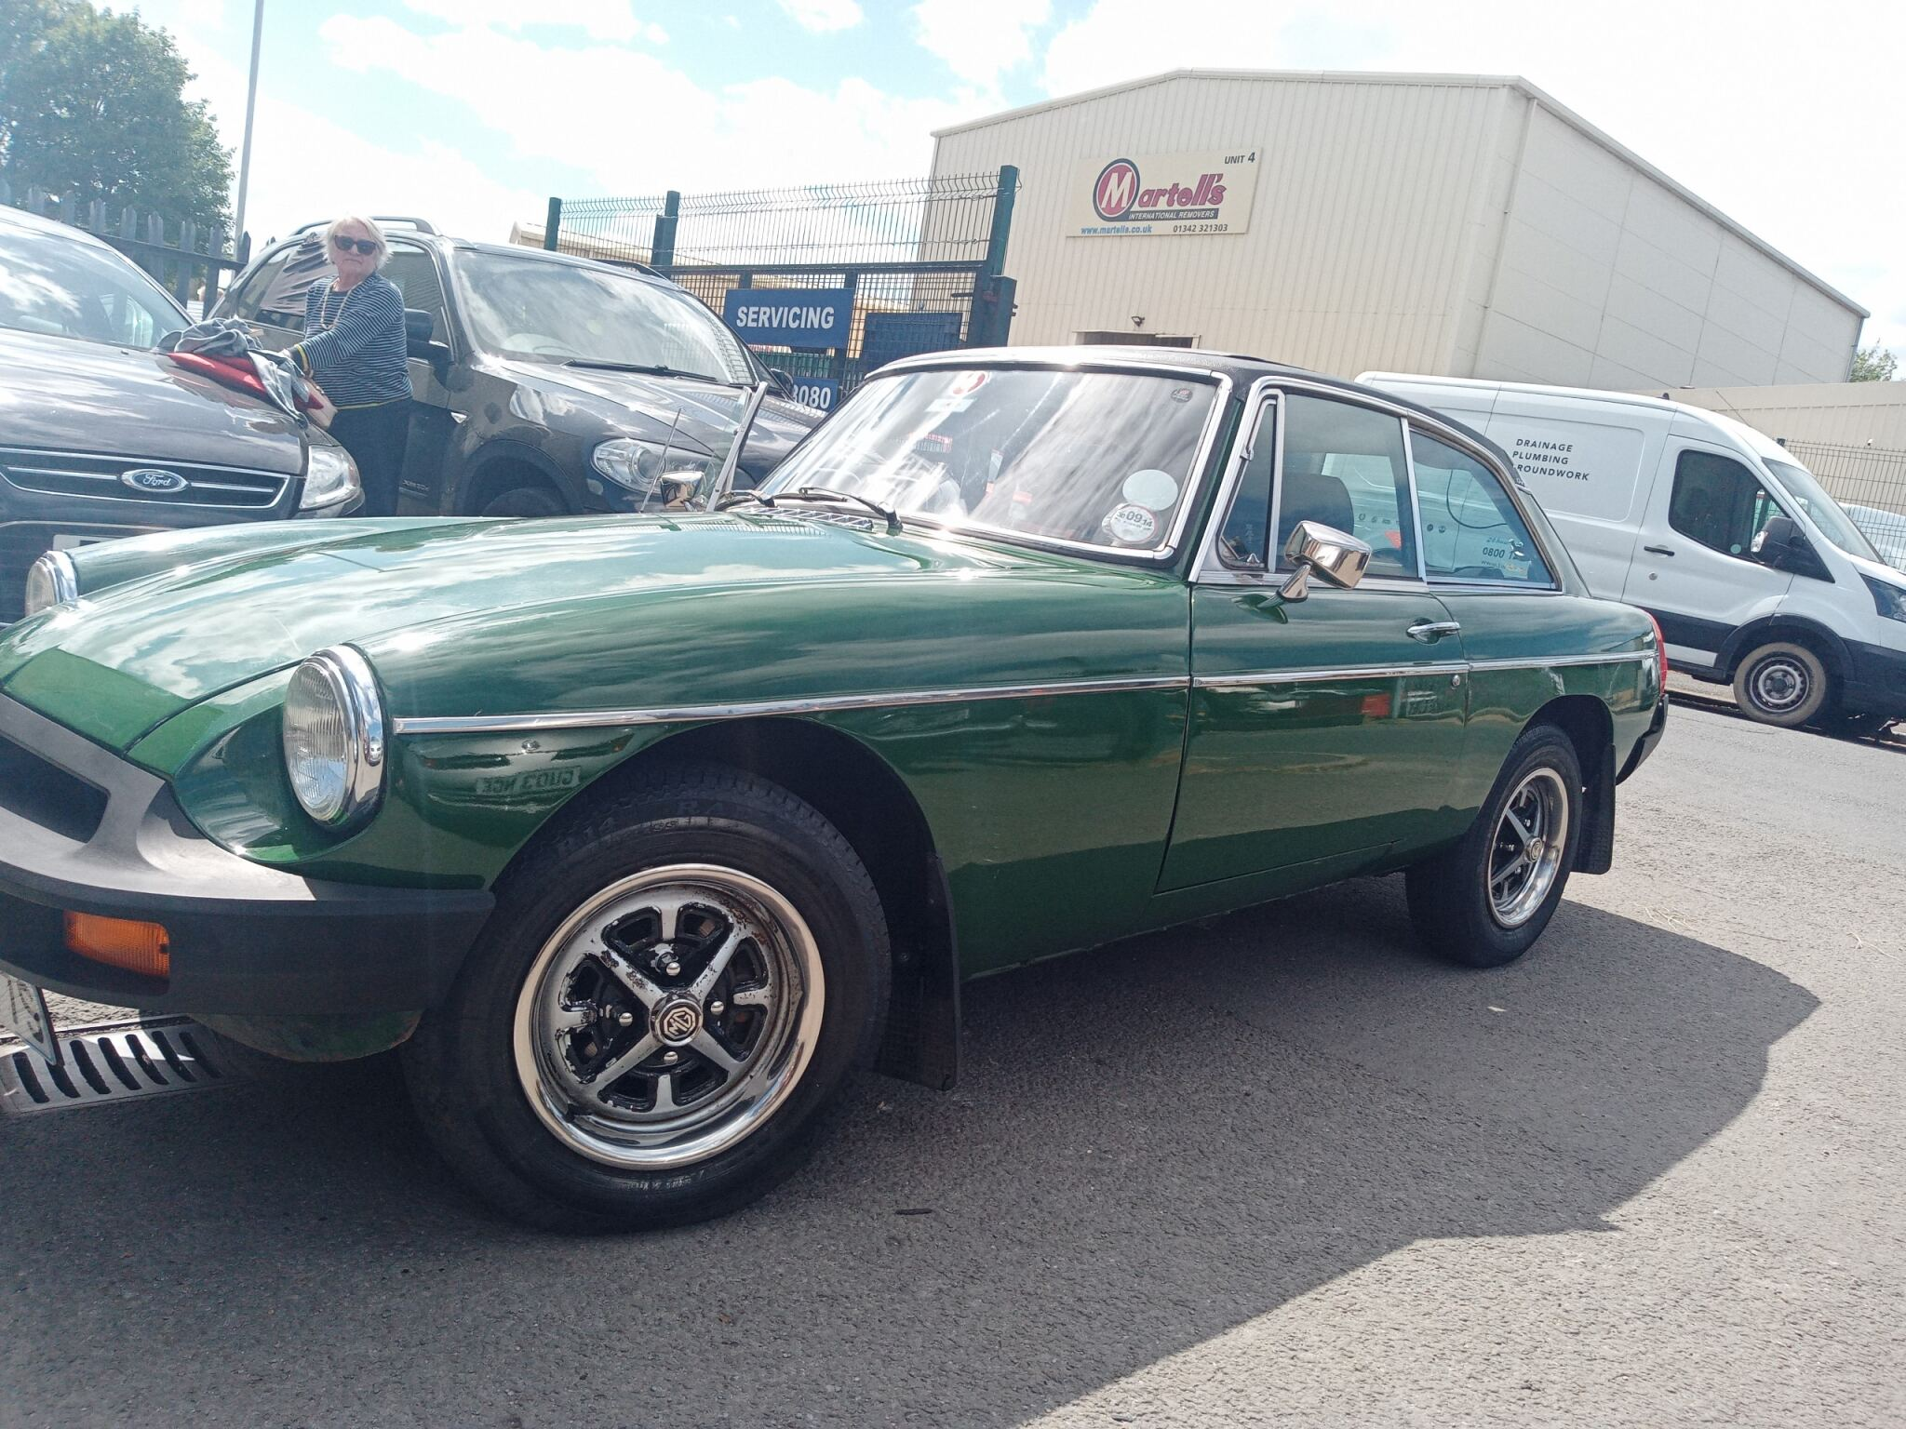
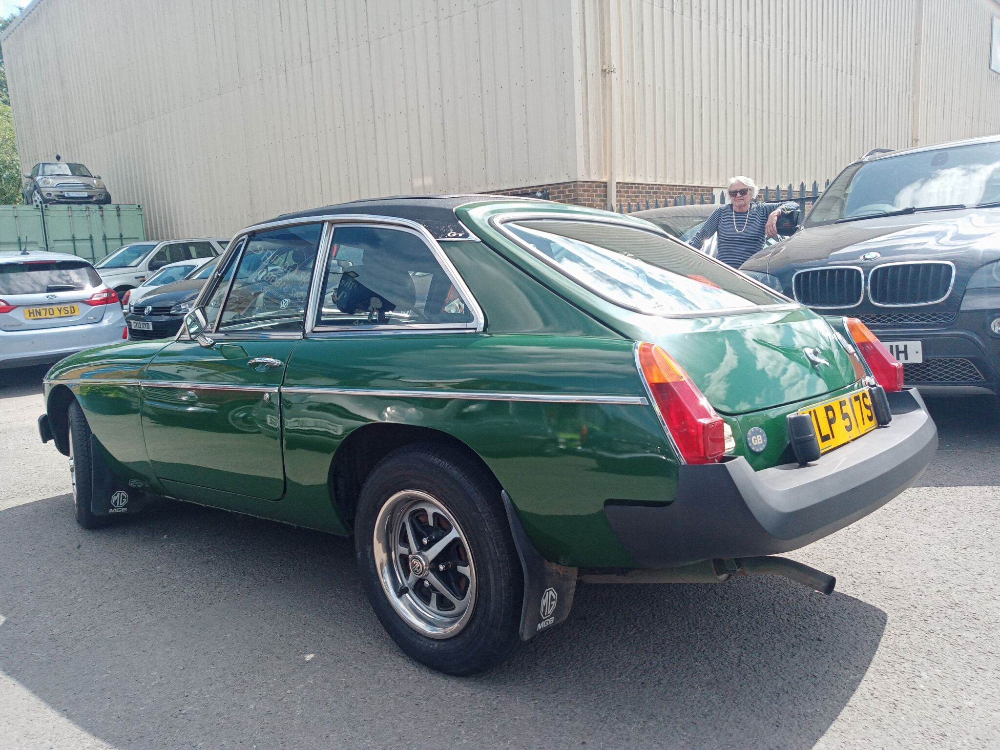
MGB parts for sale…….Prefer to sell everything as a “job lot”
Offers Invited contact John Clark on 07940769225 Canterbury area
14” woodrim steering wheel, ally spokes, no boss used but good/Pair Halogen fog lamps, horizontal type new/Pair Lucas Silver Sabre driving lamps with covers. New old stock/Smiths RVI Tacho 4”, 0-7000 used but good/Smiths speedo 4”, 0-120mphused but good/Smiths vacuum gauge with coloured segments used but good/Smiths oil pressure gauge 0-100psi. used but good/Yazaki ammeter -30 to +30 used but good/Smiths oil pressure gauge 0-100 psi New old stock/Smiths Dual oil/ temp gauge used but good /Twin SU inlet manifold used but good/Pair HS4 1.5 inch Carbs…suitable for refurbishing used but good/Overrider with rubber pad X2 New old stock/Overrider with number plate lamp X2.used/Overrider (plain) X2 used/Lucas rear lamp units…PAIR….Good Chrome used but good/Set MGB/ MGBGT Carpets used but good/Hub Bearing Kit….Unipart GHK 1005 New/Universal Joint….Unipart GUJ 101New/Choke Cable….Austin Rover...CHA 288 New

1972 MGBGT
My ownership since 2020 but now need to reduce the fleet. History available back to 2000
Working sunroof | Power steering | Electronic ignition | 5 speed ‘box | Alloys 2012 | New Blockley tyres 2020 | Revotec electronic fan 2022 | New wiring loom 2022 | New battery 2023
Bodywork could be improved hence only £5,750.00
Contact austin.banner@gmail.com

SE CENTRE TEAM
Chairman Tim Morris 07801 591689 chair@mgccse.co.uk
Secretary Austin Banner 07850 769506 secretary@mgccse.co.uk
Events Secretary Andrew Mitchell 07703 138419 events@mgccse.co.uk
Vice-Chair/ Competitions John Morgan 07802 770025 competitions@mgccse.co.uk
Treasurer Ron Kemp 07726 326070 treasurer@mgccse.co.uk
Membership Diana Calvert 07762 163617 membership@mgccse.co.uk
Scribe – Safety Fast Ray Ruffels 07970 640219 scribe@mgccse.co.uk
Scribe - Spark Editor Will Opie 07768 022044 spark@mgccse.co.uk
Internet Tim Morris 07801 591689 webmaster@mgccse.co.uk
Trophies/Archive John Davies 01737 241971 trophies@mgccse.co.uk
Regalia/Shop John Morgan 07802 770025 regalia@mgccse.co.uk
Natter/Wanderers Ian Russell 07590 498514 mgashnatter@gmail.com
General Assistant Philip Roussel-Smith 07719 196199 PhilipR-S@mgccse.co.uk
Member Lis Woolley lis.woolley@mgccse.co.uk
Member Gwen Davies 01737 241971 gwen.davies@mgccse.co.uk
NATTER LEADERS
Queen’s Head Pinner Gerry Edwards 07768 657797 Pinner@mgccse.co.uk
The Ship, Mortlake Danny Byrne. (On hold) 01932 829814 Mortlake@mgccse.co.uk
Brooklands Museum “ “ Brooklands@mgccse.co.uk
The Dog House Walton John Morgan & 07802 770025 northsurrey@mgccse.co.uk
on the Hill Austin Banner 07950 769506 northsurrey@mgccse.co.uk
The Fairmile, nr Cobham Ian Ailes & 01932 856960 Cobham@mgccse.co.uk Jon Glover 07802 318950 Cobham@mgccse.co.uk
The Red Lion, Charing William Opie & 01795 521846 NorthDowns@mgccse.co.uk Ray Ruffels
The George Inn Trottiscliffe. Wendy Wooster Ashnatter@mgccse.co.uk
The Golden Lion, Broadoak John Clark 07940 769225 Broadoak@mgccse.co.uk Canterbury.
George & Dragon, Tudeley John Morgan 07802 770025
South East MGF Register Tim Morris 07801 591689 south.east@mgccmgfregister.org
WANDERERS
Ashdown Adventurers David Oakenfold 07818 420921 AshdownAdventurers@mgccse.co.uk
Sussex Wanderers Ursula Griffiths 01403264458 SussexWanderers@mgccse.co.uk
Surrey Wanderers Philip Bayne-Powell 01483 811428 Surreywanderers@mgccse.co.uk
East Kent Wanderers Ian Russell 07590 498514 Eastkentwanderers@mgccse.co.uk
Kent Nomads Ian Russell 07590 498514 kentnomads@mgccse.co.uk
MG Car Club South East Centre web site – http://www.mgccse.co.uk
Register Office: Kimber House, PO Box 251, Abingdon, Oxfordshire, OX14 1FF
Phone: 01235 555552, Fax: 01235 533755, email: mgcc@mgcc.co.uk

Get in Touch

In the Heat this Summer!

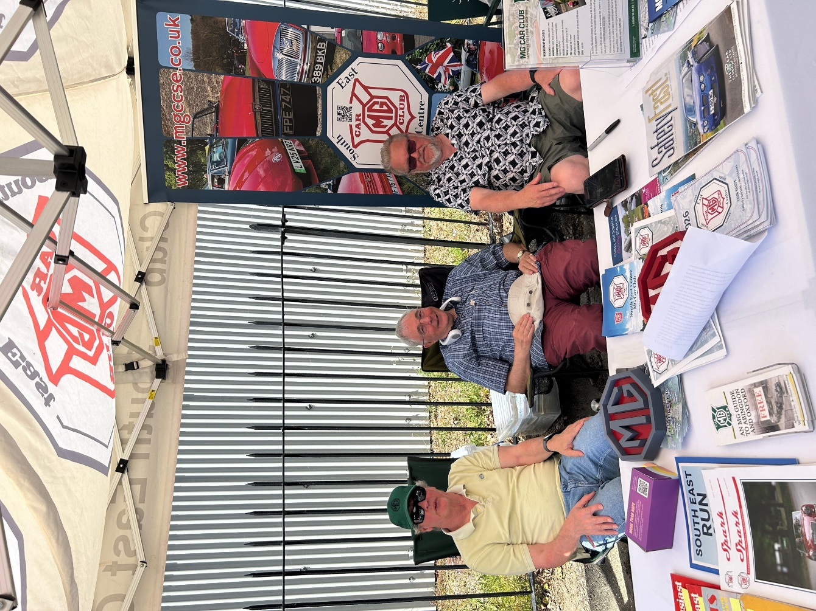
Jon Glover caught members of the Committee in action!
Well, that is up for debate in the heat at Brooklands Best of British!

From Left to Right
Philip Roussel-Smith
Austin Banner
Tim Morris
Spark 6 was brought to you by:
Tim Morris, Will Opie, Jon Glover, John Clark, Ian Ailes, Gerry Edwards, David Oakenfold, Ian Russell, Andrew Ratcliffe, Andrew Mitchell, John Morgan, Richard Harvey, Church Square Autos, Robin Lackford Engineering
SPARK Issue 6 Summer 2026
Editor : Will Opie
Deputy : Tim Morris

Spark is produced by the MG Car Club South East. All opinions are those of the contributors and not of the club or editors. The MG Car Club or editors cannot accept any responsibility or loss occasioned to any person acting or refraining from acting as the result of any material in the magazine including any mechanical or other modifications to vehicles.
Photos are original author’s collections. Credit given if source known or photograph licenced.
Copyright MG Car Club South East 2026.
I hope you enjoyed this edition!
Your contributions are invaluable from all directions, and I want to thank contributors for their input. We welcome any comments on this magazine and any articles.
If you wish to contribute to the Autumn 2026 edition, then please get in touch with the editorial team at:- Spark@mgccse.co.uk
Many Thanks - Will Opie , Editor Spark Magazine
Tim Morris – Deputy Editor

Retro Spark
Spark keeps you up to date with the modern world of the MG Car Club, but the club’s history goes back much further so each quarter we’ll end up with a look back at the South East Centre… in the past.
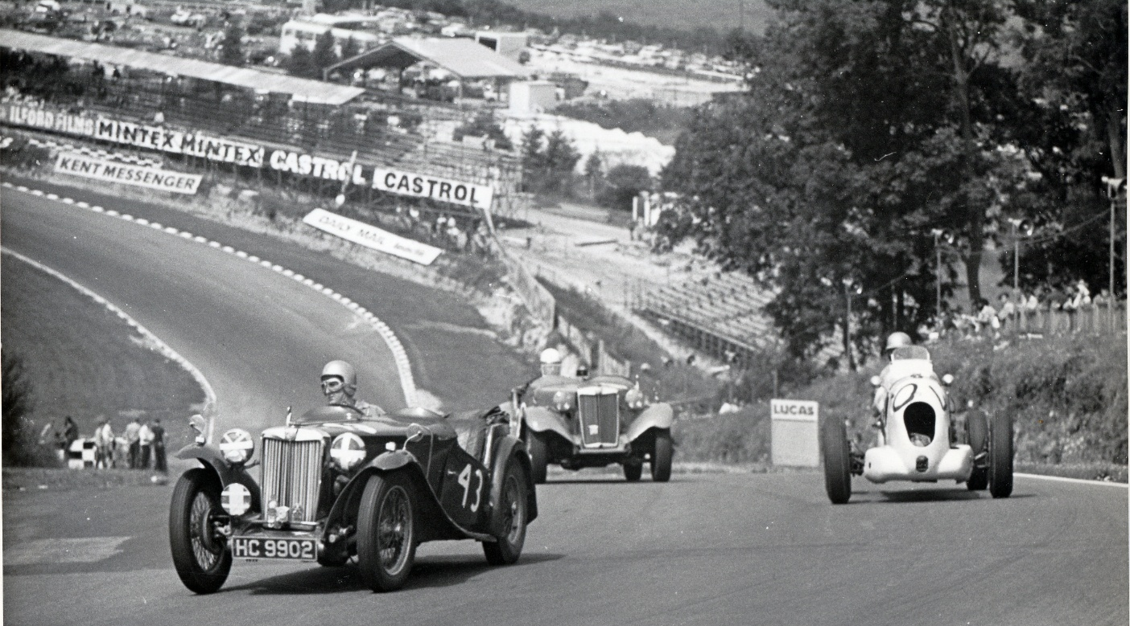

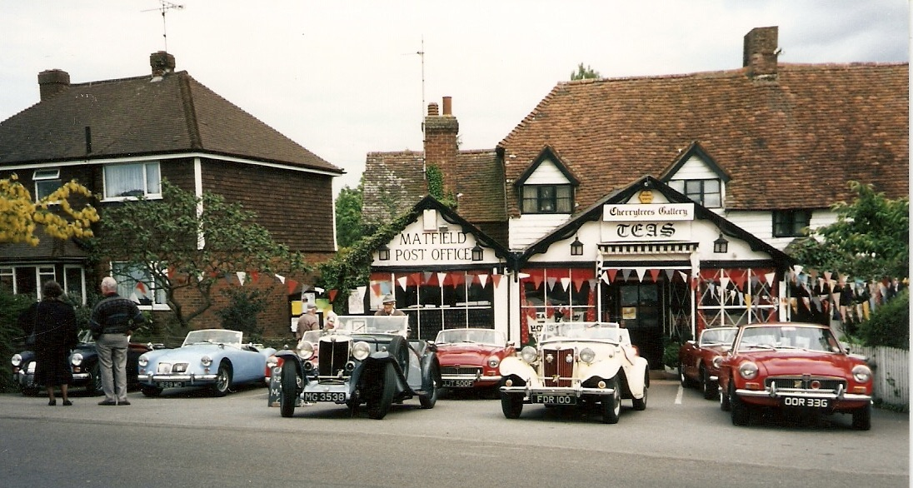
The Regular Speldhurst Cream Tea run organised by the wonderful Grahame White of the Speldhust natter at the finish in Matfield some time in the 1980s
South East MG Car Club Register race at Brands Hatch 1966 – we’ll be back there on August 16th for the first time in many years with MG Fest ‘26

