

Chiddingstone Castle & Gardens
Sunday 17th August 2025
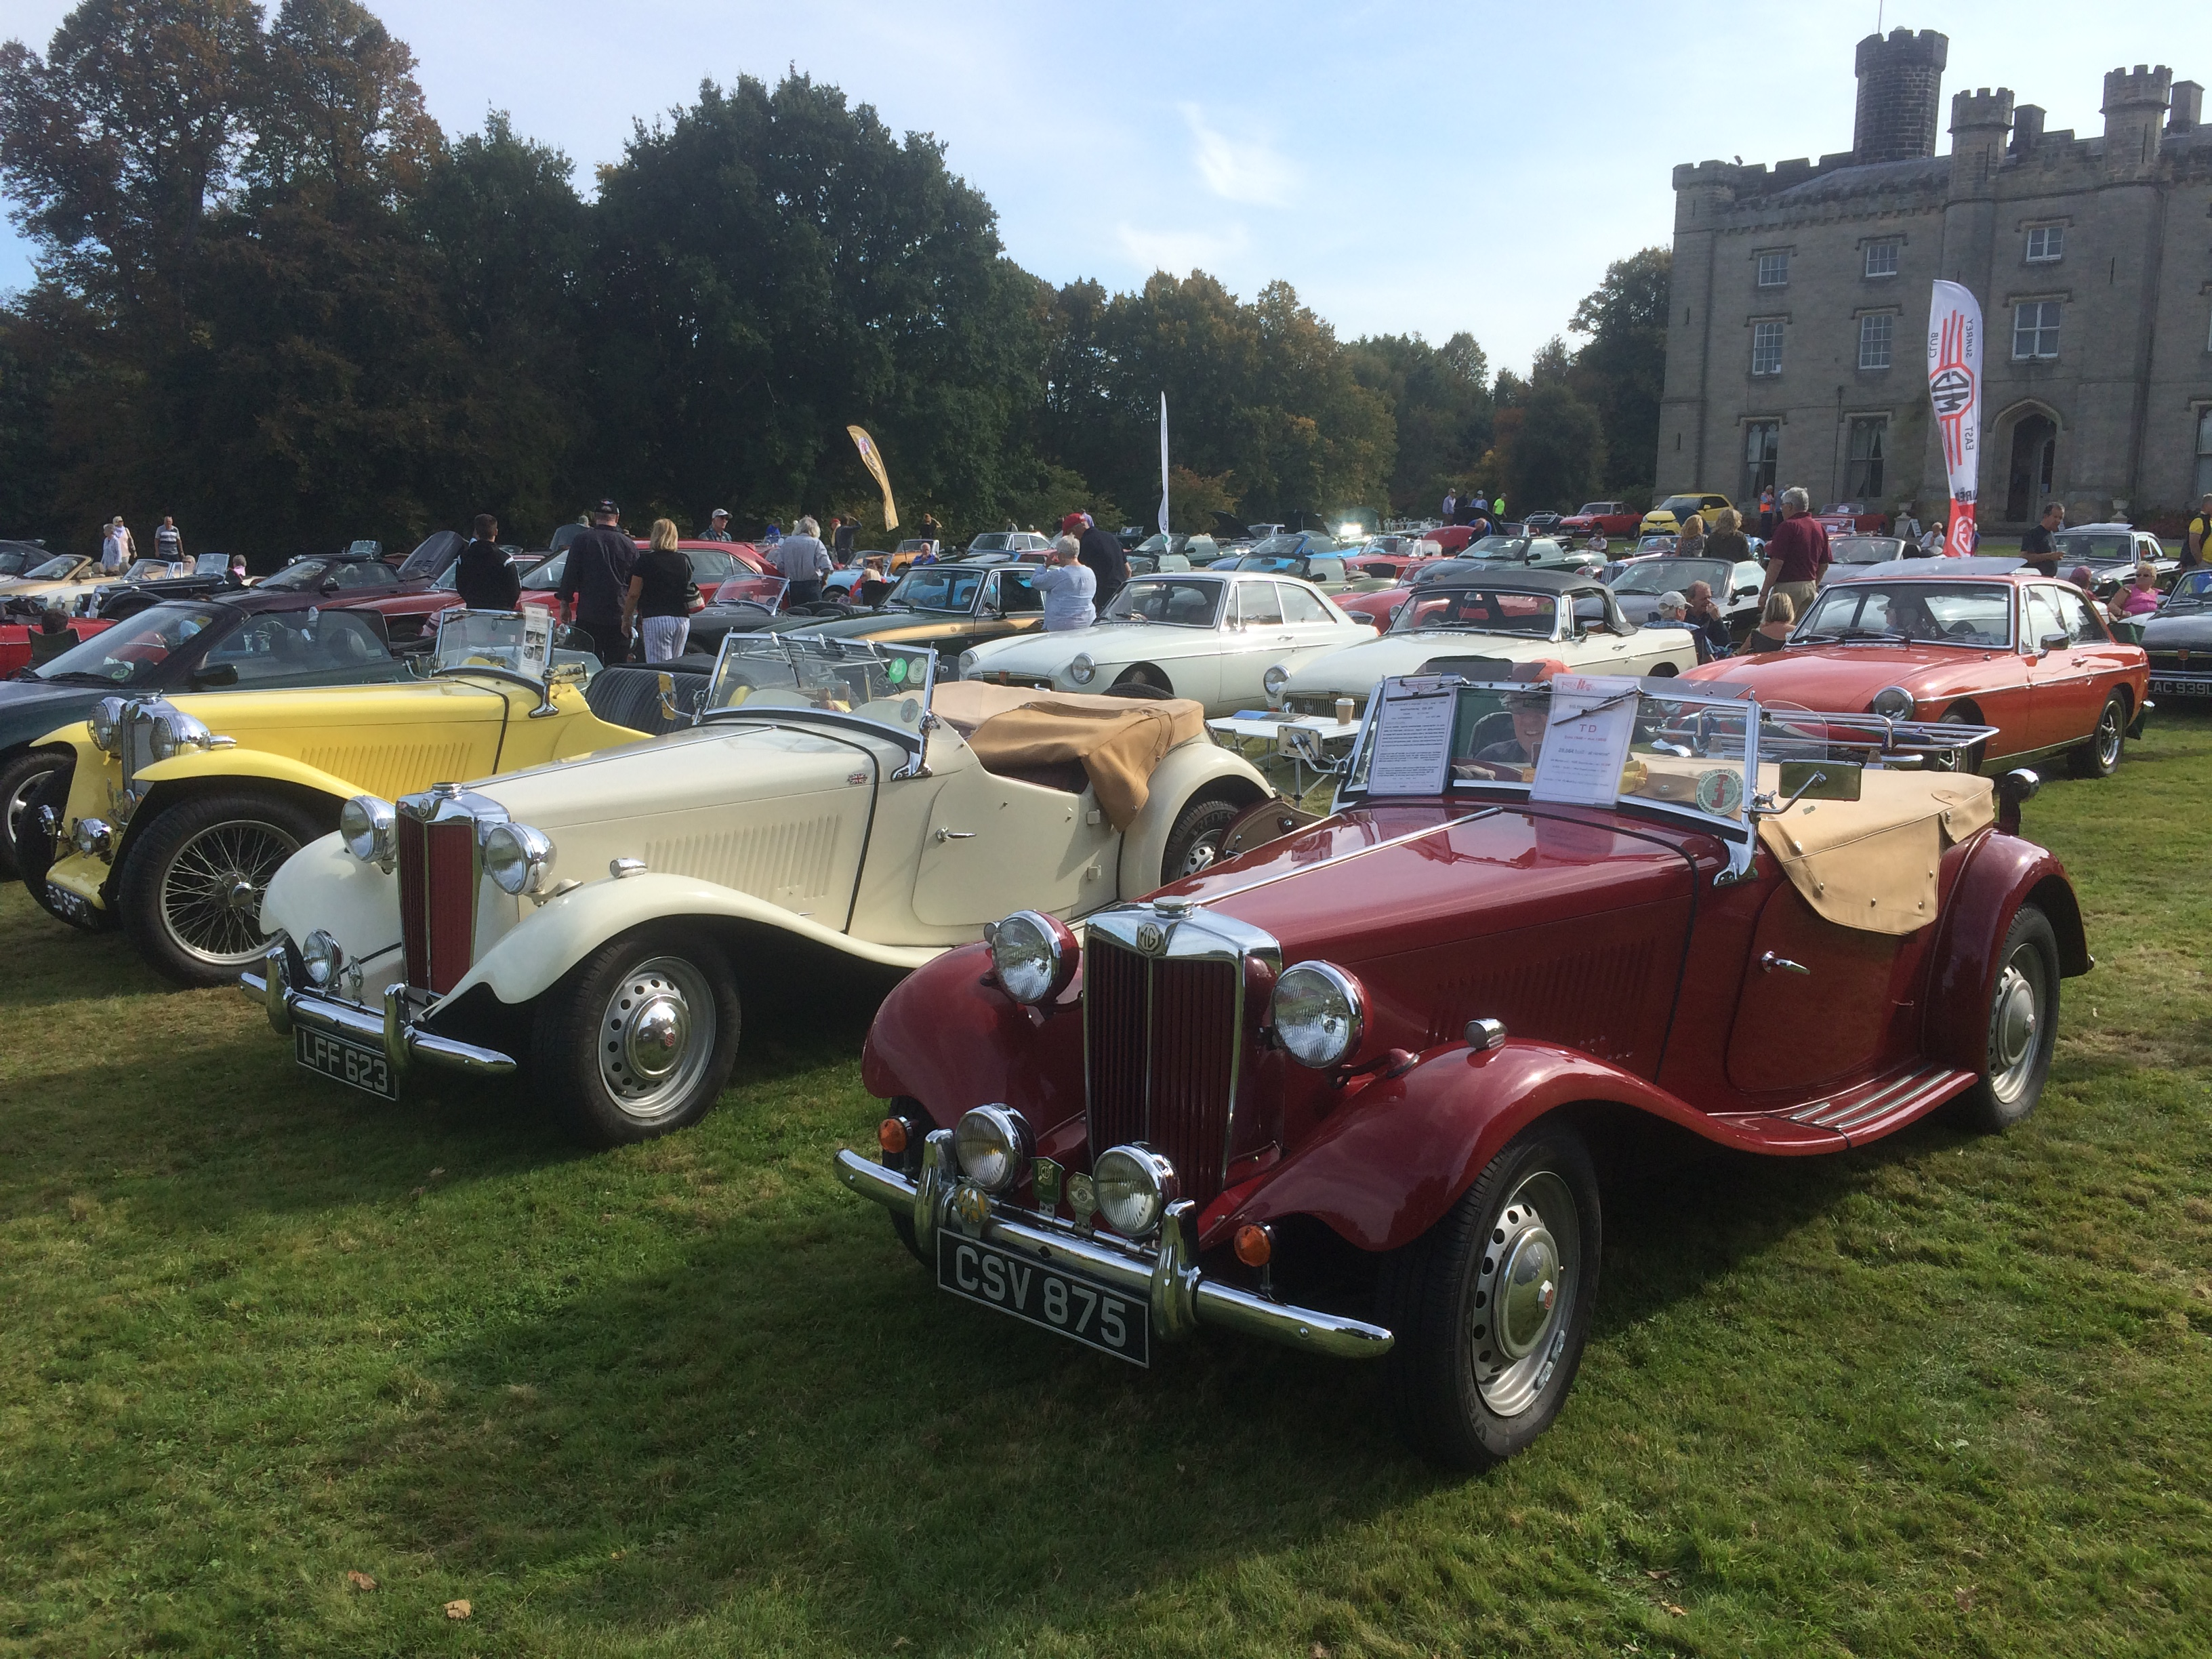
Chiddingstone Castle, Hill Hoath Road, Edenbridge, Kent, TN8 7AD
Last visited by us back in 2017; Chiddingstone Castle and Gardens, nestled in Kent nr. Hever & Penshurst, consists of a Grade 2 listed historic house with over 400 years of history with an extensive collection of ancient Egyptian, Japanese, Jacobite and Stuart and Buddhist objects.
Park up on the large flat lawn in front of the castle and show off your MG whilst enjoying a picnic and then visit the castle or stroll over to the historic Castle Inn pub & Chiddingstone village just over the nearby footbridge where lots of famous films, like “Room with a view”, were also filmed.

All of this comes at a discounted price of just :-
£10.00 / Car (Based on a car with up to 5 persons) – £13 / Car Non-Members – inc. Scenic Run into Chiddingstone, Lawn parking ONLY, Free entry into PoO, Concours, Prizes, Rosettes etc.

(Optional) Additional £11.00 / Person for Castle Entry - £13 / Person Non-Members.

Above prices Include :- Free entry into all gardens, woodland, Tea Rooms and Shop
(Well behaved Dogs are allowed in ALL the gardens & grounds)

To Enter :-
Go to our website and register at:- https://www.mgccse.co.uk/?p=11894
Or email Andrew Mitchell :- mgccse.event@gmail.co.uk (07703 138419) to confirm entry:-
Name; Car; Contact Number; Email Address & MGCC Membership number (If a member)
NB:- ALL Entries CLOSED by Sunday 10th August 2025

