MGCC Abingdon Works Centre: MG 100 Cavalcade Entry Form
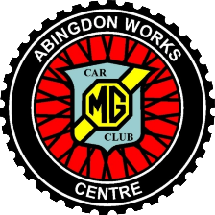 | 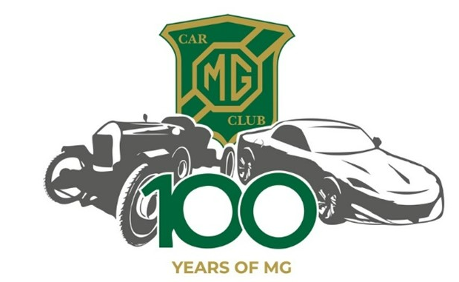

Driver: |  |  |  |  |  |  |  | MGCC membership number:
Passenger (1): |  |  |  |  |  |  |  | Passenger (2):
Car make & model: |  |  |  |  |  |  | Year: |  |  |  |  | Registration:
Home address:
Tel (home): |  |  |  |  |  |  |  |  | (mobile):
Email:

Choose your AWC Centre leg selection |  | √ Tick the appropriate box
Day 1: Wed 15th May | Gaydon to Abingdon
Day 2: Thur 16th May | KH to Brown & Gammon
Day 3: Mon 20th May Brooklands to Beaulieu

A Map style route book and a Cavalcade Rally Plaque will be supplied to members entering one or more section/leg of the Cavalcade.

There is no entry fee for participating in the Abingdon Works Centre’s Cavalcade events, but we hope you will be generous by supporting one, or both, of the very worthy official event charities being Lupus UK and the Alzheimer’s Society. The amount you donate, is of course, entirely at your discretion but we respectfully suggest a minimum of £10 per day. Collection boxes/buckets will be available at the start and finish of each run so please remember to bring some cash!

All three days runs are covered by a Motorsport UK Certificate of Exemption for a Touring Assembly permit number 135828, therefore, pre-booking and signing-on (for both days) are mandatory requirements for insurance cover.

The Abingdon Works Centre is only accepting entries for the AWC legs.
‘Safety Fast!’ March 2024 provides an overview of the entire (JOGLE) event.

The Abingdon Works Centre website is your ‘go-to’ reference covering all required and anticipated information under the MG100 Cavalcade menu tab.

Email your completed entry form to: ian.wright@mgccawc.co.uk or post to 27 High Street, West Wycombe, Buckinghamshire, HP14 3AB
Closing date for entries: Saturday 11th May

