The Provisional SE Centre 2023 Calendar will be tabled at the 2023 AGM in February 2023 and the dates will be available on the SE Centre website.
Looking back to 2022, the SE Centre continued to promote some grass roots competition and competitive events. All the events were reported on both the SE Centre website and in the newsletter, but here is a brief summary of the year’s activities:
- The Valentine Treasure Hunt on 13th February to be organised in the area South West of Reigate in Surrey. This event is a joint event with Epsom MGOC who are organising it this year.
- An Autotest Taster day event on Saturday May 8th in Kent, again at the invite of MMKMC. One or our members entered.
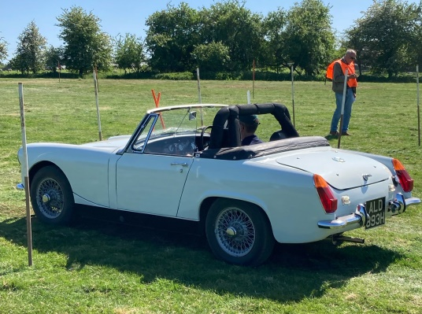 | 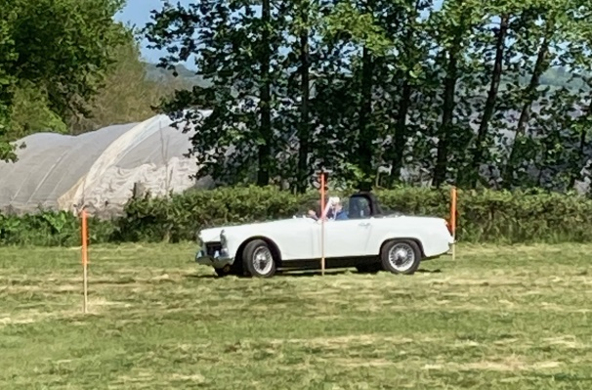
- Two Production Car Trials on 27th March and 30th October organised by MMKMC were supported. The Spring event was supported by three T Types and an MGNB and the Autumn event had just two MGs entering due to clashes with other events, a MGNB and TD.
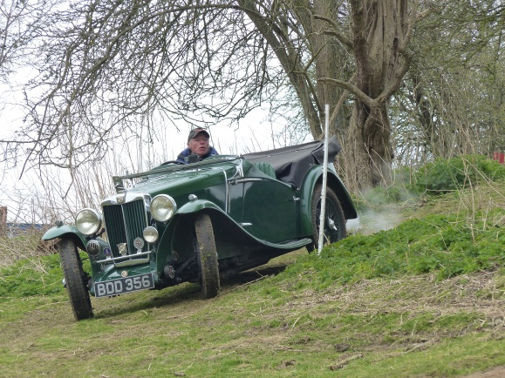 | 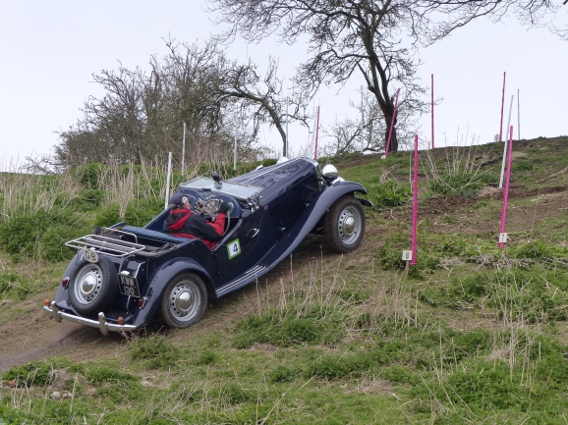
- The Spring and Autumn Naviscats took place on 20th March and 2nd October. Spring event was held in Sussex with 16 cars and the Autumn in West Kent near Sevenoaks with 12 cars.
- The Spring Gathering was held at Filching Manor, near Polegate in East Sussex and the event included both a Touring Assembly and Concours and Pride of Ownership competition.
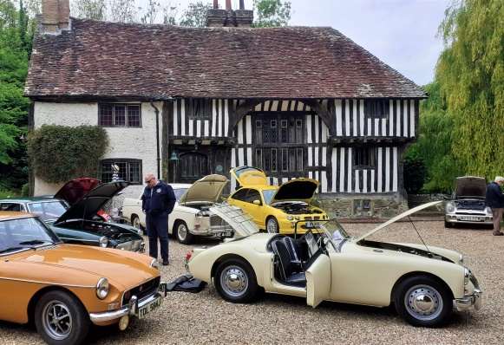 | 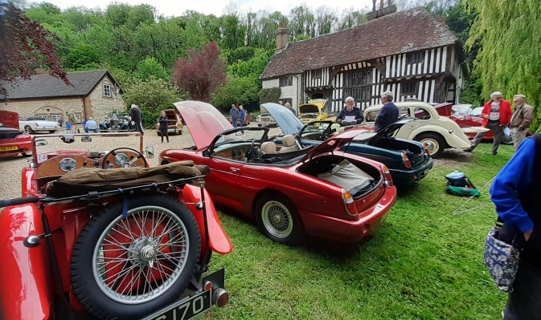

- Two Touring Assemblies were held, one in East Kent taking in Battle of Britain sites and the other in West Sussex visiting various windmills with the South Downs area.
- The Autumn Gathering was held at Belmont House and Gardens near Faversham, Kent and the event included both a Touring Assembly and Concours and Pride of Ownership competition.
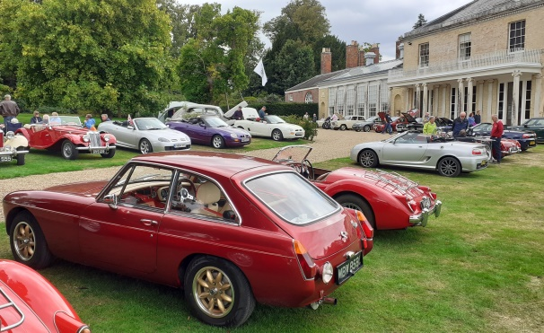 | 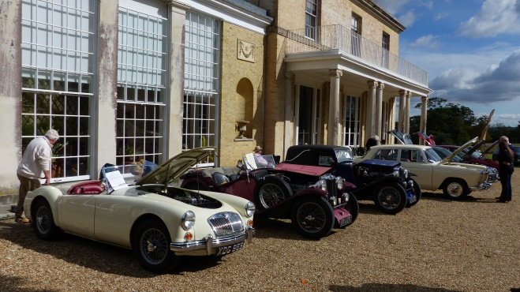
- At the end of the season, a Black Horse Autumn Leaves Run with Scavenger was held on 16th October centred between Horsham and the South Downs.
The MGCC held their Spring Race Meeting on the Indy Circuit at Brands Hatch. Later in the year MGs on Track held two Trackday events in the SE Centre, one at Goodwood Race Circuit on Monday 24th October and another at Brands Hatch on Monday 5th December.
The SE Centre continued to participate with the Association of South Eastern Motor Clubs (ASEMC) and this will allow the SE Centre to receive invitations from numerous motor clubs from all over the SE region.
The SE Centre continued to support the MGCC main club working party and the set of event guides were completed and released in April 2022. This involvement continues to monitor any updates from Motorsport UK to ensure the correct guidance is available on the Club website for all CRBs. It should be remembered, that events run under Motorsport UK Permits/Certificate of Exemption are fully insured by Motorsport UK. This requires events to be planned in accordance with the Motorsport UK ‘Blue Book’ that summarises the rules and obtaining permits/Certificate of Exemption ensure compliance with the Road Traffic Act/Motor Vehicles (Competition and Rallies) Regulations. Any other events such as Natter activities or Social Runs rely on the MGCC club insurance.
If you would like any information on how to take part, what is involved, what events are being organised, or what invitations the SE Centre has received, then either email me on competitions@mgccse.co.uk or give me a call on 07802 770025.
John Morgan – Competition Secretary

