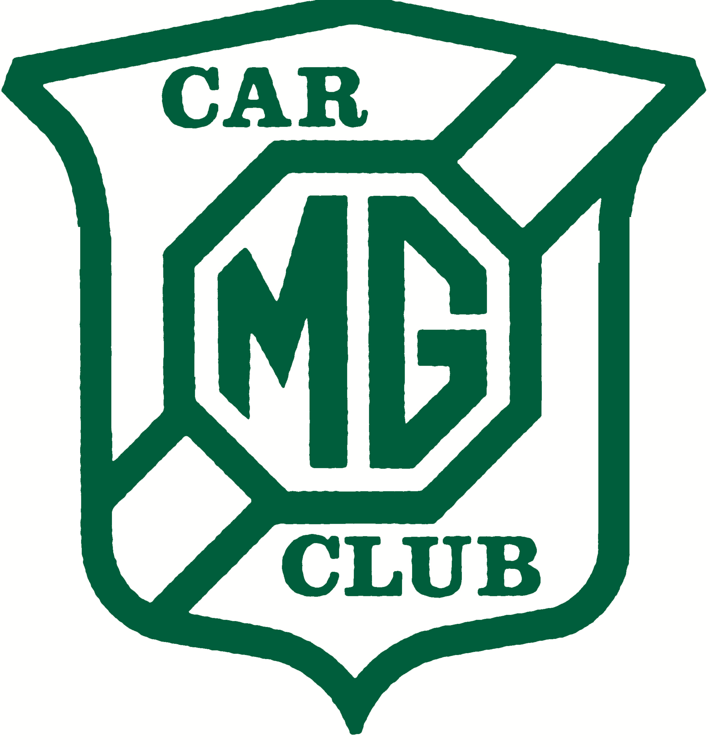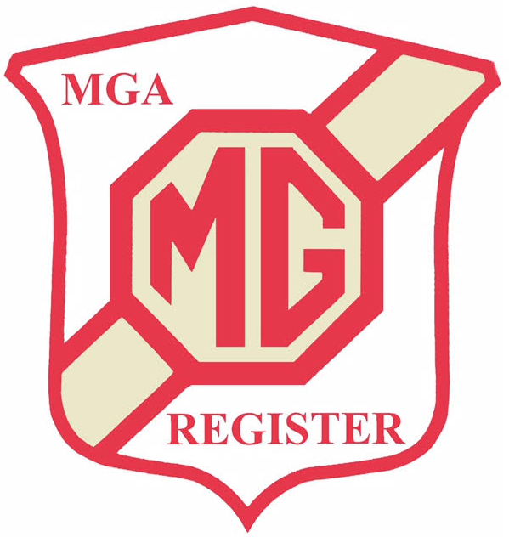
MG CAR CLUB, MGA REGISTER
AUTUMN TOUR 2022
CHICHESTER PARK HOTEL, CHICHESTER, WEST SUSSEX
30th SEPTEMBER – 2nd OCTOBER 2022

The Chichester Park Hotel will be our base for the Autumn Tour 2022. The hotel is an independent family run hotel with leisure facilities, spa bath, sauna and solarium. Situated on the outskirts of the city of Chichester it is an ideal base for discovering and exploring the county of Sussex. From stately homes, to breath-taking beaches, the South Downs National Park with its rolling hills, harbours and market towns, it is one of the UK’s most diverse counties. 50 rooms have been reserved for us.

We will also have an opportunity to visit Goodwood Race Circuit. The track is the only classic circuit in the world to remain entirely in its original form. Racing was held here between 1948 and 1966 and legends such as Stirling Moss, Jim Clark and Sir Jackie Stewart all raced here. We have been offered parking in Paddock 3 which will be an ideal photoshoot opportunity for all the cars together. We can view the historic buildings and watch cars on the track while we stop for a coffee/lunch break.

The booking details are as follows:

Friday, Saturday, Sunday rates will be the same and include Gala dinner on Saturday.

Dinner, Bed & Breakfast £140.00 double per night. £105.00 single per night
Gala Dinner only for people staying elsewhere. £45.00 per person.

Entry Details

The hotel requires a minimum of 2 nights booking.
A deposit of £50 per person will be required.
The Hotel will collect full charge for the weekend 4 weeks before event.

Cancellation policy as follows:
- Up to 8 weeks prior to the event – 100% deposit refunded
- 4-8 weeks prior to the event – deposit non refundable
- Less than 4 weeks prior to the event – 100% charge of total cost of the booking

To make your booking please contact the hotel on 01243 817400 quoting reference GA001286 or MG Car Club.

Please complete and return the attached Entry Form to: The MGA Register Organiser, Graham Eke, by post, not forgetting to include your cheque for the Entry Fee. Thank you.

MG CAR CLUB, MGA REGISTER, AUTUMN TOUR 2022
SOUTH DOWNS NATIONAL PARK, WEST SUSSEX
30 SEPTEMBER TO 2ND OCTOBER 2022

ENTRY FORM

Drivers Name: ………………………………………………………………………………………………….

Navigator’s Name: ……………………………………………………………………………………………

Address: ………………………………………………………………………………………………………….

Telephone: ………………………………………………………………………………………………………

Email: ………………………………………………………………………………………………………………

I am/am not* a members of the MGCC (Membership No) ………………………………

MGA Type: ……………..Year: …………….Colour: ………………..Reg No: …………………….

*Please delete all that do NOT apply

*I/we have booked a room at the Chichester Park Hotel for the nights of 30 Sept, 1 Oct,
2 Oct 2022.

*I/we will be making our own accommodation arrangements elsewhere

*I/we will be joining the Gala Dinner at the Hotel on 1 Oct 2022.

*I/we will be joining the Saturday*/ Sunday*/Both Tours*

*I/we enclose a cheque payable to: The MG Car Club MGA Register for our entry fee of £35.00 per car (£40.00 non MGCC members).

Please note that the entry fee includes entry to the Goodwood Race Circuit.

Please send this completed form including ENTRY FEE CHEQUE to: Graham Eke, 14 The Junipers, Barkham, Wokingham, Berks. RG41 4UX.

We will only use your personal data to process your entry for this event. You can obtain further details on this, or withdraw from the event, by contacting the organiser named above. For a copy of the MGCC Private Policy contact the General Manager, MGCC on 01235 555552 or info@mgcc.co.uk or at 12 Cemetery Road, Abingdon OX14 1AS

