Competition Secretary’s Report
Despite the pandemic extending through till mid-June 2021, the event planning adopted by the SE Centre Committee in the Autumn 2020 continued into 2021. Careful adherence to Motorsport UK Guidance allowed events to be restarted from the Spring, the SE Centre again being almost alone amongst the MGCC UK Regions to run COVID Compliant events during first half of 2021.
 | 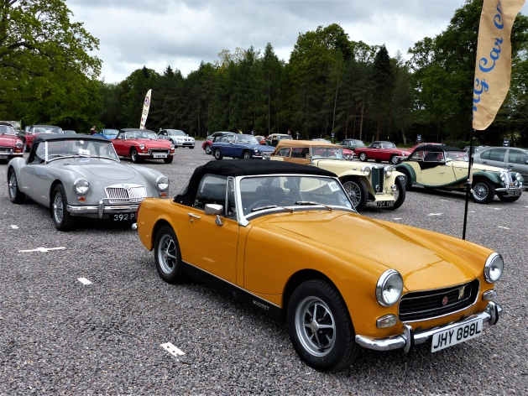 | The Spring events commenced with the Drive-it-Day Run in April from Denbies down to Rottingdean with nearly 60 cars taking part raising £450 for the FBHVC charity NSPCC Childline. This was followed by the Spring Run to Leoanardslee with two touring assemblies, one from Ashington, West Sussex and one from Leatherhead, Surrey. Again excellent support with over 90 cars attending and over 50 cars completing the runs. As expected the gardens were spectacular with the Spring colour.
 | In June, a MG display was organised at Brooklands Museum by the Fairmile Natter with additional support from the Vintage and MGF Registers. Natters recommenced in June, initially meeting outside in the pub gardens until the lockdown permitted a return to indoor meetings. In August, a gathering was organised at the K&ESR Tenterden station with over 30 cars attending and enjoying the period setting of the station and a train journey to Bodium. |  |  |  | 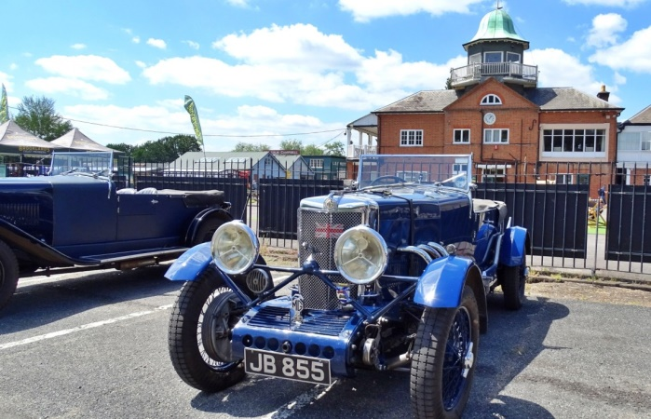
 | 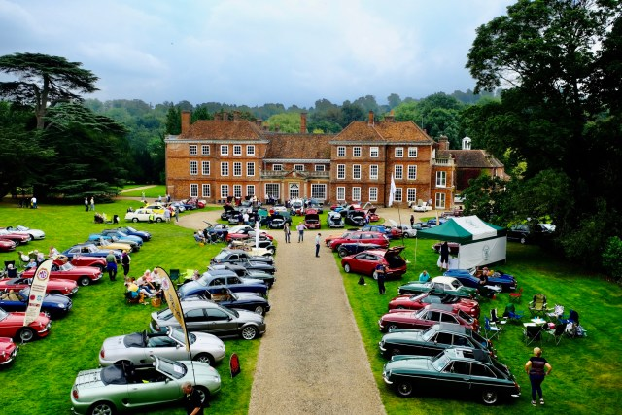 |  | The Autumn Meeting was held in its regular slot of late September and was blessed with warm Autumn day. 95 cars attended despite clashing with events such as the Goodwood Revival. Two road runs from the east and west gave entrants a scenic run to the event with 45 cars completing the tours. In addition to the road runs, a pride of ownership and concours competition was held at the castle with 24 cars taking part. Car of Show was John Langford’s MG Magnette mkiv and Spirit of the Event Derek Moore’s MGYB
Five cars from the SE Centre including a NB, three T Types and a MG Metro entered a Car Trial run by the Maidstone and Mid Kent Motor Club at a venue near Maidstone. This is the first time since 2006 had competed in this type of event. The Tomato Trophy was awarded to Will Opie in the NB for the best performing MG. The Trial sections were quite dry by in the morning the long green grass provided some slippery conditions on the tight course. |  |  |  | 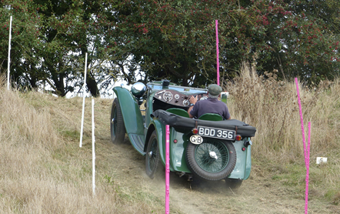
Planning is underway for 2022 with same mix of events. Some competitive events will be promoted including another Trial either in the Spring or Autumn and a Taster Autotest day in the Spring. A taster event is aimed at members who have not competed before and would like to have the experience of what is involved. The SE Centre has also re-joined the Association of South East Motor Clubs that will allow MGCC members to enter events organise by other motor clubs in the SE.
The SE Centre is also partaking in a MGCC main club working party to review requirements for club events to be fully Motorsport UK compliant and ensure that the correct guidance is available on the Club website for all CRBs. It should be remembered, that events run under Motorsport UK Permits/Certificate of Exemption are fully insured by Motorsport UK. This requires events to be planned in accordance with the Motorsport UK ‘Blue Book’ that summarises the rules and obtaining permits/Certificate of Exemption ensure compliance with the Road Traffic Act/Motor Vehicles (Competition and Rallies) Regulations. Any other events such as Natter activities or Social Runs rely on the MGCC club insurance.

John Morgan - November 2021

