MGCC South- East Centre
AGM November 2021
Secretarial Report

Introduction
2021 has seen a slow but steady return to a more normal programme of events.
Natters have progressively moved back to face to face meetings utilising outside meeting environments as much as possible. Most of our members are now “fully vaccinated” which has facilitated meetings migrating back to indoor environments.
Similarly, the Wanderer groups have been able to re-start in the second half of the year using external venues and then cautiously moving back indoors.
All our monthly committee meetings continued online. The chairman attempted to host one meeting face to face in his newly refurbished large kitchen, but he was thwarted by the fuel crisis. The meeting was cancelled just a day or two ahead of the meeting.
Natter and Wanderer leader’s meetings have settled down to a regular routine and are now held approximately bi-monthly. It is expected that these meetings will become a permanent feature of the running of the Centre and are one of the positives to come out of Covid.
Sadly, one of our longest serving and hard-working Natter leaders, Grahame White passed away and is very much missed.
Committee Members Activity
The committee members have worked extremely hard for the Centre again this year and have delivered the Centre ready for what we anticipate will be an even better 2022.
Detail is available in each of the officer and committee members reports.

Tony Atcheson stood down as treasurer soon after our last AGM and we welcomed Ron Kemp as our new Treasurer. Huge thanks are due to Tony for his work over 5 years and he handed the Centre over in excellent financial order. Ron came to us with his Car Club treasurer skills having been honed with the MGF register. He has also taken on the task of monitoring and refreshing the Centre’s equipment.
John Morgan and Andrew Mitchell have delivered an events programme virtually hand to mouth as we emerged from the pandemic. John in addition has enthused some members to take up some proper competition and we are hoping to build on that next year.
Ray Ruffels and William Opie have produced no fewer than four Newsletters with each better than the one before.
Diana Calvert has continued to monitor and promote membership which has stabilised over the year and has seen many new members joining. This is quite remarkable given the issues thrown up by Covid.
John and Gwen Davies have taken on the task of documenting the history of the Centre and they are starting to amass a large amount of material.
Tim Morris has driven forward the IT functions of the centre and now each committee member has a generic SE Centre Email address which has given the Centre a much more professional look.
Alex Lemon has taken over responsibility for merchandise and has already sold more stock at one meeting than has been sold in full years in the past.
Derek Edwards. Derek is now our official President having been endorsed at the recent Council meeting at HQ. Derek has attended all our committee meetings despite his health issues and continues to provide his pithy comments at the relevant times. The Centre is privileged to have Derek as its president.

Unfortunately, much of the committee’s time and energy this year has been taken up with the difficulties that were experienced at HQ following the dismissal of a member of staff for alleged Covid regulation breaches and the subsequent resignation of a number of Club directors.
Full reports of the Centre’s position and actions have been made available elsewhere.

Some figures
Since the last AGM at the end of January this year, the Centre has put on no fewer than 9 events including 3 Alternative Pride of Ownership competitions.
It has supported at least two Brooklands events and a number of Natter or Wanderer events were open to the wider Centre and were well supported.
We have held 11 Committee meetings, 7 Natter and Wanderer Leaders’ meetings, 5 sub-committee meetings and hosted at least 3 online natters.

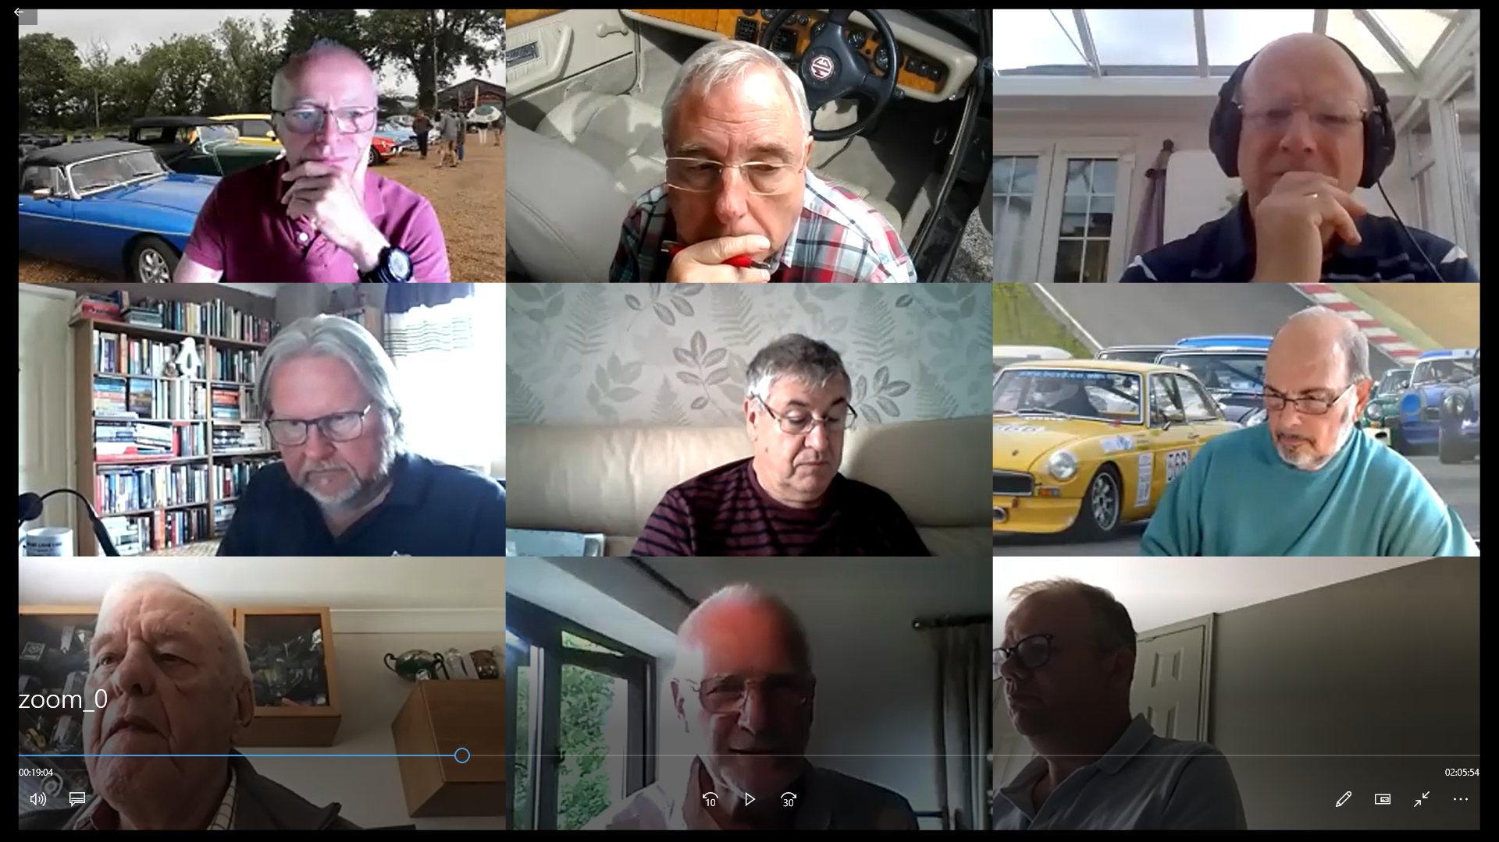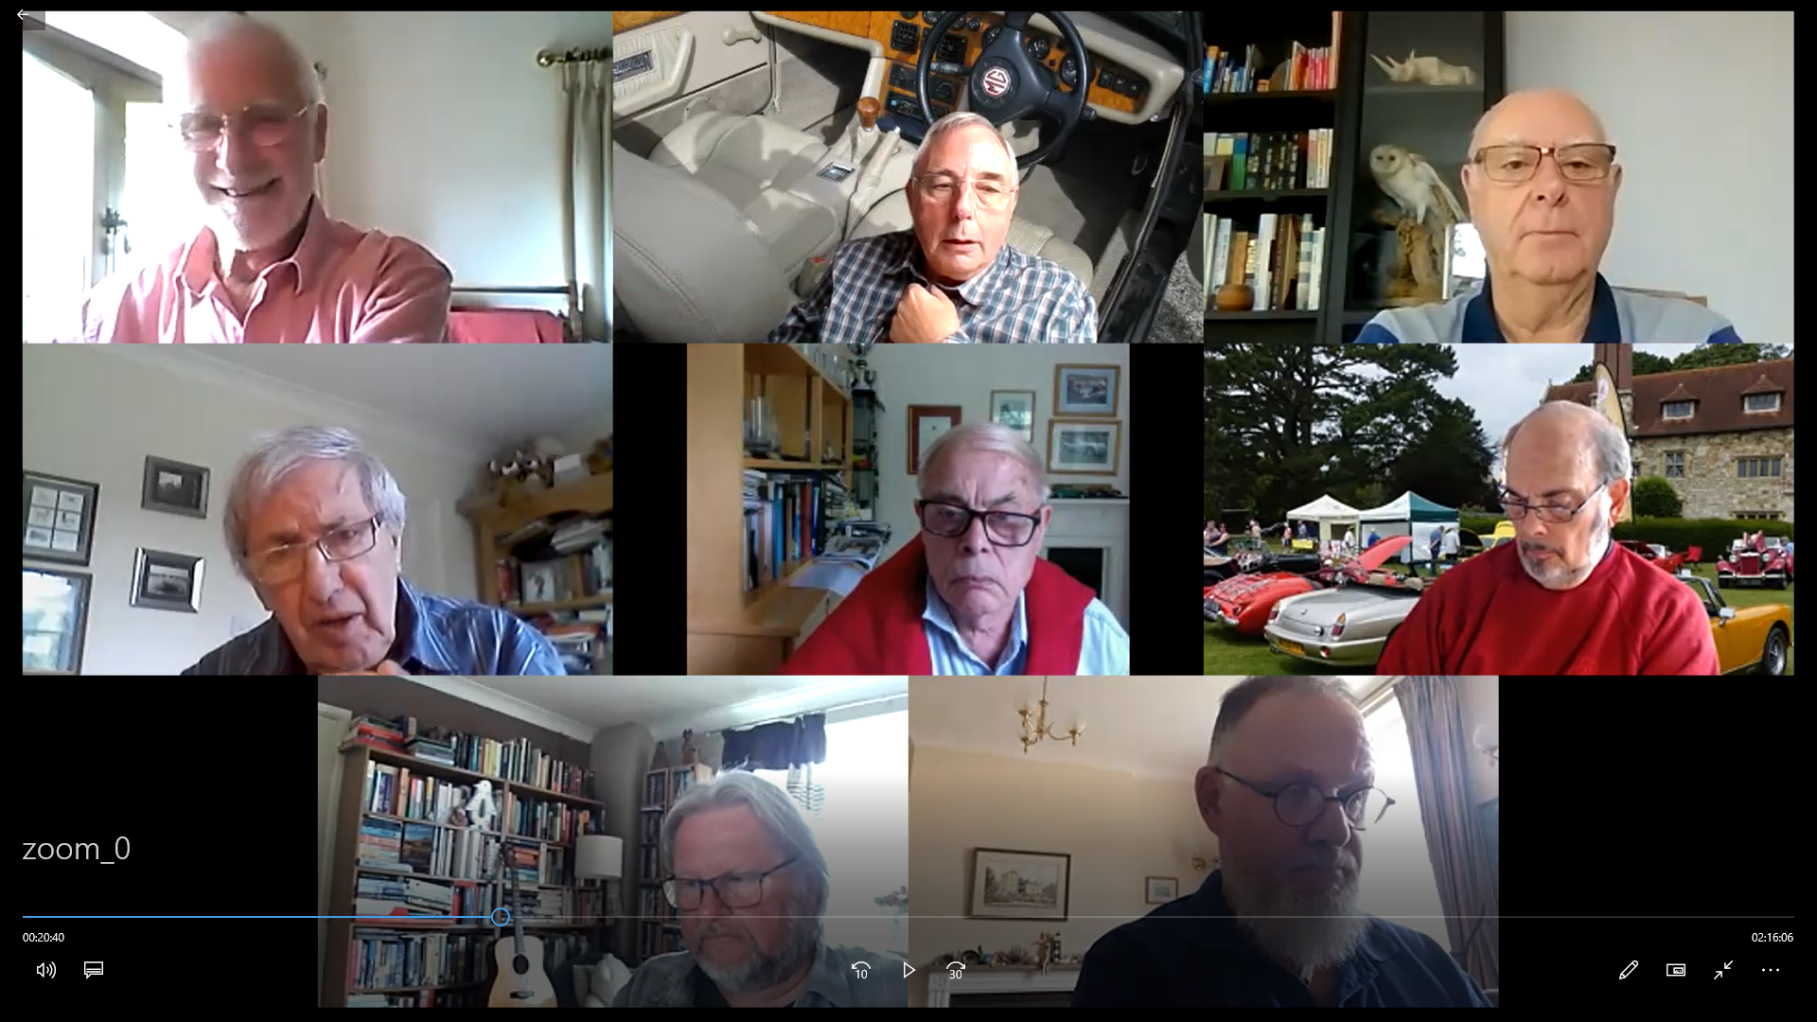

Finally
Chris Leigh our chairman has decided to stand down at this AGM.
Huge thanks are due to Chris for stepping in with no notice when Derek Edwards was taken ill.
He took over a small, slightly shell- shocked committee which was also struggling with a rookie secretary. During his three years in office he has overseen the expansion and renewal of the committee, has championed recruitment and membership issues, has guided the Centre through the turmoil of Covid and steadied the committee as it sought to respond to the difficulties at HQ.
He has provided essential wise and warm-hearted support to me as secretary and has largely managed to prevent me from implementing my more hair-brain ideas.
I will miss him considerably, but I know he will be continuing to beaver away at things MG in the future.
I look forward to working with his successor.

Austin J Banner
Secretary MGCC SE Centre
November 2021

