MGCC South- East Centre AGM 2021
Archive and History Report

'FROM THE ARCHIVES

As a committee we have been keeping watch on the Internet and other
records for trophies from the past. It is amazing what can still be
found in various ways.

The first picture from John Morgan shows Jackie Faulkner and her MGB the runner
up of the 1972 Ranmore event she was a keen supporter of the SE
Centre. By all account this event fielded a strong entry of members. It
would be good to see more ladies and gents entering our 2022 competitive
events - you are never too old.

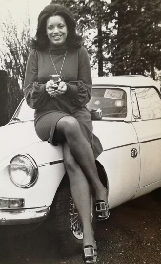

The second picture shows the Carissima Cup spotted online by William
Opie which may well have an interesting history. It was hallmarked late
1920's and is Stirling silver. It was probably not first awarded until
after World War 2 as it shows South- Eastern Centre. An older Club member
recalls marshalling in 1963 and it being awarded to the most successful
MGCC member on a night-time Hertfordshire rally. We are still searching
for more information.

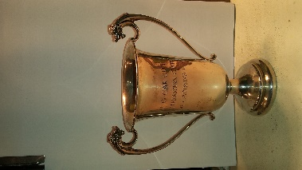

The third picture of interest is the Banana Trophy which
was featured in the April 2021 SE Centre Newsletter. By chance we came
across a copy of the house publication for November 1934 which refers to
the presentation of the Banana Trophy to the MGCC by the Central Motor
Institute (CMI). As the SE Centre we have been presenting this to the
most successful racing driver at the Spring Brands Hatch meeting
annually for a number of years.

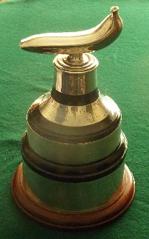

As restrictions are lifted, we have other ideas for helping preserve some of
past achievements of MG cars and their drivers. Any relevant finds or
ideas would be most welcome by the Committee and John Davies can be best
contacted by email santana@dlgmail.co.uk

Please give some thought to the competitive aspect of the SE Centre and
how we can further promote this for the future - after all way back in
1930 this was one of the prime objectives when the MG Car Club was
nationally set up.

John H. Davies

