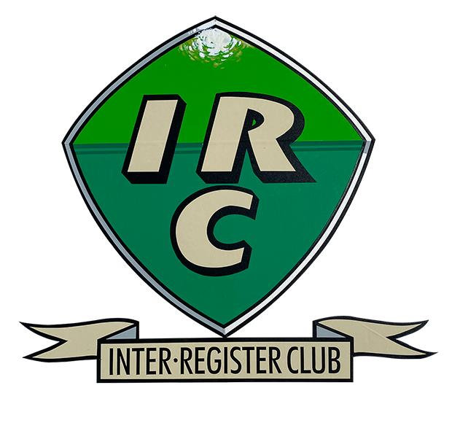 | Table Top Rally  13th September 2020 –Regulations  And Entry Form  Using OS Landranger  1:50,000 Map 187  Dorking & Reigate  2016 version

This event is being hosted by Philip and Rosemary Bayne-Powell on behalf of the Inter Register Club and the MG Car Club.
You will need the OS Landranger 1:50,000 Map 187 – Dorking & Reigate, which is the same we used for the last Table Top rally, saving you having to buy another map.
Navigation techniques will be used such as spot heights, grid references, coloured roads etc. Not all routes will be on public roads. Answers to the questions will be found on the map at the end of each section, proving that you have correctly arrived at the finish.
There will be 15 sections with increasing scores, starting with the easier clues and getting harder with ensuing sections. If you get stuck on one section, move onto the next section, so as to get the most results, and hence a maximum score.
Please confirm you wish to partake in this new event by e-mailing your entry form to 1942mgman@gmail.com before Sunday 13th September 2020. Please state your virtual vehicle so IRC points can be awarded. Also state the class that you are entering from the choice below.
Class A – Expert Competitors who have finished in the top three of any navigation scatter event or 12-car rally, or the top ten of a National B Rally, in the last 5 years.
Class B – Novice Competitors with more limited navigation experience.
The instructions and questions will be sent to all novices by e-mail at 10.00am and the more difficult instructions to all experts by e-mail at 10.30am. You will then have 2 hours (Experts) and 2¹/₂ hours (Novices) to complete the event by submitting your answers to the clues by e-mail them to the organisers by 12.30. Late entries incur a penalty of one point for every minute late.

Results will be distributed by e-mail as soon as possible on the day, depending on the size of the entry..
If any further information or details are required, please e-mail Philip on 1942mgman@gmail.com or phone 01483 811428.

Table Top Rally 13th September 2020
ENTRY FORM

Driver’s name ............
Navigator’s Name .....................
Virtual car details ...........
Class entered A (expert) .........
or B (novice) ...............
Entrant’s Car Club .............
Telephone Number ...... e-mail .........

