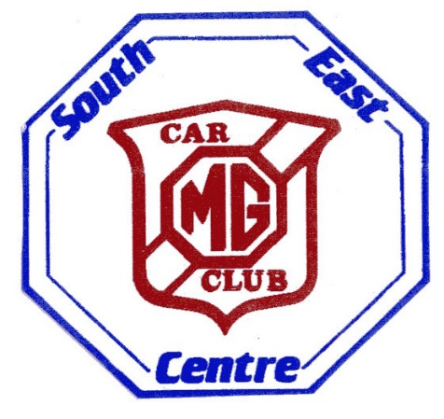
MG CAR CLUB – SOUTH EAST CENTRE

AUTUMN NAVISCAT
SUNDAY 6th OCTOBER 2019

SUPPLEMENTARY REGULATIONS
1 The MG Car Club (South East Centre) will organise a Navigational Scatter Rally on Sunday 6th October 2019.
This event will be held under the General Regulations of the Motor Sports Association Ltd (incorporating the ………………provisions of the International Sporting Code of the FIA) and these Supplementary Regulations.
An MSA Certificate of Exemption has been obtained and route liaison work carried out.

2 The event will be run using the 1:50000 scale Ordnance Survey map, Landranger 188, Maidstone & Royal Tunbridge Wells area. A recent version of this map, plus writing implement for marking points on the map and filling in answers to the questions, will be the minimum that is required. Coloured stickers (or coloured highlighters) for marking are up to the individual teams. Romers will be provided.

3 The event will start from the Bo Peep Public House, Chelsfield, Kent BR6 7QL. (Map Ref 490635)
Signing-on will take place between 10.00am and 10.45am and any competitor not signed-on by then may be deemed a non-starter. Participants will start at 11.00am and the finish will be at 2.30pm back at the Bo Peep Public House. Refreshments are on sale at the start venue.

4 Participants will be required to visit a selection of locations defined by map references and at each place will need to answer a related question. The list of locations will be handed out at 11.00am. Participants will not
Be required to visit all locations and a maximum number of answers to count towards the final score will be specified in the Final Instructions handed out at the start.

5 Classes will be as follows:
A Pre-1955 MG cars
B All MGBs
C MGs from 1955-1995
D MGs from 1995 to present
E Non-MGs, including Inter Register non-MG cars

6 Awards will be as follows: (The organisers reserve the right to amalgamate classes if necessary)
1 First MG
2 First in Class (subject to 4 entries in class)
3 Second in Class (subject to 6 entries in class)
4 Novice Award
5 IRC Awards (individual and team)

Rosettes will be presented on the day and the awards for the MGCC members will be given out at the Awards Dinner in April 2018. IRC prizes will be given out on the day of the rally.

7 An entry fee of £10 per car (£12 on the day) must be enclosed with the entry. The maximum number of entrants is 50 and the minimum number is 10. Those entering on the day will need to complete an Entry Form before signing-on. Cheques should be made payable to “MG Car Club South East Centre”.

8 Global Positioning Systems are not allowed -the penalty for use is disqualification.
Three-adult teams will incur a 10% penalty on their final score, whilst four-adult teams will incur a 15% penalty.

9 Entry Forms and fee should be sent to the secretary of the meeting:
Chris & Janice Leigh, The Old Bellhouse, Lower Warren Road, Aylesford, Kent ME20 7EH.

