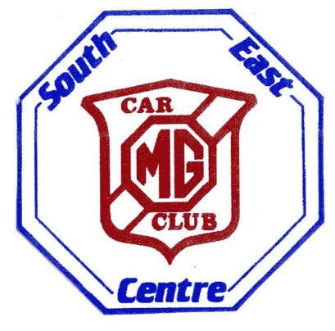
MG CAR CLUB – SOUTH EAST CENTRE
AUTUMN NAVISCAT
SUNDAY 6th OCTOBER 2019
The Bo Peep Pub & Restaurant, Chelsfield, Kent The Best Pub Baa None…
INTRODUCTION
Our final competition of 2019 is the Autumn Naviscat. This will take place around the North Downs and Darenth Valley and it starts and finishes at a beautiful pub conveniently close to the M25 at Junction 4.
Members of the MG Owners Club and the Inter Register Club are also invited to take part.
There will be pre-war Rileys, Alvises, Austins, Humbers and Sumbeams etc. competing.
Please bring your own copy of Ordnance Survey Map Sheet 188 – “Maidstone & Royal Tunbridge Wells”. Naviscats are rather like other Treasure Hunts but they require a knowledge of 6-figure map references.
You use a Romer (provided free) to plot your clues on your map and help is available if needed.
A pen and three different coloured highlighters are also very useful.
The Start of this Naviscat is the ancient Bo Peep Public House near Chelsfield in West Kent BR6 7QL.
Signing-on is from 10.0am and a briefing is given at 10.50am ready for an 11.00am start.
Hot drinks and Bacon Rolls can be purchased on arrival.
Please also make sure that you order any food with us before you set off.
Once the clues have been plotted on your map you will decide which route to take to collect most points.
Please note that it is physically impossible to visit every location provided in the time allowed but only your best 30 answers will be accepted under the rules.
If you are a Novice Entry it is probably better to visit the 1-point “drive-by” locations.
2-point and 3-point clues have a suitable place to park nearby because you will have to leave your car.
It is your choice whether you have a lazy time enjoying the pretty Kentish country views or try to win the event. A special prize is always given to the best Novice Entry.
It is very important to hand-in your completed answer sheet at the “Finish Table” at the Bo Peep by 2.30pm There is a 1-point penalty for every minute of lateness!
Your previously ordered lunch should be ready soon after you arrive back at the Bo Peep
Get a drink and find an appropriate seat!
Photos of the correct answers will be available for inspection in the pub after the finish.
Results and rosettes will immediately follow your meal.
Please see the “Supplementary Regulations” for fuller details or phone Chris or Janice Leigh
on 01634 201145 (mobile 07890 017507) for advice.
For more information on Naviscats generally, visit the MGCC South East Centre website:
Click on “comps” and then click on “click here for an introductory guide”.

