MG CAR CLUB – SE CENTRE
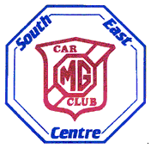
SUMMER GATHERING
Sunday 21st July 2019
at Michelham Priory,

Upper Dicker, Hailsham,
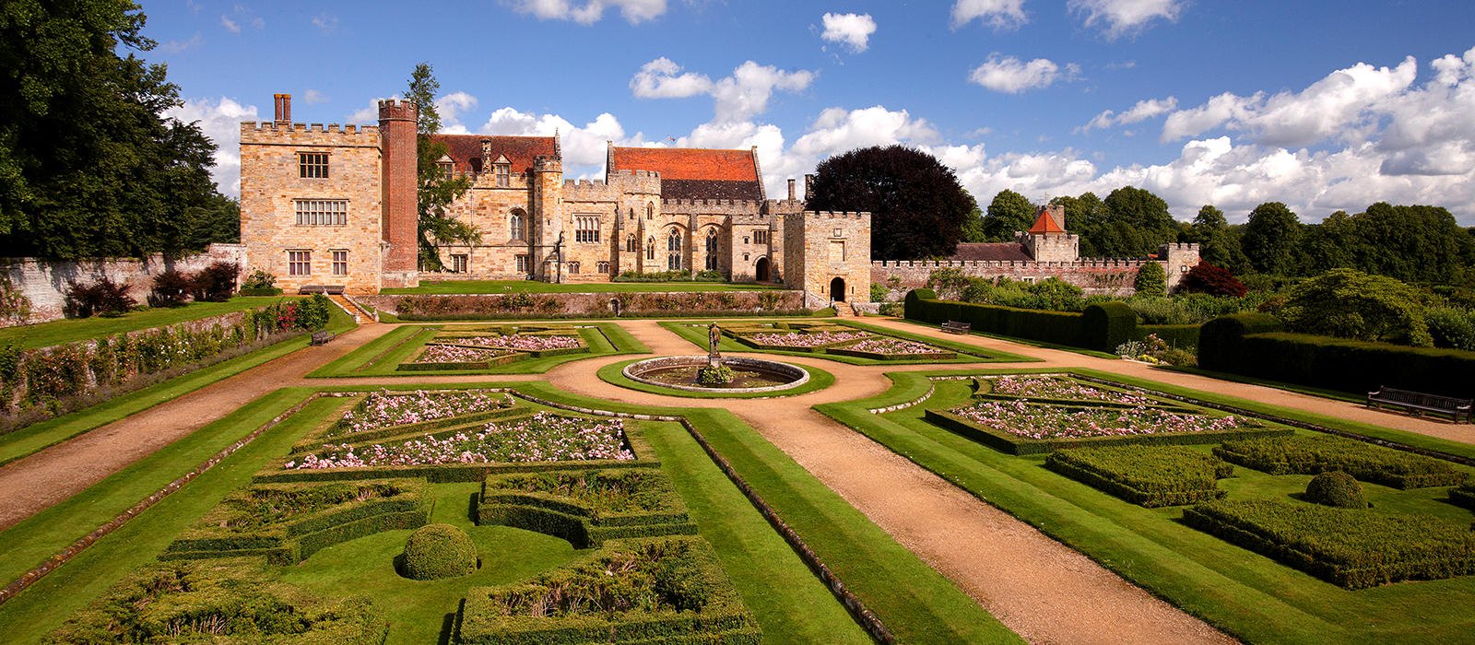
East Sussex, BN27 3QS

Michelham Priory is England’s oldest medieval moated country house, dating back to 1229, when it was founded by Augustinian canons. There is much to see apart from the rows of MGs of all ages; these include an historic watermill, and working forge, together with a replica bronze age roundhouse, an interactive medieval gallery in the 14th century gatehouse, and trails through the grounds ’7 acres.
There is also a cafe and shop to help you dispose of your money.
Our own events, will be the usual Concours and self-judging Pride of Ownership competitions. We shall be selling our SE Centre regalia, as usual.
Please pre-enter on the enclosed form, although you can enter on the day.
The gates open at 10am, and we hope to announce the prizes around 4pm.
Dogs are not allowed on the rally site.

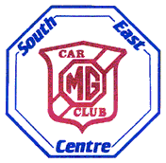

CONCOURS AND PRIDE OF OWNERSHIP

The Centre Committee, having listened to the points raised by the membership regarding this subject, has decided that the following principles shall be applied to all such events taking place under the auspices of the Centre.

The Centre wishes to encourage as many members as possible to take part in events, where their cars are shown as good examples of the MG marque, seen by as many people as possible, and are assessed for their condition and appearance. These conditions are part of organised Pride of Ownership and Concours competitions. We believe that it is only fair on all entrants, and would-be entrants, that cars, which are excellent examples of their model, i.e. those that win awards, will be ineligible to compete in that same class for an agreed time period. We also recognise that the Centre ‘Car of the Show’ award should be for that car which is judged to be the best overall of the various cars entered. We have, therefore, decided that the ‘Car of the Show’ award shall be solely awarded to those entered in the Pride of Ownership, Premier Pride of Ownership, and Concours.

A new and separate award is being instituted called ‘The Spirit of the Event’ and shall be awarded to the car and driver, which in the opinion of the Committee members present at the event, most embodies the spirit of owning and using an MG, at that Centre event.

New principles

1. Every car entered in any Centre organised PoO and/or Concours events, must have a valid MOT certificate and be driven to the event. Cars may be entered in any class felt suitable for the condition of that car.

2. Any member taking part in a SE Centre organised, Pride of Ownership and winning their Class, or receiving the Overall Winner award, if such is made, shall for a period of two years after the event, not be eligible to enter that car in the same PoO class at any subsequent SE Centre event. They may during the time enter the car in a higher class, e.g. Premier PoO. For any entry into the ‘Premier PoO class, the requirements of Principle 3, below, will also be applicable.

3. Any member taking part in a SE Centre organised, Premier Pride of Ownership event and winning their class or receiving the Overall Winner award, if such is made, shall for a period of two years after the event, not be eligible to enter that car in the same Premier PoO class at any subsequent SE Centre event. They can during the time enter the car in a higher class, e.g. Concours. For any entry into the Concours class, the requirements of Principle 4, below, will also be applicable.

4. Any member taking part in a SE Centre organised, Concours event and winning their class or receiving the Overall Winner award if such is made, shall for a period of two calendar years after the event, only be eligible to enter that car in the Premier Concours class at a SE Centre event [if such a class is offered].

