The MG Car Club S.E. Spring Run 28th April 2019
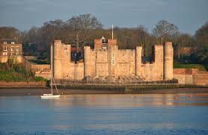

The Spring Run will start from The Toby Carvery, Halstead Kent, TN14 7AD at 9.30 am on Sunday 28th April. Grid Ref 498613 Landranger Map 177.
Tea, coffee and breakfast available. Cars Start 10.30. The run finishes at Medway Yacht Club, Lower Upnor, Nr Rochester,
ME2 4XB. Grid Ref 763713 Landranger Map 178.
A detailed route will be provided so the maps mentioned above will be needed!
There is private secure parking at the club with a clubhouse overlooking the Medway. A carvery lunch will be available for purchase in the Clubhouse Bar and Galley.
Weather permitting for a suggested donation of £2.00 per head a club launch will be doing short trips up river to view Upnor Castle with all proceeds going to RNLI.

Entry fee £5.00 payable on the day

Contact Dick Owens richard@printd.co.uk

