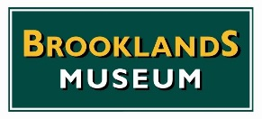
ADVANCED TICKET APPLICATION FORM
For MGA Twin-Cam 60th Anniversary Display Cars
MG Era Day
Sunday 8th April 2018

Name:
Address:

Postcode:
E-mail address:
Contact telephone numbers: Home Mobile
Car Type Registration Number
Colour
Are you a BTM Member: YES / NO (Please delete as appropriate)

Please note the closing date for advanced applications is Wednesday 28th March 2018 to ensure sufficient time for the dispatch of tickets by post. We will not be able to leave tickets on the gates for collection, so please make sure your application reaches us before the closing date.
Ticket Types Number Required Total
Feature Display Car Tickets (per Person) £10.00 £
TOTAL PAYABLE £

If you are paying by cheque, please send it with this form, made payable to BROOKLANDS MUSEUM TRUST LTD
Payment Card Details (No Diners, Amex, Solo or Euro cards accepted, sorry)
Card Number
Issue Number (Switch only) Security Number
Valid From Expiry Date
Return form by post to: Events Department, Brooklands Museum, Brooklands Road, Weybridge, Surrey, KT13 0QN
Or by e-mail to events@brooklandsmuseum.com or stevecastle@brooklandsmuseum.com

