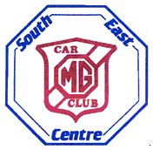 | SOUTH EAST CENTRE  Summer Gathering 15th July  Hollycombe Steam Museum  Liphook GU30 2LP
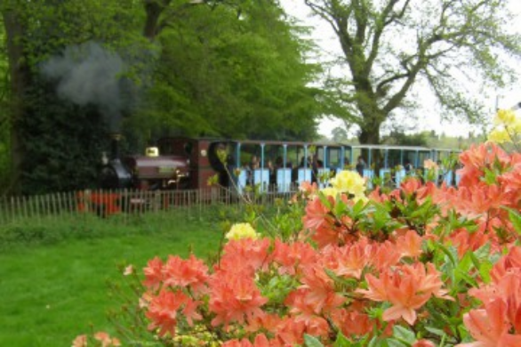
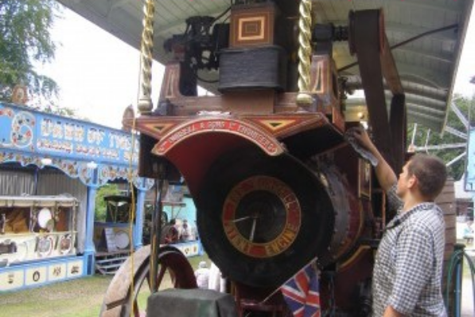

Our Summer Gathering this year returns to the Hollycombe Steam Museum, after 15 years. Hollycombe was set up in 1951, and opened to the public in 1971, with original steam driven attractions sourced from around the country, some of which are over 100 years old.
We will be joining in with their special Fairground Weekend, where incoming steam organs, traction engines and models will be joining the permanent steam fairground attractions, which include Gallopers, Swing Boats, Car-o-Planes, Big Wheel and a Razzle Dazzle. There is also a narrow gauge steam railway (1st rides start at 12am), steam farm, a waterwheel and beam engine to explore. The café, toilets and gift shop are just a 5 minute walk away from our rally field
We are also encouraging full family participation, as the day is ideally suited for children, who can arrive in a modern car, separately to the MG entry, for the same discounted entry fee, which covers all attractions.
We will be organising the usual Concours and self-judging Pride of Ownership competitions. There will also be a raffle and our regalia tent.
There will also be the usual feeder run to the event starting at the Pheasant pub at Buckland, Surrey, RH3 7BG. The run will be about 40 miles long and take under two hours.
The gates open at 10am, and we hope to announce the prizes around 4pm. Dogs are allowed but must be kept on a lead.
Please enter on the enclosed form, although you may enter on the day.


